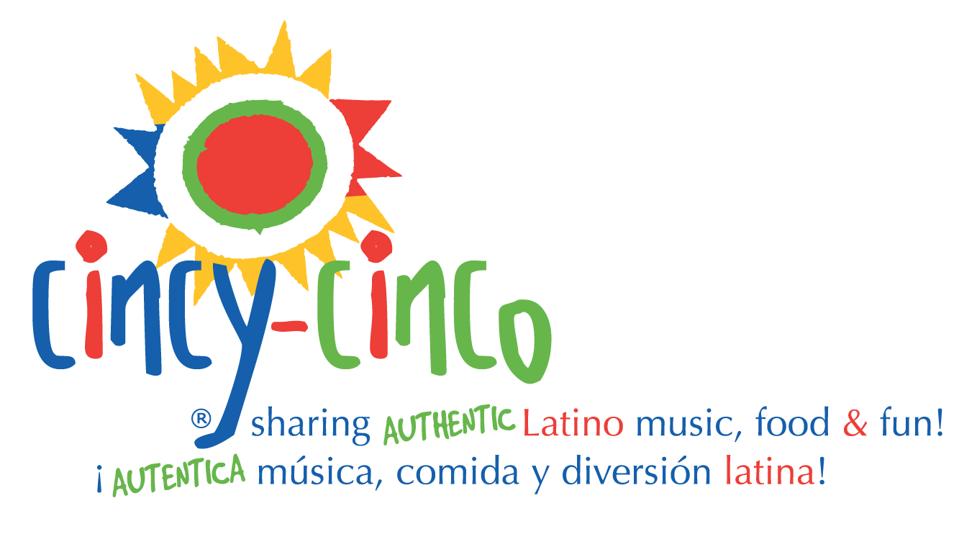
2022 Cincy-Cinco Latino Festival
GRANT REQUEST

Non - Profit Contact Information

Tax ID#:

Organization Name:

Address:

Primary Contact:

Prefix:

Name:

Office Phone:

E-mail:

PROGRAM SPECIFICS

- Organization Background and Mission Statement

- Program Title

- Grant Request Amount (not to exceed $5,000)

- Previous Year Results vs. Request – how were funds used including how many people served (especially children) by race/ethnicity. REQUESTS WILL NOT BE CONSIDERED IF RESULTS FROM LAST YEAR ARE NOT PROVIDED.

- Population to be Served by race/ethnicity (please be specific – how many people (especially children) served.

- Program General Description:

  - Program overall summary;

  - Key strategies, goals, and objectives;

  - Estimated or actual amounts of funds for total program/project

  - Statement of the anticipated impact on the issue (long term outcomes of the program);

  - Program time frame;

  - Evaluation: top four indicators you will measure.

- List other organizations involved with the program and their roles.

- Provide information on how your organization will acknowledge Cincy–Cinco’s support/partnership for this program should you be awarded a grant. Examples: names of flyers, listed in media releases (TV, Radio, Newspaper). Acknowledgment read FUNDED IN PART BY CINCY-CINCO, a program of Hispanics Avanzando Hispanics.

- Complete the Board of Directors section. Only include name of director and the company /Organization each director represents.

Cincy-Cinco Grant Request

Required Forms

Required Forms: Furnished upon request

- IRS letter of determination of 501(c) (3) status or tax-exempt status under IRS sections 115 & 170 (applicant agency only).
- Copy of applicant organization’s current operating budget. (one-page summary)
- The most recent annual report from the organization and/or department.
- Applicants must complete the attached application.
- The deadline is August 12, 2022
- Notifications and funds will be sent out during the September - October of 2022.
- A midyear report is due December 31, 2022, and a final report is due June 30, 2023. All funds must be used within the year. The outline for the report will be included in the acceptance letter.

Please submit all grant request information & forms to
via email michael@hahcincinnati.org or mail to

Hispanics Avanzando Hispanics
2637 Erie Ave. Suite 206
Cincinnati, OH 45208

