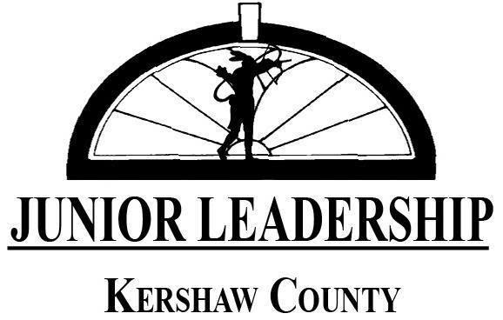
Thank you for your interest in participating in Kershaw County’s Junior Leadership program!
Requirements for participation:
- Must be a rising Junior or Senior in high school.
- Must be a face-to-face learner during the 2022-2023 school year.
- Must be able to attend the opening session on Friday, August 19, 2022 and the Team Building activity on Saturday, August 20, 2022 (no exceptions); note: If August 20th is a SAT testing day; you will not be excused for missing on that day to take the SAT; therefore, please plan accordingly.
- Must be able to attend all other sessions (with only 2 excused absences possible for the entire school year). Please take into account Dual Enrollment and Sports Schedules.
Description of the Program:
Junior Leadership Kershaw County is a year-long program that is supported by the Kershaw County Chamber of Commerce in partnership with the Kershaw County School District and Camden Military Academy. Participants represent Camden High, Lugoff-Elgin High, North Central High and Camden Military Academy.
The program starts with an introductory session and a team-building challenge at Camp Canaan in Rock Hill. Other sessions during the year cover public speaking, social and economic issues, non-profits, touring each of the high schools, and visiting the State House in Columbia to meet the local legislative delegation.
Tuition:
If selected, there is a $75 tuition to help cover expenses such as travel, meals, and supplies. DO NOT SUBMIT MONEY WITH YOUR APPLICATION.

Need-Based tuition scholarships are available for those with demonstrated need.
Junior Leadership School Advisors:

Camden High School
Laura Horton
Laura.horton@kcsdschools.net
803-425-8930, ext. 3608

Camden Military Academy
John Heflin
academics@camdenmilitary.com
803-432-6001

Lugoff-Elgin High School
Kelley Little
Kelley.little@kcsdschools.net
803-438-3481. ext. 5630

North Central High School
Caroline Duke Keen
Caroline.dukekeen@kcsdschools.net
803-432-9858, ext. 7227

Junior Leadership Adult Leaders:

Kershaw County Chamber of Commerce
Amy Kinard
director@kershawcountychamber.org
803-432-2525

Kershaw County School District
Teri Luther
teri.luther@kcsdschools.net
803-424-2860

Full Name __________________________________ Estimated GPA: _____________
Grade next year ____________________
Home Address _________________________________________
Phone numbers: Home ___________________ Cell ________________________
Parents’/guardians’ names ___________________________________
___________________________________

List current school activities and any offices held (include sports):

Non-school activities (church, community involvement, work, etc.):

Awards and honors you have received in school and non-school activities:

List two teacher references:

(They will be given an evaluation form to complete after you apply.)

Respond to the following questions:

- Why do you want to participate in Junior Leadership and why should you be selected?

- What do you consider your strongest characteristics?

3. What are your goals after you complete high school?

