Presented by
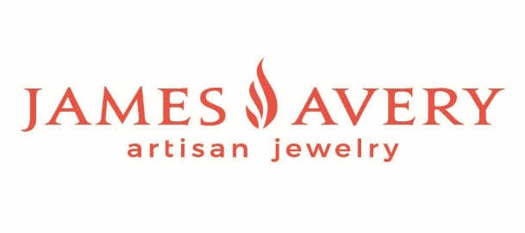

BusinessExpo-2023
MAJOR SPONSOR includes One 10x10 booth space with an 8-ft table in a premium location, two sides open, and two chairs. Electricity is included. 2 Vendor Badges – Sponsor Supplied Banner displayed during the event. Full-page Ad in the Expo Program will be provided at the event—weekly promotion to over 2500+ e-mails. Title sponsorship also receives a 25% discount on other Chamber Events during the calendar year of your sponsorship. SOLD

PREMIUM BOOTH includes One 10x10 booth space with two sides open, an 8-ft table, two chairs, and two vendor badges. The logo will be listed on the Chamber’s Website and the Expo Program, which will be provided at the event for $500

STANDARD BOOTH includes One 10x10 booth space with a 6-ft table, two chairs, and two vendor badges. Business name listed in the Expo Program, which will be provided at the event for $350. Same booth at a discount for Non-Profits - $300
Non-Profits must be 501c3 charitable organizations with pre-approval by the event planning committee.

HOME AND GARDEN SPACE: One 10x20 Space with a 6-ft table, two chairs, and two vendor badges. Business name listed in Expo Program, which will be provided at the event for $400 – Inside Expo Hall

FOOD TRUCK: Trucks will be located to the right of the main entrance. Tables will be provided for eating inside the Expo Hall. Business name listed in the Expo Program, provided at the event for $225

Non-Chamber Members will pay an additional $200 for Booth Space, ask about becoming a member and save!!

Prices will increase by $150 across all sponsorship levels after the
FINAL DEADLINE of JULY 14, 2023
Presented by

BusinessExpo-2023
Friday, August 4th – First Friday Wine Share - 5:15 p.m. – 8:00 p.m.
Saturday, August 5th - Expo - 10:00 a.m. – 3:00 p.m.
Hill Country Youth Event Center – Happy State Bank Expo Hall
3785 Highway 27, Kerrville, TX 78028
FIRST COME, FIRST SERVE ON BOOTH LOCATION
Business Name: ______________________________________________Type: ______________________________
Contact Person: ___________________________________________________________________________________
Work #: ________________________________________Cell #: ___________________________________________
E-mail: ___________________________________________________________________________________________
PLEASE CIRCLE DESIRED SPONSORSHIP:
Premium Booth - $500 YES / NO BOOTH CHOICES:
Standard Booth - $350 YES / NO 1ST Choice – Booth # ________
Standard Non-Profit Booth - $300 YES / NO 2nd Choice – Booth # ________
Home & Garden Booth - $400 YES / NO 3rd Choice – Booth # ________
Food Trucks - $225 YES / NO
The Chamber Accepts: MASTERCARD, VISA, DISCOVER, AMEX, CHECKS, OR MEMBERS CAN BE INVOICED
Business: __________________________________________________________________________________________
Name on Card: _____________________________________________________________________________________
Credit Card Type: __________________________________Billing Zip Code: ___________________________________
Credit Card #: _____________________________________________________________________________________
Expiration Date: ____________________________________CVV#: __________________________________________
Amount Authorizing: ________________________________For_____________________________________________
Check #: __________________________________________________________________________________________
SEND THE COMPLETED APPLICATION TO
Kerrville Area Chamber of Commerce * 1700 Sidney Baker * Kerrville, Texas 78028 * FAX TO 830-896-1175
or EMAIL pilar@kerrvillechamber.biz

Presented by
BusinessExpo-2023
Suggestion

VENDOR SETUP AND TAKEDOWN INSTRUCTIONS

Booth set-up can begin Friday at 10:00 am until 4:30 p.m. TAKE DOWN CAN NOT BEGIN EARLIER THAN 3:00 p.m. CANCELLATION OF BOOTH MUST BE MADE 15 DAYS IN ADVANCE OF EVENT FOR A 50% REFUND.

Booth Information

Each exhibitor will have one draped 10x10 with an 8-ft table or 6-ft table and two chairs.

- Vendors must stay open till 3 pm on Saturday, August 5th – NO EXCEPTIONS
- Vendors are encouraged to provide a prize at the end or after Expo (Vendor will be responsible for contacting winners - Chamber will NOT be announcing winners
- Vendors are welcome to sell their merchandise or food on both days.
- NO open flames are allowed in the building.
- If using electricity – the vendor must bring their own extension cords and power strips.
- Vendors CAN give out food samples, drinks, or logo products.

If you have any questions please get in touch with us at the Chamber
830-896-1155 or Email pilar@kerrvillechamber.com

