**Chamber Awards Banquet**

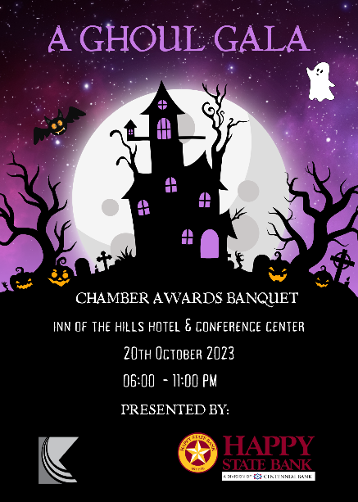

**Friday, October 20, 2023**

**Inn of the Hills Hotel & Conference Center**

Doors Open – 5:30 pm

Cocktail Hour & Silent Auction – 6 pm

Whiskey & Cigar Pull – 6 pm

Dinner – 7 pm

Awards Program – 7:30 pm

Dancing – 9 – 11 pm

**ATTIRE: Costume**

**

**Costume Contest: Best Male, Best Female & Best Couple**

**Please send us 3 song selections for the Music List**

**Title Sponsor** includes - 1 VIP table for 8, full-page ad on the back of the program, verbal recognition at the event, logo running on-screen during Year in Review, Company logo on the website’s event page, 2 bottles of premium wine at the table, post-event e-blast, and 16 drink tickets (two per person). Ad dimensions 7”w x 8.5”h/300 dpi or higher. **\*SOLD – Happy State Bank**

____ **“The Ghostly** **Ghoul” VIP Sponsorship** **- $2,000** – A premium table for 8, verbal recognition at the event, full-page ad in the program, logo on the website’s web page, 1 bottle of premium wine at the table, post-event e-blast, and 16 drink tickets (two per person). Ad dimensions 7”w x 8.5”h/300 dpi or higher

____ **“The Ghoulish** **Goblins” Table Sponsorship - $1,500** – A Second-tier table of 8, ½ page logo in the program, signage, chamber newsletter, name listed on website’s webpage, post-event e-blast, and 8 drink tickets (one per person). Ad dimensions 7w x 4”h/300 dpi or higher

____ “**Spooky” Tickets - $100** – Individual tickets – first come first serve, open seating

Business Name: ____________________________________________________________________________________

Contact Person: __________________________________ Email: ____________________________________________

Phone: _______________________________ Name on Card ________________________________________________

Credit Card # ____________________________________________ Expiration Date _____________CVV#____________

Billing Zip Code_____________________ Check#_______________ Invoice______________

Total Amount Authorizing __________________________

**Contact Pilar Gregory @ the Chamber with any questions – at 830-896-1155 or pilar@KerrvilleChamber.biz**