 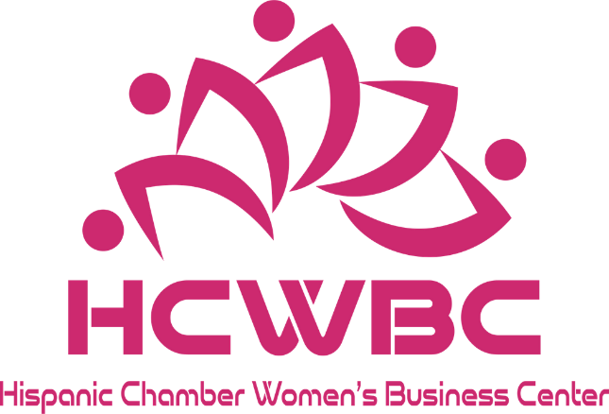

**REPORT 2019-2022**

**IMPACT**

**SUCCESS H I STORIES BEYOND BUSINESS**

294

LIVES IMPACTED

**GOING FURTHER CLASSES 2019-2022 PAST INCOME**

**PARTNERS**

I M P A C T

294

WOMEN'S BUSINESSES

BENEFITED

41

NEW BUSINESS



IDENTIFIED

104

P I PELINE

IDENTIFIED

YIMMA GILMA

S U C C E S S T O R I E S

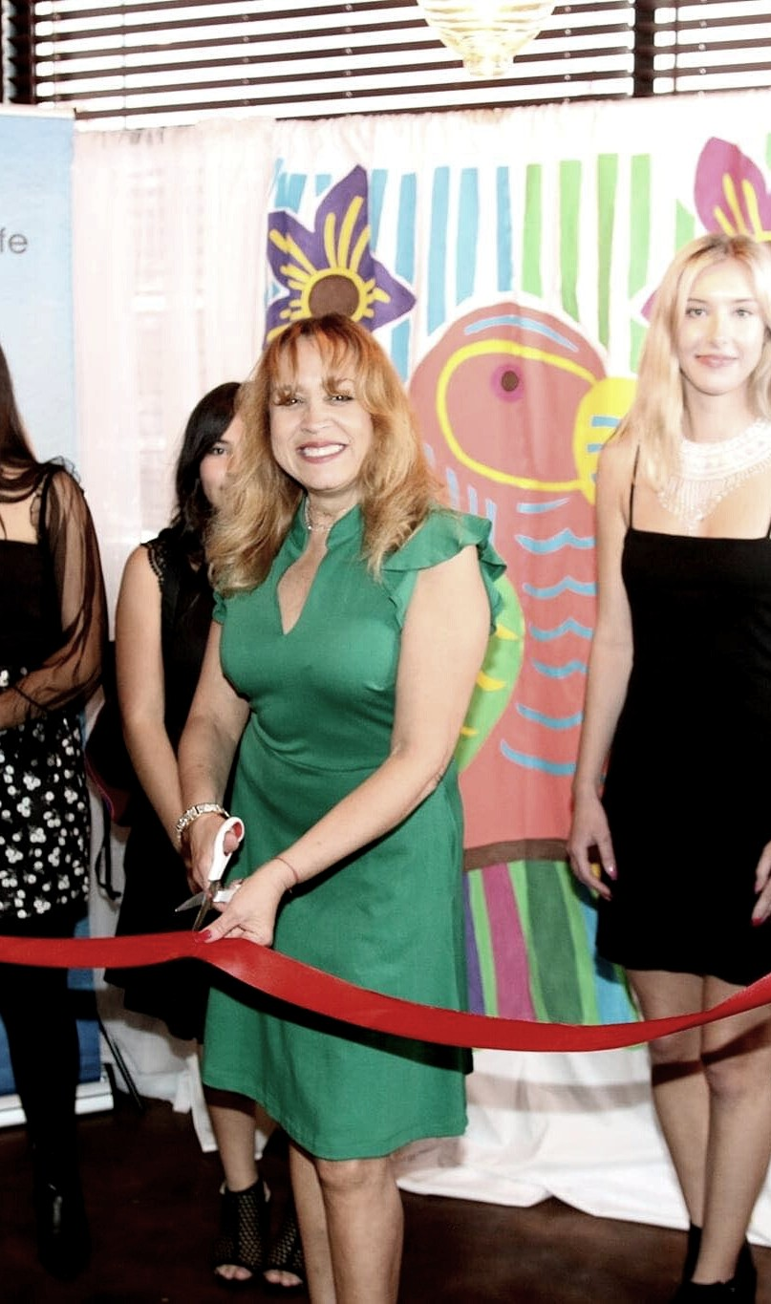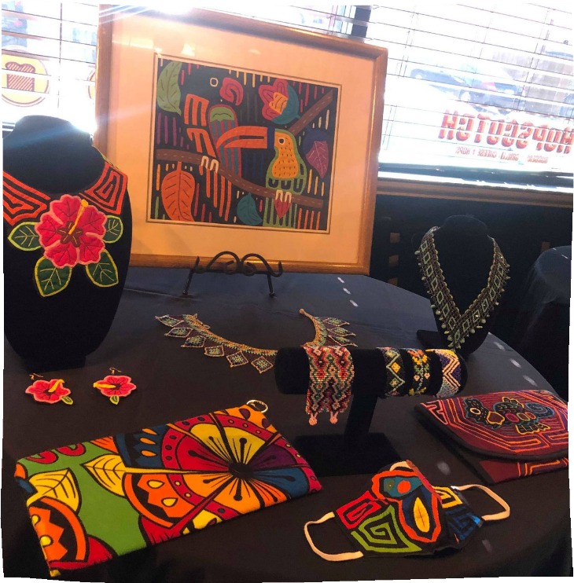

One of the wonders of life is learning every day and thanking God for every tool we can have. I am very grateful to Hispanic Chamber Women’s Business Center for the opportunity it gave me to attend these workshops that were very knowledgeable and that we will apply in future businesses.

It is a great joy to be able to talk about what I received in the teachings.

On June 4, 2019 I received the first class of basic principles for launching a business. Basically, I have a Family Day Care at home business, I was struck by an article that I read in relation to business training, I had in mind to open another business, this is how that internal desire to open something new with the purpose of help my indigenous people in Panama City, my native country.

I discussed my plans and my dreams, little by little my concern developed more in each training or training. I learned the important value transactions of business, financial advice, how to insure a business, how to make taxes, self-esteem as a person, dressing with a low budget; One that touched me a lot was that of dreams, if you have something in mind, do not wait for it, follow that dream, try to achieve it, do not fear, open ups and downs, do not give up, perceive what you want.

The most satisfactory thing is when you finally receive a Certification of having been able to achieve that training.

Today I was able to open what I longed for, I have put my heart, yes because my desire is to continue helping my people in Panama and to publicize the handmade beauties that I can distribute.

My business is called Guna-Yala, website: guna-yala.org

Thank you all for the opportunity provided, I will always thank you for this training that will be serving me.



I started my classes during January 2020 in person, but I finished it online. During the classes we were preparing everything for our business and we managed to launch it in March of this year, however, due to the situation, we stopped a bit, but as of today, we are back in the market, little by little getting more people get to know us, and we have managed to increase sales month by month.

Thanks to Hispanic Chamber Women's Business Center, for the guidance, encouragement and information they gave us to start a dream turned into a business for our family, Thank you.

**Zayda Machado. Los Toros,** **Tacos y Más**

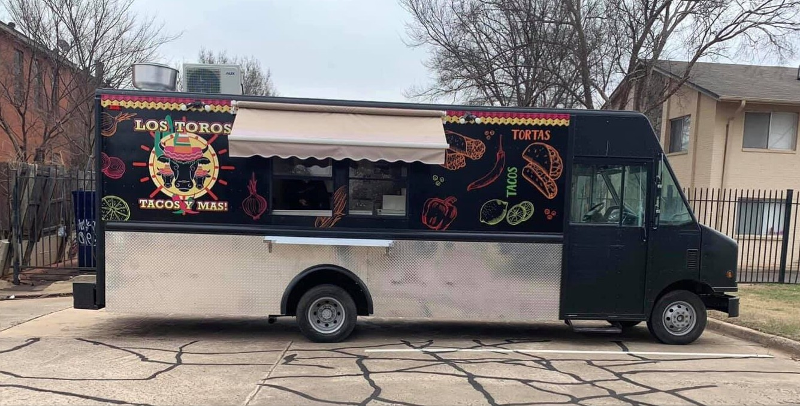

The Women's Business Center Program helped me in many aspects, meeting other women who, like me, also had a dream, filled me with a lot of security and confidence, I met very valuable people and made friends, there is a companionship environment, where we learned from the experiences of the other girls.



It helped me understand more about my crafts business and to see it as an opportunity to generate income beyond a hobby, it showed me all the resources available to women that I can draw on to start and grow my business.

Lucy Moreno, D'Glamour Bows, Sep 2020

"HCWBC helped me to change many aspects of my company that were not important to me before. Now with this course that I took, I have changed and improved my way of working because I feel more prepared, more empowered and ready to GROW"

Vanessa Díaz, Alarmas Zona Segura, Mexico -Dec 2020

I was just looking for information and guidance about how start my own online store, and I found a support group, a lot of training that today, with my sportswear online store, has been so helpful. Thank you.



Diana Michelle, Miich. Dec 2020

"I realized that I was not wrong when treating my employees as I liked to be treated, that it is important to know people, to know if they really have an interest and a willingness to learn, when they are, it is a person to whom I owe invest my time to develop it and prepare it to grow. Now I understand that the sky is the limit, that only we must not stop working, fighting and dreaming, our mind is powerful enough to stop us or to propel us. I am ready with enough weapons to grow and make others grow."

Fabi Valenciano, Dec 2020.

I have owned a sewing and alterations business for 8 years, I enrolled in these classes with the aim of learning, helping and motivating new entrepreneurs. I realized that there is a lot of information that would have served me well when I started my business. I learned a lot, and now I understand that I was missing many things to be able to grow my business. They helped me with the creation of a logo, facebook page, and I'm sure that will help me attract more customers. An excellent program, and very inspiring to hear the story of all the companions.

Dunia Dubon. Mabel's Fashion & Alterations. Dec 2020

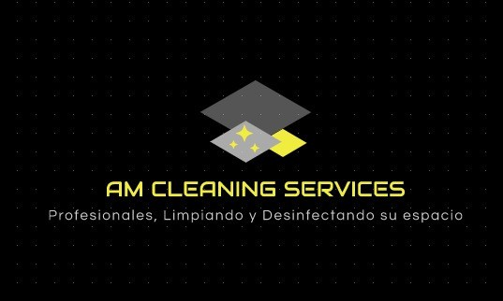

"In 2019 I enrolled in the Women's Business Center, I had the plan of starting a cleaning service company. I got information and guidance and launched my business, but I did not finish the classes. Today, I have my own company and went back to these classes because I felt that I was needing help. I learned how necessary it is to have a logo, what I need to motivate my workers, what I need to know about hiring people, and a lot of more things, but what I'm really grateful for is that now I have a support group, and now I know that sometimes I need a break to recharge my batteries and it's okay not to be able to do it all"

**María Wright, AM Cleaning Services, Dec 2020**

I recently started a small event decoration business. It's a small thing, and I signed up for the course just to prepare and learn about other stories. Today I know that if I put my mind to it, I can make my dream grow, I can formalize my business, find more clients, and I'm already looking for a space to rent and exhibit work.



I have 5 children, and at first I saw it as an obstacle and said that I did not have time, but listening to the stories of other women, and knowing that I am not the only one trying to achieve my dream, has given me courage and motivation to continue preparing myself. and achieve my goal, now I want to have my own business, for them, for my children.

Soltkenya, Sol Decorations. Dec 2020.

For me it was extraordinarily wonderful, I learned more than I thought, it exceeded my expectations. I am grateful for the support in the decision of the logo of my cake business, I have been doing it informally for several years, but now I know that if I want to, I can formalize it and grow as much as I propose.



Zonia Calderon - Dec 2020

BEYOND BUSINESS...



"I feel that this course came at the right time for me, during the time that the course lasted, everything happened to me; I went through a divorce, I had to sell my house, moved, I had a crash, and everyone in my family was positive Covid, but even with all these circumstances, I managed to complete the course. Now I know that I have a new support group, that I know that they believe in me, that they listen and support me, even though we do not know each other physically, the positive vibe and good wishes are felt, even when my own family sometimes does not trust me.

I have had my cleaning business for a long time,

however, I had left it for a while, and today I am going to start it again, I understand that it is not about cleaning, but about giving work and support to other families, about teaming up with my workers, and now I know that I have the energy and capabilities to make my business successful"

**Laura Armendariz, LA Cleaning Services. Dec 2020**

We made contact with a Female Entrepreneurship group from Texas on Facebook, which includes part of the Oklahoma Northeast. Since we are still virtually, we hope to reach more women from more areas of Oklahoma, and probably from Texas as well.

GOING FURTHER...(Identified)

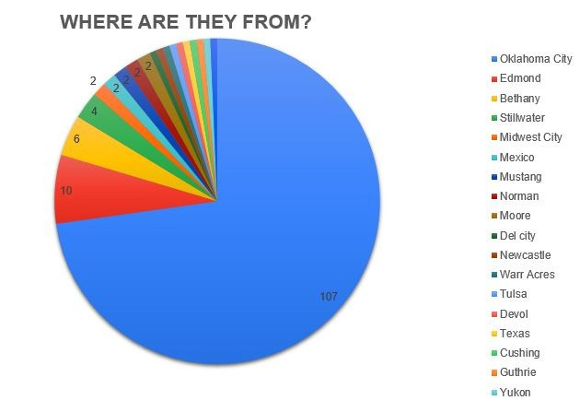

# PROGRAM 2022

Startup Basics/ Principios Básicos para Business Model / Modelo de Negocios

Market and Marketing / Mercado y Mercadotecnia

Financial Projections / Proyeeciones Financieras Funding Sources

Accounting/ Contabilidad Insurance / Seguros

Social Media / Redes Sociales Quickbooks

Human Resources/ Recursos Humanos

Google Ads

Time Management /Administración del Tiempo Leadership / Liderazo

Psychology of money / Psicología del dinero

Customer Service Experience / Experiencia de Servicio al Cliente

Women's Entrepreneur Conference / Conferencia Emprendimiento Femenino

During the program, we will be working on every business plan and proje

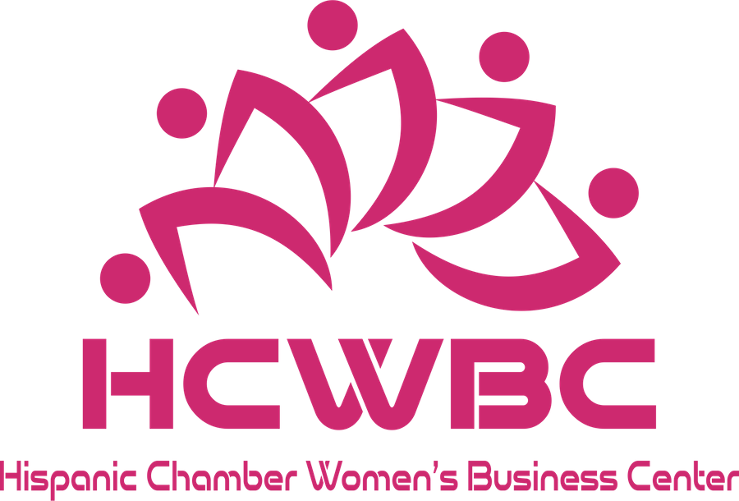

**2023 Classes**

MUJER CRECE/MUJER EMPRENDE



**Past INCOME**

## PROGRAM FEES

15 CLASSES

ONE TO ONE CONSULTING PERSONALIZED MONITORING OF EACH PROJECT

BUSINESS PLAN

PARTICIPATION CERTIFICATE

15 PERSON X 3 PROGRAMS PEAR YEAR X $100 FEE

## $ 4, 500

Past SPONSORS

TINKER FEDERAL CREDIT UNION

SIMMONS BANK

ARVEST BANK

VICTOR CHAVEZ AGENCY SONIC

WELLS FARGO BANK

BancFirst

Bank of America

## IN KIND

GREATER OKC HISPANIC CHAMBER OF COMMERCE METRO TECH

ON MEDIA & DESIGN

UNIVERSITY OF CENTRAL OKLAHOMA VASQUEZ TAX SERVICES

SMALL BUSINESS DEVELOPMENT CENTER OKLAHOMA STATE UNIVERSITY

THE PAPER BOX

## $1 7, 000



PARTNERS

