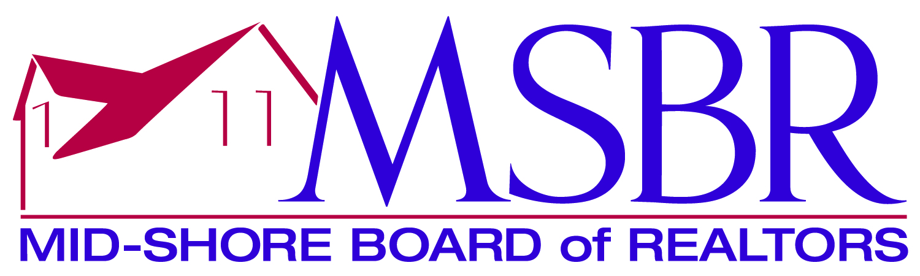

Affiliate of the Year Application
In recognition of outstanding service to the REALTOR Community

Name:
Firm:

Mid-Shore Board of REALTORS Activity

Service on Committees:

Continuing Education classes taught:

Lunch & Learns Held:

Events Sponsored:

Participation:

Other:

Civic Activity outside Mid-Shore

Service on Civic & Service Clubs:

Education/Designations showing dedication to area in industry

Certifications/Designations:
Higher Education Degrees:

Business Conduct & Practices

