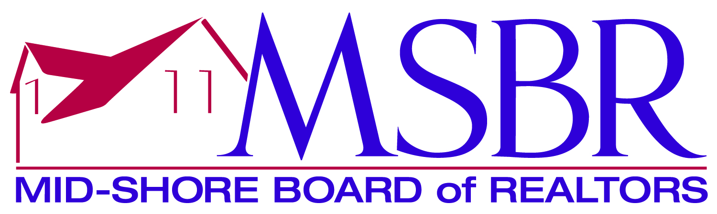

2022 Rookie REALTOR of the Year: This award recognizes a Realtor who has been in the business four years or less, has demonstrated excellence in knowledge, work production, civic activity and service to their local, state and or national association.

Name

Company

(Based on entire career, not just this past year)

Education (25%) Credit given for seminars, Lunch & Learns courses toward designations, any professional education courses that improve ability and expertise. (Based on whole career)

Productivity (20%) 1% per settled transaction side up to a maximum of 20%
(Based on the number of transactions and not volume in the past 12 months from submission date, i.e. 1 transaction =1%, 10 transactions=10%, 20 transactions=20%, 25 transactions=20%)

Participation in Local Board/Association, State (MR), National (NAR) Activities (20%)
Participation includes attendance at conferences, conventions, on committees, and other activities. (Based on whole career, bulleted in chronological order.)

Community Service, Charitable, and Civic Activity (10%) Involvement, membership, or leadership roles in any community service, charitable, and civic organizations.

Rookie Signature: _____________________________________________________

Broker/Manager Signature: ______________________________________________

Comments from the Broker/Manager:

