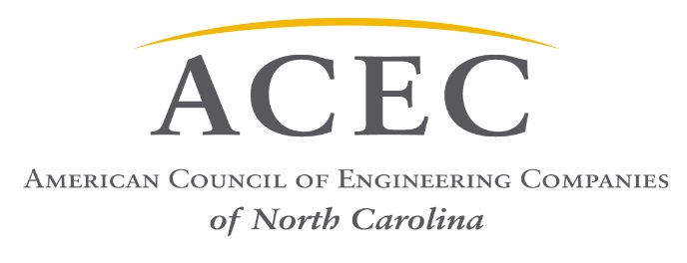

Legislation of Interest to the Engineering Industry
Transportation:
- HB 81 – STI Regional and Division Weighting YES
- HB 92 – Blue Ribbon Commission on Long Term Transportation Funding YES
- HB 219 – Transportation Mega Project Funding YES
- HB 220 - State Infrastructure Bank Revisions YES
- HB 266 – Terminate Agreement for Tolling I-77 NO
- HB 468 – DOT Fund for Preliminary Engineering YES
- SB 351 – Short Term Lease Tax/Highway Fund YES
- SB 170, HB 266 – Remove Limits on Light Rail Funding YES
- HB 533 – Stop the Revolving Door NO
- Support a potential Transportation Bond ($3 Billion) YES
Environment/Energy:
- SB 131 – Regulatory Reform Act of 2016 (removed objectionable fast-track permit language) YES
- SB 366/HB470 – Responsible Wind Energy Implementation YES
- HB 267 – Utilities/Amend REPS Requirements (amend the renewable energy portfolio)
- HB 465 – Military Ops Protection Act (temporary moratorium on onshore/offshore Wind Energy Facilities) NO
- HB 794 – NC Permitting Efficiency Act YES
Buildings/Infrastructure:
- HB 252 – Building Code Regulatory Reform (removed objectionable language related to by-passing professional engineers in design) YES
- HB 436 – Local Government/Regulatory Fees NO
- HB 583 – Pay-As-You-GO Capital & Infrastructure Fund YES
- HB 590 – Interior Design Profession Act NO
- SB 607 – Job Order Contracting Method NO
- SB 660 – Economic Development Incentives Modifications YES

K-12 School Construction (assisting Tier 1 Counties):
- SB 511 – Bond Protection for project participants YES
- HB 333, HB 437, SB 166 – Afford schools same sales tax access as transit YES
- SB 234, HB 481 – Increase Lottery Revenue for Schools YES
- SB 542 – Support $1.9 Billion Bond YES

