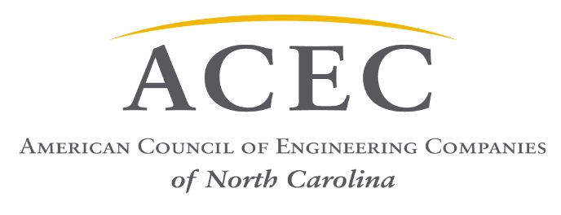

May 23, 2017
Senator Tommy Tucker
300 N. Salisbury Street, Room 300-A
Raleigh, NC 27603-5925

Senator Tucker:
The American Council of Engineering Companies of North Carolina (ACEC/NC) represents over 200 engineering firms and affiliates employing 7,500 engineers, technicians, and administrative staff throughout the state. I am writing you today to voice our opposition to Senate Bill 607 and the process of Job Order Contracting and Cooperative Purchasing Agreements.
The Job Order Contracting model, as proposed in SB 607, is used in many states to award projects to a job order contractor through a cooperative purchasing agreement. Currently, NCGS 143-129 (e) (3) allows for the purchase of goods through a competitive bidding group (basically a cooperative purchasing entity). The intent of this exception is to allow for the purchase of commodity items, such as pencils, paper, etc., based on volume pricing.
Currently, NCGS 143-129 (g) waives the requirement for bidding when there is a previously bid contract. Any NC public entity can purchase goods from a cooperative purchasing agency if they have previously bid for those commodity items.
SB 607 as proposed endeavors to modify this waiver to include “construction or repair work, including construction or repair work through job order contracting….” We believe this is a clear attempt to circumvent state statute and sound professional practice.
Proponents of the JOC and Cooperative Purchasing delivery methods aim to delegate the role of the designer (Architect or Engineer) to the contractor. A study performed by Arizona State University frequently cited by JOC advocates states: “Specifications and drawings are compiled by designers who often do not have the best construction experience” as one of the primary deficiencies with conventional delivery methods. This reported deficiency attempts to minimize the need for the professional judgement of licensed design professionals in construction projects. This same study also concluded that “It has not been documented that the JOC process delivers at a lower price”. This finding is not widely advertised by the supporters of the practice.

We believe that the use of cooperative purchasing agreements to procure construction and construction-related services through job order contracting as proposed in SB 607 leads to several problems, including:
- Lack of Transparency: Given the significant sums of public money involved, information should be available about cooperative purchasing entities such as their budgets, to whom and what they sell, and the amount of income accrued by providers, in addition to how those “recommended providers” are selected.
- Inhibiting Competition: Although these entities have pre-bid price information for certain services, the nature of current market conditions will often yield a lower price when all factors are considered.
- Circumvention of architectural/engineering judgment: Our current system includes architectural and engineering considerations, which usually helps lower costs and protect public safety by ensuring reduced operating expenses and increasing the feasibility and functionality of the improvement project.
We believe that the use of Job Order Contracting through Cooperative Purchasing Agreements for site-specific services such as construction is inappropriate and a highly questionable use of taxpayer dollars. Construction and construction-related services should be competitively procured on a project-by-project basis. This leads to greater scrutiny, more disclosure, lower costs, and increased taxpayer savings.
We respectfully request you reconsider your support of SB 607, and stand ready to discuss our concerns with you further.
Sincerely,

James A. Smith, Jr., PE
ACEC/NC Executive Director
jsmith@acecnc.org

