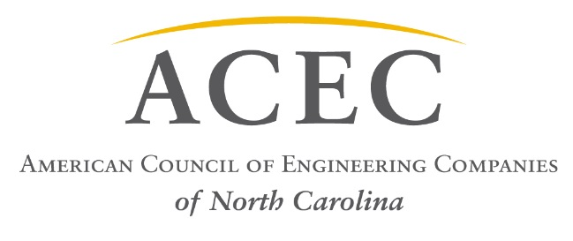

December 1, 2016

Position Statement - Engineering Firm Ownership
On behalf of the American Council of Engineering Companies of North Carolina (ACEC/NC) representing more than 200 firms statewide and more than 7,500 employees, it is our official position to oppose any revision to North Carolina General Statute Chapter 55B, Professional Corporation Act (1969), in regards to Engineering Firm Ownership. This Act states in part:
§ 55B-6.a.- Provided, it shall be lawful in the case of professional corporations rendering services as defined in Chapters 83A, 89A, 89C, 89E, and 89F, for non-licensed employees of the corporation to own not more than one-third of the total issued and outstanding shares of the corporation;

Our Board of Directors passed a resolution that “ACEC/NC respectfully opposes any revision in this requirement, and believes the current General Statute as enacted by the North Carolina General Assembly protects the health, welfare, and safety of the general public.”

Sincerely,

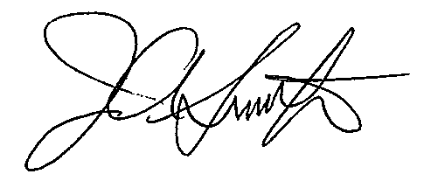
James A. Smith, Jr., PE
Executive Director, ACEC/NC

