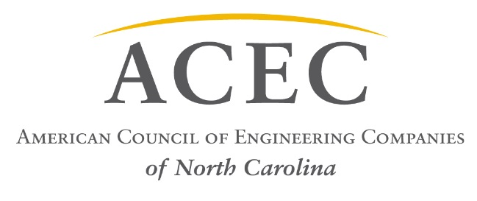

March 23, 2017
Position Statement – HB 252 Building Code Reform
On behalf of the American Council of Engineering Companies of North Carolina (ACEC/NC) representing more than 200 firms statewide and more than 7,500 employees, it is our position to oppose the following sections of HB 252-Building Code Reform:
SECTION 3.(a) G.S. 153A-352 is amended by adding a new subsection to read:
"(e) No certification by a licensed architect or licensed engineer shall be required for any component or element engineered by the manufacturer of the component or element when the manufacturer has certified that the component or element complies with the North Carolina State Building Code or the North Carolina Residential Code for One- and Two-Family Dwellings."
SECTION 3.(b) G.S.160A-412 is amended by adding a new subsection to read:
"(e) No certification by a licensed architect or licensed engineer shall be required for any component or element engineered by the manufacturer of the component or element when the manufacturer has certified that the component or element complies with the North Carolina State Building Code or the North Carolina Residential Code for One- and Two-Family Dwellings."

The Problem:
The provisions outlined above conflict with NCGS 89C-23 which states:
“§ 89C-23. Unlawful to practice engineering or land surveying without licensure; unlawful use of title or terms; penalties; Attorney General to be legal adviser. Any person who shall practice, or offer to practice, engineering or land surveying in this State without first being licensed in accordance with the provisions of this Chapter, or any person, firm, partnership, organization, association, corporation, or other entity using or employing the words "engineer" or "engineering" or "professional engineer" or "professional engineering" or "land surveyor" or "land surveying," or any modification or derivative of those words in its name or form of business or activity except as licensed under this Chapter or in pursuit of activities exempted by this Chapter, or any person presenting or attempting to use the certificate of licensure or the seal of another, or any person who shall give any false or forged evidence of any kind to the Board or to any member of the Board in obtaining or attempting to obtain a certificate of licensure, or any person who shall falsely impersonate any other licensee of like or different name, or any person who shall attempt to use an expired or revoked or nonexistent certificate of licensure, or who shall practice or offer to practice when not qualified, or any person who falsely claims that the person is registered under this Chapter, or any person who shall violate any of the provisions of this Chapter, in addition to injunctive procedures set out hereinbefore, shall be guilty of a Class 2 misdemeanor. In no event shall there be representation of or holding out to the public of any engineering expertise by unlicensed persons. It shall be the duty of all duly constituted officers of the State and all political subdivisions of the State to enforce the provisions of this Chapter and to prosecute any persons violating them.”
This statute requires all firms performing or offering to perform engineering services for any entity in North Carolina be duly licensed by the board. The provisions of the bill included herein may allow a local or foreign manufacturer to practice engineering without a license.
Furthermore, the cited text may conflict with NCGS 133-2 which states:
“§ 133-2. Drawing of plans by material furnisher prohibited. It shall be unlawful for any architect, engineer, designer or draftsman, employed on county, State, or city works, to employ or allow any manufacturer, his representatives or agents, to write, plan, draw, or make specifications for such works or any part thereof.”
…when a project is funded wholly or in part with public funds.
The Effect:
If HB 252 includes the above proposed revisions and is passed as written, ACEC/NC foresees companies, who may or may not be licensed to practice engineering in the state of North Carolina, providing or offering to provide services that are otherwise prohibited by NC General Statutes. All engineering services performed in the state should be performed by properly licensed engineers working for licensed engineering firms who have considered the required design, code, and life safety requirements.
The Request:
ACEC/NC respectfully requests that the above referenced provisions of HB 252, Sections 3.(a) and 3.(b) be removed from the Bill.

Sincerely,

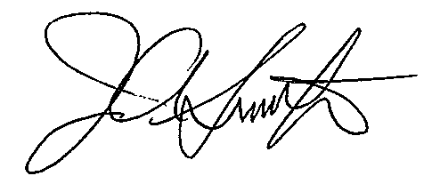
James A. Smith, Jr., PE
Executive Director, ACEC/NC

