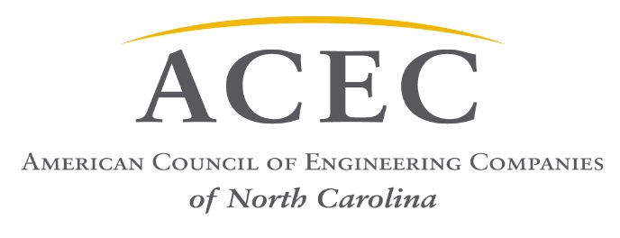

Legislation of Interest to the Engineering Industry
Transportation:
- HB 81 – STI Regional and Division Weighting YES
- HB 92 – Blue Ribbon Commission on Long Term Transportation Funding YES
- HB 156 – Special Assessments/Critical Infrastructure YES
- HB 219 – Transportation Mega Project Funding Failed
- HB 220 - State Infrastructure Bank Revisions YES
- HB 266 – Terminate Agreement for Tolling I-77 NO
- HB 454 – Surveying and Plat Recording Changes Passed
- HB 468 – DOT Fund for Preliminary Engineering YES
- SB 351 – Short Term Lease Tax/Highway Fund YES
- SB 170, 171, 172 – Remove Limits on Light Rail Funding YES
- HB 533 – Stop the Revolving Door NO
- Support a potential Transportation Bond ($3 Billion) YES
Environment/Energy:
- SB 16 – Additional Regulatory Relief to NC Passed
- HB 56 – Amend Environmental Laws YES
- SB 131 – Regulatory Reform Act of 2016 (removed objectionable fast-track permit language) Passed
- SB 366/HB470 – Responsible Wind Energy Implementation YES
- HB 267 – Utilities/Amend REPS Requirements (amend the renewable energy portfolio)
- HB 465 – Military Ops Protection Act (temporary moratorium on onshore/offshore Wind Energy Facilities) NO
- HB 589 – Competitive Energy Solutions for NC Passed
- HB 637 – Clarify Regional Water/Sewer Funds Passed
- HB 794 – NC Permitting Efficiency Act YES

Buildings/Infrastructure:
- HB 252 – Building Code Regulatory Reform (removed objectionable language related to by-passing professional engineers in design) Passed
- HB 436 – Local Government/Regulatory Fees Passed
- HB 583 – Pay-As-You-GO Capital & Infrastructure Fund Passed
(Included in Budget Appropriations Bill)
- HB 590 – Interior Design Profession Act NO
- HB 600 – School Construction Flexibility YES
- SB 607 – Job Order Contracting Method NO
- SB 660 – Economic Development Incentives Modifications YES

K-12 School Construction (assisting Tier 1 Counties):
- SB 511 – Bond Protection for project participants YES
- HB 333, HB 437, SB 166 – Afford schools same sales tax access as transit YES
- SB 234, HB 481 – Increase Lottery Revenue for Schools YES
- SB 542 – Support $1.9 Billion Bond YES
General
- SB 257 – Appropriations Act of 2017-2018 Passed
(See Separate Budget Bill Summary)

