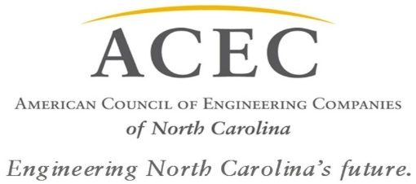

Legislative Agenda 2015-2016
Infrastructure
- Support the State Blue Ribbon Commission studying Infrastructure Needs and Funding (established under HB 1043) and development of a long-term funding program for non-transportation infrastructure.
- Support the development of a long-term sustainable funding program for transportation-related infrastructure, including the elimination of non-related transfers from the Transportation Trust Fund and gap-funding for NCTA projects.
Energy
- Support the development of a long-term sustainable energy program with appropriate funding that considers all energy sources.
- Support the reinstatement of Renewable Energy Investment Tax Credits due to expire.
Economic Development
- Support the reinstatement of Historic Preservation Tax Credits by the NCGA to promote continued economic development and conversion of existing properties to beneficial use.
Professional
- Support the change of the waiting period for state employees moving to the private sector from 6-months to 30-days and remove the restriction prohibiting state employees from collecting earned state retirement while working for private engineering firms.
- Support passage of Certificate of Merit legislation to reduce the incidence of frivolous lawsuits against architectural and engineering design professionals.
Environmental
- Support continued Regulatory Reform efforts begun under SB 743.
- Support investment in Water/Sewer/Storm water Infrastructure as studied by the State Blue Ribbon Commission.

