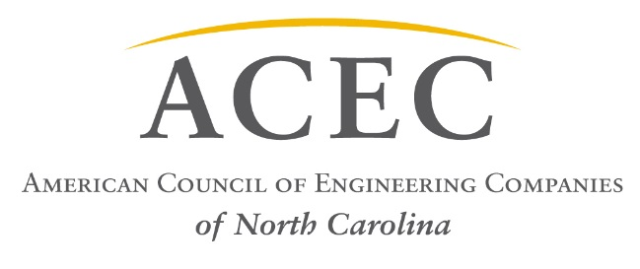

July 28, 2017

Position Statement – USDA Water Funding Programs
On behalf of the American Council of Engineering Companies of North Carolina (ACEC/NC) representing more than 200 firms statewide and more than 7,500 employees, it is our official position to oppose the Administration's budget proposal for FY'18, which among other things proposes to eliminate USDA's rural development programs, such as rural water programs and the CDBG program.

Our Board of Directors passed a resolution that “ACEC/NC respectfully opposes any reduction and/or elimination of these USDA programs that help promote and protect the health, welfare, and safety of the general public.”

Sincerely,

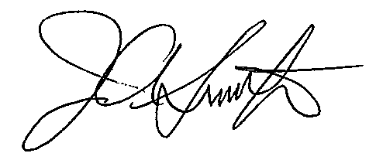
James A. Smith, Jr., PE
Executive Director, ACEC/NC

