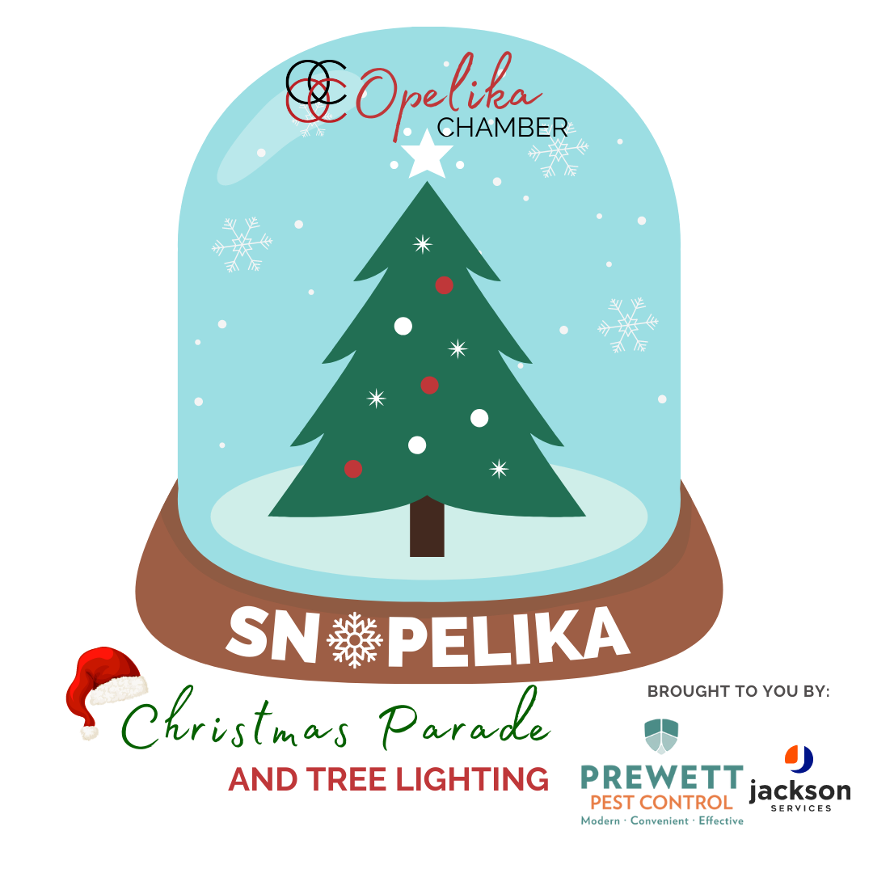
Float & Parade Guidelines
THEME: Winter Wonderland

Friday, December 2, 2022
Start Time: 5:00PM
Line Up Time: 4:00PM

**In the case of inclement weather, the
parade will be moved to Saturday,
December 3, 2022 at 5:00PM

Who May Participate?
Clubs, troops, churches, businesses, and social organizations may enter a marching group and/or a float (preferably handcrafted) that you create. Approval by the Parade Committee will be required on other type units.

*Vehicles (automobiles and vans not pulling floats) entered for the sole purpose of advertising will be placed on wait list status.

Float & Vehicles Pulling Trailers Guidelines:

1) Maximum height, 13ft. 6 in. No tractor trailers or 18 wheelers.

2) Do not place too many people on your float or trailer…if your float is too crowded you will be asked to remove people in order to participate.

3) Drivers of all vehicles, including vehicles pulling handcrafted floats must be at least 21 years of age or older to drive. In addition, all eligible drivers must provide Driver’s License and Proof of Auto Insurance. This is a requirement from Opelika Police and Chamber insurance company. NO EXCEPTIONS.

Marching Group Guidelines:

1) Walkers must be 3rd graders or older.

2) All bands, Musical Groups and vehicles playing music are asked to play Seasonal Music or Christmas Music.

3) Marching Groups must provide an estimated number of participants per group.

Parade Guidelines:

1) Participants are allowed to throw or hand out items such as candy and treats during the parade, but the items must be packaged and not handmade. No paper handouts during the event.

2) No participants may have their arms or legs dangling over the side of their float/entry.

3) Do NOT have anyone dressed as Santa on your float. Santa will arrive at the end of the parade in grand fashion, and we don’t want to confuse the children!

4) Handcrafted Floats will be judged on creativity, originality, neatness and overall appearance, and adherence to theme. Prizes will be awarded as follows: 1st - $300, 2nd- $200, 3rd - $100

5) The non-refundable entry Fee of $25 must be received by 5 p.m. Friday, November 18th, 2022. NO EXCEPTIONS. To participate, entries will be accepted on a first come, first serve basis pending approval of the Opelika Chamber’s Christmas Parade Committee. Seventy-five (75) entries will be accepted.

6) All money, Copy of Drivers Licenses, Proof of Insurance and signed Hold Harmless Agreement Form are due with the Application to ensure your space in parade. Only one entry is accepted per application, and we recommend no more than three entries per group.

Founded in 1941, the Opelika Chamber of Commerce is a membership organization that strengthens our community as the champion of business. It is its own nonprofit organization and is not a division of the City of Opelika.

Please contact the Opelika Chamber with concerns or questions at (334) 745-4861 or e-mail Mackenzie Poole at mackenzie@opelikachamber.com.

Thank you!

