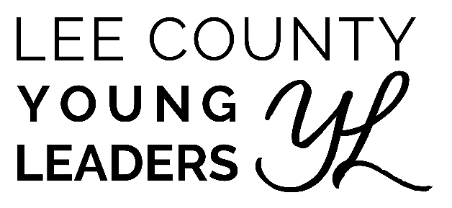
PROGRAM INFORMATION
& APPLICATION
Program Vision: Ensuring our youth are prepared as leaders to meet future challenges that arise in our city, county, and state.

Program Sponsors:
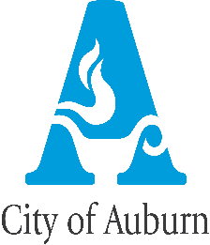
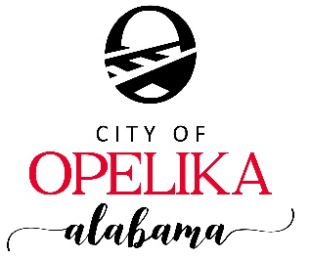

Auburn City Schools
Lee County Board of Education
Opelika City Schools

Program Description: It is a county-wide program designed to nurture and develop positive leadership qualities in our high school students. We want to create successful leaders in Lee County and this program should give the students of our area the knowledge, tools, and contacts to do so. The ultimate goal is that graduates of the Lee County Young Leaders program will possess a unique understanding and appreciation of the inner workings of their community and will return home as excellent future candidates to serve on local boards, committees, and task forces.

Program Goals:
- To select a diverse class of highly motivated participants who represent the diversity of racial, ethnic, and socio-economic groups in Lee County, Alabama.
- To explore the diverse facets of Lee County’s government, business, economic development, health care, criminal justice, and other aspects of community life.
- To instill and nurture a sense of social responsibility in our youth.
- To provide opportunities for students from diverse backgrounds to meet and develop mutual understanding, respect, and trust.
- To offer participants opportunities for volunteer community involvement and service.
- To encourage our youth to find satisfying job opportunities so he/she will come home to Lee County, Alabama to live, learn, work, worship, play, raise his/her family.

Program Format and Participation
Lee County Young leaders begins in September and consists of one session per month until April 2025. In addition, there will be a mandatory orientation session in the month prior to the first class session and a Graduation in April. Participants are exposed to a variety of viewpoints that illustrate the political, educational, and social factors at work in Lee County. They will meet area leaders in business, media, government, education, and service organizations. The student also receives a 1-hour Leadership credit to Southern Union State Community College.

Participants must make a commitment to the program. Attendance at each monthly session are prerequisites for graduation from the program. Participants will be allowed to miss two full-day sessions due to illness or a death in the family. However, it is preferred that class participants strive for perfect attendance. Students missing more than 2 full-day sessions will be dismissed from the program.

While we certainly understand that students are busy, we have high expectations for this program in order for our students to accomplish the many learning objectives. Also, because of the tremendous amount of time and effort that goes into planning our sessions, we need all of the students present for the ENTIRE day.

For the students selected to participate in our program, we stress that the students need to make arrangements with their teachers, coaches, band/choir directors, etc. so that they can attend for the full day. We ask that the school’s administration help our students with this so that they can make up any work and/or activities that they miss as a result of participating in this program.

Selection Process
Thirty-four (34) juniors and seniors in high schools, home schools and private schools in Lee County are chosen for the program through an application process. The applications are judged anonymously based on application neatness, extracurricular activities, career choice and hobbies, and leadership potential.

To participate in the Lee County Young Leaders Program, students must meet the following criteria:
- Reside in Lee County, Alabama.
- Attend a city or county regionally accredited high school, private or home school in Lee County.
- Must be willing and able to attend all the sessions.
- Be an 11th or 12th grade student during the period of the class program.
- Must be up to date on Core Classes.
- Maintain a 3.0 Grade-Point Average.
- Provide own transportation to Session.

Program Dates & Times (2024-2025 Academic Year)
For each of the following dates, the students will meet at the Lee County Board of Education Building (2410 Society Hill Road, Opelika, AL 36804). With the exception of the orientation, which will last from 2:00pm to 3:15pm, all session days will last from 8:00am to 3:00pm.

August 25, 2024 – Introductions & Orientation Day
September 10, 2024 – Team Building Day
October 1, 2024 – Education Day
November 6, 2024 – Public Safety Day
December 3, 2024 –Judicial Day
January 14, 2025 - Economic Development Day
February 4, 2025 – Health & Human Services Day
March 6, 2025 – State Government Day
April 3, 2025 – Local Government Day
TBD – Graduation Day

Program Contact
Mackenzie Poole
mackenzie@opelikachamber.com
334-745-4861

Please have ALL interested juniors and seniors for the 2024-2025 school year submit applications by visiting the following link:

https://forms.gle/ELkpSRNDyn9KWF4U7

APPLICATIONS MUST BE SUBMITTED BY FRIDAY, APRIL 12, 2024.

