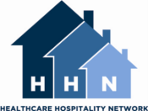

**NATIONAL HOSPITALITY HOUSE WEEK**

SOCIAL MEDIA TOOLKIT

*Updated June 2023*

*Prepared by:*

Chloe Morel, Project Manager JW House

Santa Clara, CA [www.jwhouse.org](http://www.jwhouse.org/)

Jena Prokopchuk, Director Rosenbaum Family House Morgantown, WV [www.rfhwvuh.com](http://www.rfhwvuh.com/)

HHN Marketing Committee

*For more information:* [*www.hhnetwork.org*](http://www.hhnetwork.org/)

*800.542.9730*

# SOCIAL MEDIA TOOLKIT

**Contents**

* **Using your website**
* **Facebook interaction**
* **YouTube and Video**
* **Leveraging online donations**
* **E-Newsletter**
* **Share your experience**

**PREFACE**

National Hospitality House Week will be celebrated by HHN member houses the last week of June (Sunday to Saturday). The HHN Board of Directors extends appreciation to the Marketing Committee for their work in updating the Hospitality House Week materials. In particular, this Social Media Toolkit is an excellent guide to leveraging social media opportunities. Not limited to National Hospitality House Week, this Social Media Toolkit offers tips, suggestions and instructions that can be used year-­‐round in promoting your houses, events and activities.

We want to thank Chloe Morel, JW House, Jena Prokopchuk, Rosenbaum Family House, and members of the HHN Marketing Committee, for creating this Social Media Toolkit! We could not provide this amazing guide to our members if it were not for Chloe’s outstanding efforts.

Mark your calendar now.

# USING YOUR WEBSITE

When someone is interested in finding out more about your organization, what is the first thing they do? Gone are the days of calling to find out more information. A quick Google search should give any potential volunteer, donor, or guest the who, what, when, and why about any event your organization is planning.

For this reason, your first stop in social media marketing should be creating a place for Hospitality House Week on your organization’s website.

CALENDAR

You can keep it as simple as updating your website’s calendar to reflect your Hospitality House Week scheduled activities. Be sure to include a place to RSVP if you are requiring advanced registration. There are many websites that will collect RSVPs for you, including Eventbrite, Jotform and Google Forms.

Facebook events can also be a great way to leverage social media to get the word out. Make events specific -­‐ “*Tours and Root Beer Floats, Tuesday from 1pm-­‐4pm*” -­‐ rather than general -­‐ “*Hospitality House Week at Hope Lodge!*” This will give people concrete information and a place to be, rather than a general show of support. Look into online fundraising platforms (below) if you would like a more general “get the word out” event page.

PAGE

The best way to aggregate all of your information and clearly explain Hospitality House Week is creating a page on your website dedicated to Hospitality House Week exclusively. All of your activities for the week can be in one place with proper contact information. If you have need for volunteers, you can ask. If you have a media kit ready to go, you can have a link. If you have event sponsors, be sure to list them or include their logo. Set your site to something simple, for example [www.yourorg.org/hhweek](http://www.yourorg.org/hhweek) or [www.yourorg.org/hhn.](http://www.yourorg.org/hhn)

Share this page with your community every time you mention Hospitality House Week in newsletters, on social media, or in email. Imagine it as your main information hub – anyone who asks about Hospitality House Week or any of your activities for the week should be directed to your well thought out, easy to navigate hub.

Be sure to include HHN’s logo as a clickable link so visitors to the page can visit HHN’s website as well. This will help lend credibility to your events. Many of your social media posts will mention Hospitality House Week briefly with no explanation, so branding your page with Hospitality House Week information will help viewers learn more and receive the big picture of your work.

BANNER AND FRONT PAGE

When people visit your website, they may spend as little as 30 seconds finding the key information they need-­‐ usually a phone number, address, or contact email. Leverage the time they spend on your webpage by having information about Hospitality House Week front and center on your page in the form of a banner. Always ensure the banner and any text links back to your Hospitality House Week page.

Example Banner:

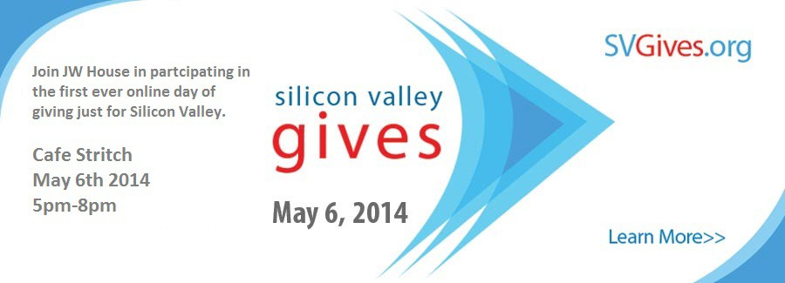

# SOCIAL MEDIA INTERACTION

Facebook and LinkedIn can be wonderful tools for promoting events, and also for showing the fruits of your labor. Here are some Social Media FAQs for event promotion:

**How often should I post about Hospitality House Week?**

Post well and post often. Leading up to Hospitality House Week, share your webpage and the photo of your banner. Set the banner for your website as your Facebook cover photo-­‐ this is a great double whammy! Always try to reuse materials, from photos to graphics to wording, in many different places. When you and your staff are becoming sick of a color, graphic, image-­‐ the “public” is just beginning to remember your branding!

**What should I post about Hospitality House Week?**

Video is widely regarded as the most engaging form of content on social media platform. The combination of visual appeal, storytelling potential, digestible format, higher engagement rates, mobile-friendliness, algorithm preferences, and the ability to establish human connection makes video the most engaging form of content on social media platforms.

Photos are also a good bet. They are easily shared and can illustrate your work. Ask volunteers to make a graphic of your agenda for the week. Take photos of volunteers stacking fliers to bring to your hospital. Your Facebook fans and Linkedin Connections want to feel included and see the “behind the scenes” action-­‐ what makes you different from every other page they follow.

**What should I post before Hospitality House Week?**

Post photos, quotes from guests, and event invitations to get the word out about your activities. Show the “behind the scenes” action. Always include a consistent link as your call to action. This will help guide people to RSVP, register, or look at more information – or perhaps even donate!

Examples:

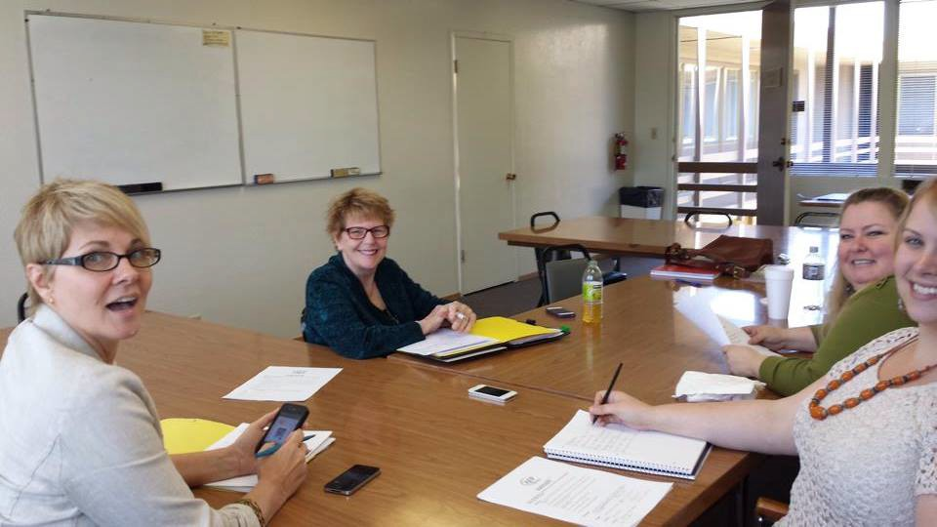

*“Our Hospitality House Week Committee met tonight to plan the activities Ronald McDonald House will be hosting. Which will you be attending? Check out our schedule here:* [*www.linktoyourwebsite.org*](http://www.linktoyourwebsite.org/)*”*

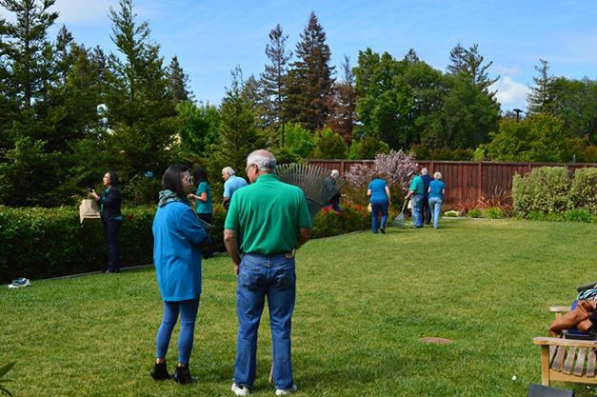*“Our volunteers are hard at work getting Hope Lodge ready for Hospitality House Week open houses and tours! We hope you’ll join us.*

*RSVP here:* [*www.linktoRSVP.com”*](http://www.linktoRSVP.com/)

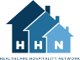

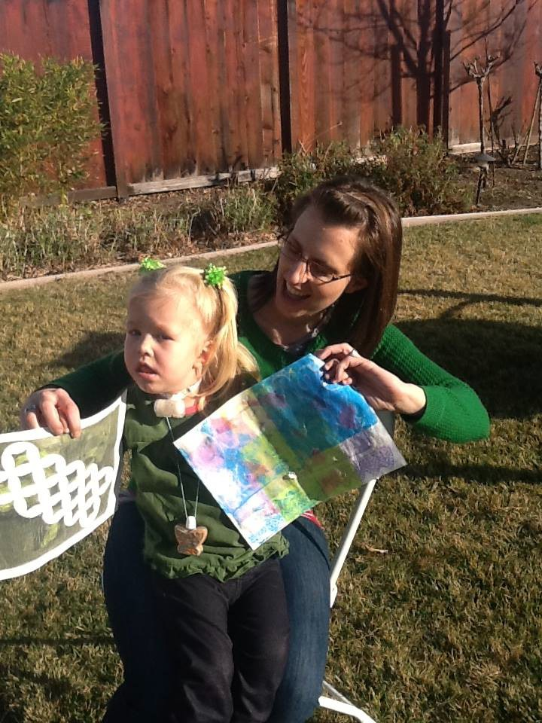*“Family House was there when we needed love the most” – Jessica, overnight guest. Come to the Family House Donor Appreciation event during Hospitality House Week to hear Jessica’s story of perseverance. Learn more here:* [*www.YourHHWeekPage.org*](http://www.YourHHWeekPage.org/)

**What should I post during Hospitality House Week?**

Just as with donations and donors, you want to show your followers the fruits of your labor and the successes of your Hospitality House Week. As events happen, designate a photographer in your group. This could be as simple as using a cell phone, or you could seek out a hobby photographer from your volunteer pool or community to take some very high-quality photos. Upload these often to your social media profiles, preferably at least one or two every day. This will keep up the buzz, and drive people to your website (or donation site).

Examples:

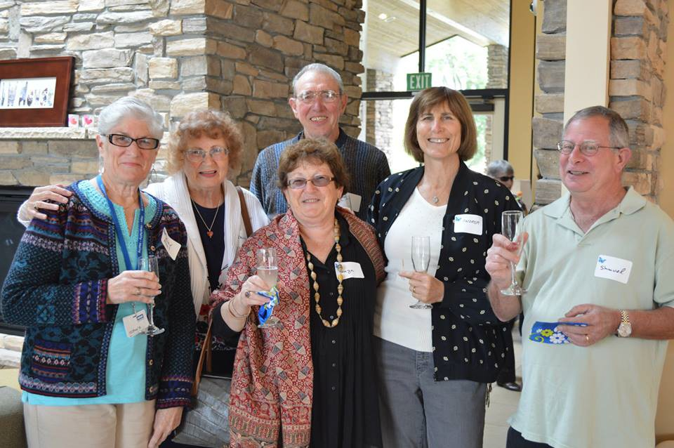

*“Our open house is in full swing! We’re celebrating Hospitality House Week and the work of the over 200 hospitality houses around the country that are also celebrating Hospitality House*

*Week by giving tours of RMH to members of the community!”*

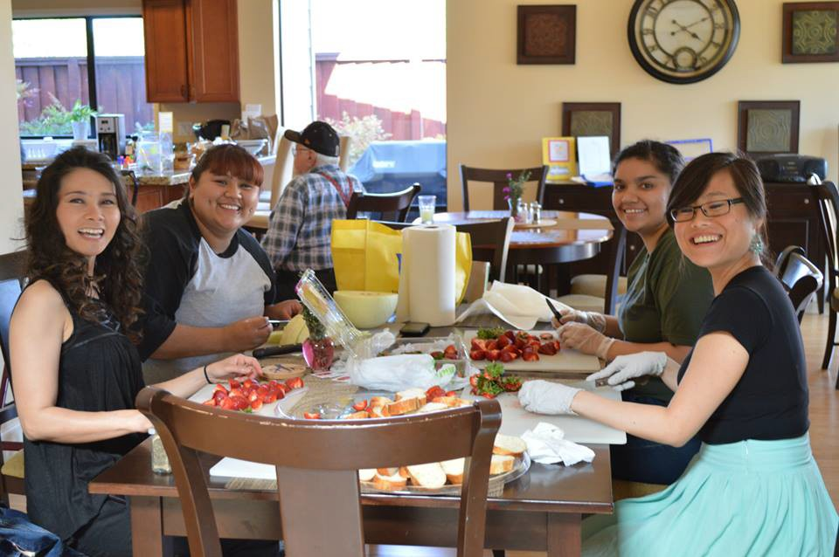*“We love @Mass General Hospital employees! Part of our celebration of Hospitality House Week was to give all of the Pedi staff a breakfast treat and a smile –*

*mission accomplished!”*

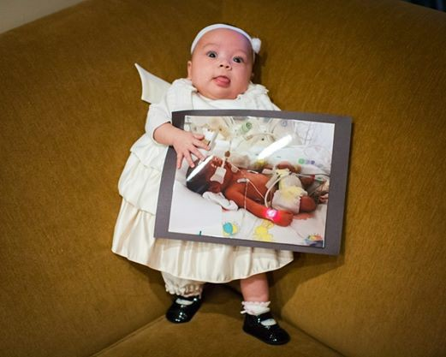*“Kaiser San Francisco has a display in their main lobby of photos from Fisher House. Stop by any time from July 23-­‐26 to see this great art display. Thank you to @Jim Wall Photography for the beautiful photos!”*

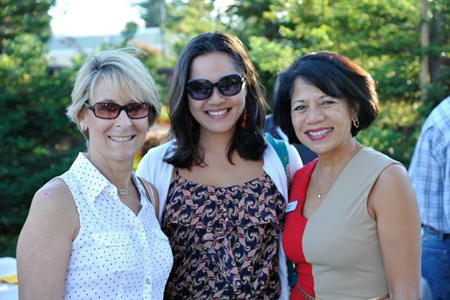

*“Board President Joan stands with @Hilton Garden Inn General Manager Linda and @Heritage Bank Manager Jill at our annual donor appreciation event! Thank you to these generous in-­‐kind sponsors for their ongoing support of Golden House.”*

Rules of the Road:

* When you mention Hospitality House Week, be sure to have a link in the post that leads the reader to understand what HHN is, and what Hospitality House Week means.
* Tag businesses, nonprofits, and HHN using the @ symbol, beginning to type their name, and then clicking on the name you are looking for. This is a GREAT recognition for sponsors and supporters, and also a great way to start interaction on your page.
* Internally differentiate between posts with a call for action and posts to inform. Generally, the posts before Hospitality House Week should include some call for action, while posts that week should inform.
* If you receive media attention – post it ASAP! Social media moves quickly, and is a great way to get the word out quickly.
* Don’t reinvent the wheel! Looking for things to post? Follow other HHN members on Facebook and share their content. Or look to the HHN Facebook for articles, press, and information to share.

# YOUTUBE AND VIDEO

There are two distinct ways to use video-­‐ as event promotion and as event wrap up/thank you. Either one is appropriate for Hospitality House Week. Are you inviting people to your events and hoping to boost revenue or attendance? Or would you prefer a lasting show of your work, and a success story to show future funders?

Tips for a pre-­‐Hospitality House Week Video:

* Have your Board President or Executive Director talk about Hospitality House Week and the impact of the network of 200 hospitality houses across the country.
* Outline your activities for the week, using imagery as you are able. For example, “We will hold a volunteer brunch on Friday morning” could have an image of a past event with volunteers and food.
* Close with your logo as well as the HHN logo, then a call to action. For example, “visit [www.yourorganization.org](http://www.yourorganization.org/) to RSVP for any Hospitality House Week activity”
* Share on Facebook, have it as the headline in your enewletter, and feature the video at the top of your HH Week page!

Tips for a post-­‐Hospitality House Week Video:

* Open with both your logo and the HHN logo, co-­‐branding the event and adding credibility to your activities.
* Smiling, happy faces will showcase your work the best – both photos and video.
* Throughout the week, designate a videographer. This can be as simple as taking video cell phone or you can look into your volunteer pool or community for someone especially skilled at video and production.
* Have a board member, volunteer, or guest talk about activities of the week and how important it is for others to know about the work of the 200 HHN member houses across the country.
* Close with both the HHN logo, your own logo, and a call to action. For example “visit [www.yourorganization.org](http://www.yourorganization.org/) to donate”
* Share on Facebook with a thank you to volunteers, sponsors, etc. Feature on your website, and send out with your enewsletter with a story about Hospitality House Week’s successes.

# LEVERAGING ONLINE DONATIONS

There are many options for online giving sites and many ways to leverage online giving throughout the year. Hospitality House Week may be a time when you are getting more attention than usual, however, and having a simple way to direct new people to give can be very beneficial to you and your donor base! Here are some basic best practices for leveraging online giving during Hospitality House Week:

* Choose a donation platform you love. Some popular ones are MightyCause, PayPal, JustGive. Customize it to really tell YOUR best stories.
* Have a simple link to give on your Hospitality House Week webpage, in a color that stands out from the rest of the page. Use an online button generator to create a standout button! That way, every time someone visits your high traffic Hospitality House Week page, they will have the option to give.
* Many nonprofits ask for gifts at the end of the calendar year. July marks an excellent point in the year to ask again-­‐ if you are not asking at least twice a year, you could be missing potential donors who are either too extended around the holidays, or simply too busy. Don’t let your donors think you only need them around December, when you really need their support year round. Hospitality House Week can be a great time to ask existing donors for their support, as well as engage new donors.

Using MightyCause:

MightyCause is an easy way for your organization to collect donations online, as well as for others to collect donations on your behalf. MightyCause collects a 4.9% fee from every donation you receive, but in return you get a slick and easy interface for online fundraising.

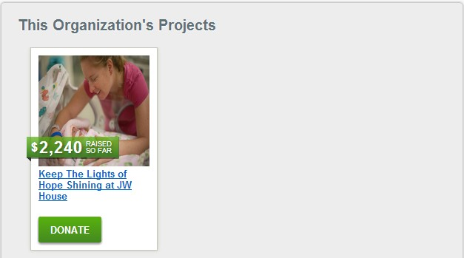

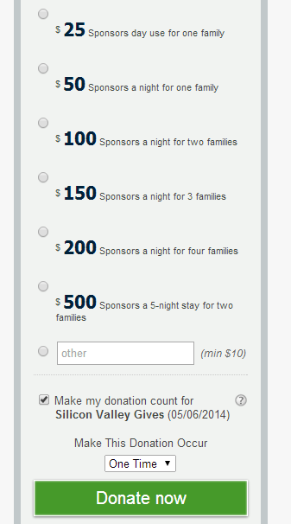*Create a project for Hospitality House Week – Your nonprofit page can have separate projects, and one can be just for Hospitality House Week! You can talk about your activities for the week (pull your verbiage from your webpage) and also about the families you serve.*

*Create donation levels – Donation levels online can help you really tell your story through numbers.*

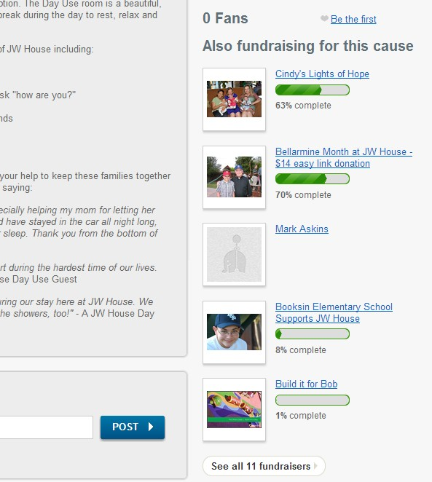

*Encourage others in your community to start their own fundraisers – Individuals can fundraise through MightyCause for your nonprofit. They solicit the donations, and a check comes to your each month.*

# ENEWSLETTER

Your E-newsletter may be the most effective way to get the word out about Hospitality House Week and your activities. Start now! Do you already send out an e-newsletter monthly, quarterly or more often? Feature Hospitality House Week and the publicity you receive. Many newsletter services will let you create and schedule your e-news in advance. Take advantage of this! Especially if you plan to release an e-newsletter during busy Hospitality House Week. Be sure to include the HHN logo in your e-news with a link to the HHN website for curious viewers!

3 months before Hospitality House Week – Article about HHN and your house’s membership. Have you attended conference? Do any of your staff participate in committees? Have you visited other HHN member houses in your area? Does your house use HHN materials? Familiarize your readers with the fact that your house is part of a larger effort! This information alone will make donors and volunteers feel like they are part of a bigger picture.

2 months before Hospitality House Week – Announce your participation in Hospitality House Week. You may have all of your activities planned, you may not. Swipe language from your press release and the samples in this packet to tell the impact of your work and the impact of HHN across the country. List your activities for the week if they are final-­‐ if not, wait. Have links to your online donation page as well as your Hospitality House Week webpage available.

1 month before Hospitality House Week – Release a detailed itinerary of activities for the week, along with volunteer opportunities and ways to RSVP. Make this enewsletter all about the call to action! Do you want people to give? Do you want them to RSVP? Do you want them to invite friends, volunteer, or mark their calendars? Tell them! Keep message consistent between your enewsletter and other social media. Share your pre-­‐ HHN video now if you have one!

1 week before Hospitality House Week – If you are doing events that require community participation, send a special reminder when your itinerary as well as links to any press you have received.

During Hospitality House Week – Send out an enews with success stories (pull from your Facebook!) as well as links to press. Be sure to add any new contacts you’ve received over the course of the week to your email list!

After Hospitality House Week – Send a wrap-­‐up with more success stories and links to press. Unveil your post-­‐Hospitality House Week video if you have made one. THANK all those involved, and consider sharing Hospitality House Week success stories from other houses.

# SHARE YOUR EXPERIENCE

Tell us about your National Hospitality House Week! What went well? What didn’t work as anticipated? What would you do again? What would you do differently? Did you use these tips and suggestions for other events, activities or promotions of your house?

Let us share your successes!

Your Healthcare Hospitality Network exists to support members across the continent. Your ‘lessons learned’, samples, pictures and results will become an important part of HHN’s Member Resources.

To share your information, contact the Healthcare Hospitality Network, Inc. [info@hhnetwork.org](mailto:info@hhnetwork.org)

[www.hhnetwork.org](http://www.hhnetwork.org/) | 800.318.8861