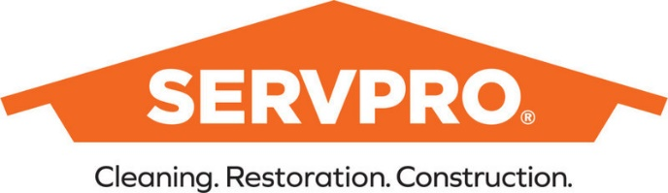
FOR IMMEDIATE RELEASE
Contact:
Sean McCabe
SERVPRO® of Columbia, Montour & Sullivan Counties
(570) 759-0966
smccabe@servpro11451.com

Traveling for the Holidays? 'Waterproof' Your Home Before You Leave

Local SERVPRO water damage remediation specialist provides a six-step plan for keeping your home dry and healthy while you're away
Bloomsburg, PA (Grassroots Newswire) November 21, 2022 - For many, the holiday season includes travel, whether it is to join a family gathering or enjoy a holiday vacation. These traditional holiday trips stand to amplify an already growing travel demand. The U.S. Bureau of Transportation Statistics* reports that for July 2022, the number of people boarding a U.S. airline plane for domestic or international travel grew to 69.9 million, up 8.6 percent from July 2021 numbers. As the holiday travel season approaches, the water and fire remediation specialists at SERVPRO® of Columbia, Montour & Sullivan Counties caution homeowners that they need to go beyond buying tickets and packing a suitcase before they leave on a trip. Homeowners need to "waterproof" their homes.
"Your home is subject to water damage from inside and out when you head out on a trip," says Sean McCabe of SERVPRO® of Columbia, Montour & Sullivan Counties. "Leaking or burst pipes can wreak havoc on the inside of your home. Severe weather can pose a flooding threat inside and outside your home. If you are planning to travel this holiday season, there are six important steps you can take before you leave to help ensure your home will be ready and welcoming when you return."

- Ask Someone to Check on the House While You're Gone. Taking the simple step of asking a friend or family member to stop by while you're gone may catch a potential problem before it becomes a disaster.
- Check for leaks. Inspect pipes under kitchen and bathroom sinks, check your water heater for cracks or rust, and ensure that hoses connected to dishwashers, refrigerators, and washing machines are leak free.
- Insulate exposed pipes. Insulating exposed pipes can help prevent them from freezing in cold climates, but wherever you live, your home needs constant air circulation to help prevent water damage and mold caused by condensation. Keep the HVAC system turned on and open the cupboard doors under sinks to promote airflow.
- Turn Off the Main Water Valve. If you don't already know where this is, this is a good time to find out â€“ and then shut it off if your home will be unattended and vacant during your trip.
- Clear Gutters and Downspouts of Debris. Clear out debris, dirt, leaves, and sticks and position downspouts to direct water at least ten feet away from the home to prevent flooding.
- Inspect and Test the Sump Pump. If you have a sump pump, test it before you leave by filling the sump pit with water and watching to see if the pump empties out the water. This can mean the difference between finding a dry or flooded basement when you arrive home.
"We specialize in water damage remediation so we know how difficult it can be to deal with flooding caused by burst pipes, failed sump pumps, or heavy rainfall, even if you discover the problem right away," says McCabe. "It would be even more heartbreaking to return to your home after a holiday trip to find that water has been creating chaos while you were away. Taking steps to 'waterproof' your home before you leave on your holiday trip can help ensure you return to a dry, safe home, rested and relaxed from your time away."
SERVPRO specializes in fire and water cleanup and restoration services and repair services, helping to remediate damage for both commercial and residential customers. For more information on SERVPRO of Columbia, Montour & Sullivan Counties, please contact Sean McCabe at (570) 759-0966 or smccabe@servpro11451.com. For more information about SERVPRO, please visit www.servpro.com/.

