January 2, 2023

Dear Member:

The Columbia Montour Chamber of Commerce, in partnership with the Columbia-Montour Visitors Bureau, is creating an updated image piece for our two-county region. The "Quality Living in Columbia and Montour Counties" publication is scheduled for release in April 2023 and will include information about business/industry, demographics, education, health care, housing/real estate, recreation, arts/culture, and more. The goal of the image piece will be to assist in attracting new businesses, employee recruitment/retention, and to serve as a relocation guide. 6,000 – 8,000 copies, in an attractive 8.5” X 11” format, will be produced with an expected shelf life of up to three years.

Victor Koons Graphic Design of Danville is handling the design of this publication. Lois Wolfe is the third-party representative handling ad sales. Both the Chamber and Visitors Bureau have long-standing professional relationships with Victor and Lois who are both well-recognized throughout the region. Lois will begin reaching out to our members starting the week of January 9th.

We believe this image piece is an attractive representation of our area and presents our members with a high-quality, long-lasting opportunity to represent themselves to the reader. If you have any questions or concerns, you may contact us at (570) 784-2522,
or email Chris Berleth, Vice President, at cberleth@columbiamontourchamber.com.

Thank you,

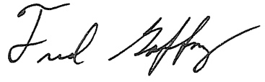

Fred Gaffney; President - Columbia Montour Chamber of Commerce

