Association of Educational Service Agencies

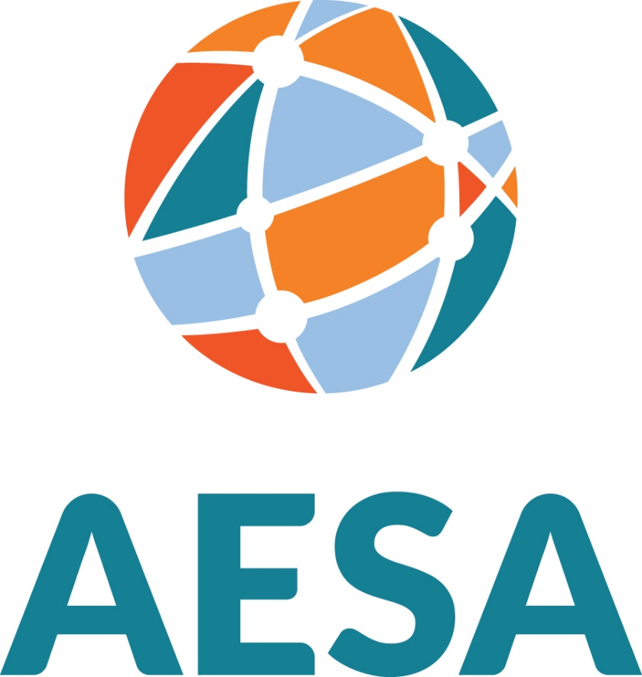

2023 Congressional Service Award
Nomination Packet

2023 AESA Congressional Service Award

Purpose

To recognize a Member(s) of Congress for meritorious support of federal education legislation and Educational Service Agencies.

Guidelines/Criteria for the Award

- The Federal Advocacy Committee Chair (or designee) will solicit nominations annually from the Federal Advocacy Committee, the AESA Executive Council, and AESA Federal Advocacy staff.
- The Federal Advocacy Committee has opened the nominations for the 2023 AESA Congressional Service Award. Nominations will close June 12, 2023. A subgroup made up of the Federal Advocacy Committee Chair, Vice-Chair, the AESA President and/or President-Elect (or designee), and AESA staff shall review all nominations to determine merit & eligibility and shall submit a recommendation of qualified candidates to the AESA Executive Council.
- The Federal Advocacy Committee Chair and the AESA President will present the award(s) at the October Educators’ Call to Action Conference.
- Criteria
Candidates must have demonstrated one or more of the following (list not inclusive):

- Strong support for furthering the federal role and funding of Educational Service Agencies.

- Advocated for positions on federal legislation supported by AESA.

- Served in a leadership role or on a congressional committee sponsoring legislation supporting Educational Service Agencies at the federal level.

2023 Congressional Service Award
Nomination Form

Name(s): Click or tap here to enter text.

State: Click or tap here to enter text.

Criteria
Candidates must have demonstrated one or more of the following (list not inclusive):

- Strong support for furthering the federal role and funding of Educational Service Agencies.

- Advocated for positions on federal legislation supported by AESA.

- Served in a leadership role or on a congressional committee sponsoring legislation supporting Educational Service Agencies at the federal level.

Nomination Information:
Nominations must include and not exceed:
1. This cover sheet.
2. Two pages total, addressing all criteria of the award for which the person(s) is nominated.
3. Optional: Two additional pages for any correspondence of relevance including letters of support.

Submitted by (signature): ___________________________________________________________

Name/Date: Click or tap here to enter text.

Title: Click or tap here to enter text.

Institution: Click or tap here to enter text.

Address: Click or tap here to enter text.

Telephone: Click or tap here to enter text. Fax: Click or tap here to enter text.

All nominations must be submitted via email to jbass@aesa.us by June 12, 2023. Late entries will not be considered.

Direct nominations and inquiries to:
John Bass, COO
E-mail: jbass@aesa.us
Phone: 806-290-3092

