Association of Educational Service Agencies

2023 National Awards

Nomination Packet

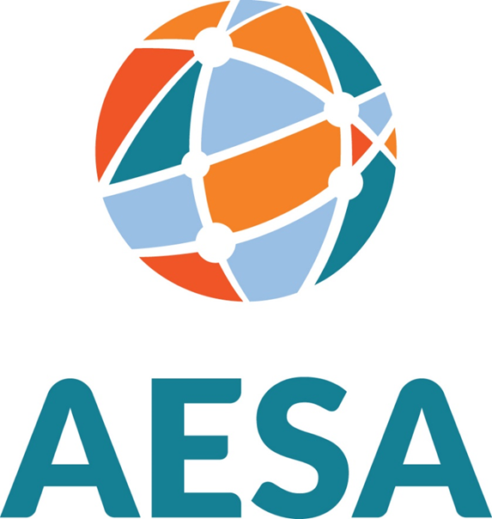

AESA Awards & Nomination Guidelines
The Association of Educational Service Agencies sponsors national awards to recognize individuals for outstanding contributions to educational service agency programs at the regional, state, and/or national levels. (Individuals currently serving on the AESA council are not eligible for nomination). The awards are:

Excellence in Executive Leadership Award In honor of Justus A. Prentice, BOCES Superintendent in New York, who began working with AASA to support an independent organization for ESAs. Portrayed as one of the original Founding Fathers of AESA, Justus A. Prentice was elected as the first President of AESA's Executive Council.
The Excellence in Executive Leadership Award acknowledges contributions through executive leadership in advancing regional educational service agency (ESA) programs at the regional, state, and national levels. Nominees have included past or present educational service agency executives and staff.
Criteria for this Award:
- Advancement of the goals and philosophies of educational service agencies.
- Outstanding accomplishments and innovative practices.
- Exercise of leadership.
- Service to educational service agencies.
Outstanding Individual Achievement Award In honor of Dr. Walter G. Turner, who chaired the original committee that developed AESA, developing the vision, mission, and bylaws for this new organization, Dr. Turner was the first Executive Director for AESA.
The Outstanding Individual Achievement Award recognizes individual contributions to advancing regional educational programs at the regional, state, or national levels. Nominees could include board members, state/federal legislators, local/state/national educators, and professional association staff.
Criteria for this Award:
- Advancement of the goals and philosophies of educational service agencies.
- Outstanding accomplishments and innovative practices.
- Exercise of leadership.
- Service to educational service agency community.
Outstanding Achievement in ESA Writing & Research Award In honor of Dr. Robert E Stephens, a trusted friend of ESAs who wrote the original legislative language to create one of the first systems in the nation for Iowa's Area Education Agencies (AEAs) and whose primary research focused on ESAs and rural education. Dr. Stephens supported the mission of AESA throughout his career. He authored several articles and books about ESAs, including The Educational Service Agency: American Education's Invisible Partner.
The Outstanding Achievement in ESA Writing and Research award acknowledges contributions of individuals or agencies that advance understanding of regional educational agencies through research, writing, or publications at the regional, state, and national levels. Nominees could include any individual whose work(s) meet(s) this Award's intent and add to the research base on educational service agencies.

Criteria for this Award:
  - Advancement of the goals and philosophies of educational service agencies.
  - Scholarly nature of the work(s).
  - Impact of the research on educational service agencies.

Exemplary Service & Innovation for Technological Advancement Award In honor of Dr. Brian L. Talbott, AESA Executive Director for fourteen years. Dr. Talbott started several strategic initiatives, including the Executive In Residence and AESA Business Partnership programs. He was also a key leader on E-Rate through his service as Chair of the Universal Services Administrative Company Board of Directors (USAC). In addition, through his leadership, AESA became a leader in technology.
The Exemplary Service and Innovation For Technological Advancement Award acknowledges an individual or agency for contributions to technological innovation and support to local districts and educational service agencies.
Criteria for this Award:
- Advancement of the goals and philosophies of educational service agencies.
- Evidence that the agency/person has provided innovative technology support to constituent schools in instruction or business management that have caused positive improvement.
- Evidence that the agency/person has effectively used technology to enhance the agency's operation and accountability.

Women of Inspiration in Leadership Award In honor of Dr. Susan Leddick, Senior Advisor to AESA. Dr. Leddick was a founding member of the AESA Foundation and always an innovator as she initiated the ESA Women's Leadership Network, Systems Design Thinking, and Business Strategy Framework specifically for ESAs. In addition, she was an executive coach and mentor to many educational leaders.
The Women of Inspiration in Leadership Award recognizes an extraordinary woman leader who inspires others and has earned the respect of her colleagues as an educational leader and role model. In addition, she empowers, supports, and mentors other women in leadership.
Criteria for this Award:
- Evidence that she is an ambassador for other women leaders.
- Understands the importance of innovative ideas for education.
- Proven record of growth, success, and influence in education.
- She is known for her positive influence and competent abilities.

Nomination Information

All nominations must be submitted via email to AESA COO John Bass at jbass@aesa.us by June 12, 2023. Late entries will not be considered.

- Nominations must be signed and submitted only by executive directors or board presidents of member agencies.
- Agencies are welcome to submit nominations for each award; however, only one nomination per award will be accepted. (Individuals currently serving on the AESA council are not eligible for nomination.)

Nominations for each award should address the candidate's contributions to regional education based on the criteria for that particular award. Nominees must agree to the nomination. Because the competition for the award will be high, it is suggested that the nomination address each criterion and include specific examples or documentation for each award criterion.

Nominations must include and not exceed the following:

- The enclosed cover sheet.
- Two pages total that specifically address all criteria of the award for which the person is nominated.
- Optional: Two additional pages for any correspondence of relevance, including letters of support.

Please nominate your worthy colleague for an AESA national award by submitting the required information by June 12, 2023, to John Bass, AESA COO, at jbass@aesa.us.

Final selections are made by the AESA Executive Council. The awards will be presented at a statewide meeting in the state where the awardee is located. In addition, AESA staff will travel to the state to present the award. Awardees will also be recognized at the AESA Annual Conference. The nominee must attend the awards ceremony at the statewide meeting to be considered for an award. These awards are based on merit and may or may not be given annually.

Questions? Email John Bass, COO, at jbass@aesa.us or call at 806-290-3092.

2023 Annual Awards Cover Sheet

Nomination for (check one):
☐ Excellence in Executive Leadership Award
☐ Outstanding Individual Achievement Award
☐ Outstanding Achievement in ESA Writing & Research Award
☐ Exemplary Service & Innovation for Technological Advancement Award
☐ Women of Inspiration in Leadership Award

Nominee Information
Name: Click or tap here to enter text.
Title: Click or tap here to enter text.
Name of ESA: Click or tap here to enter text.
Complete Address: Click or tap here to enter text.
Email Address: Click or tap here to enter text. Telephone: Click or tap here to enter text.

Additional Nomination Information
- All nominations must be submitted via email by June 12, 2023.
- (Individuals currently serving on the AESA council are not eligible for nomination).
  - Please comment on the nominee's activities using the criteria for each award as listed in the guidelines. Because the competition for the award will be high, it is suggested that the nomination address each criterion and include specific examples or documentation for each of the award criteria.
  - Nominations must include and not exceed:
    - The enclosed cover sheet.
    - Two pages total, addressing all criteria of the award for which the person is nominated.
    - Optional: Two additional pages for any correspondence of relevance, including letters of support.

Submitted by (signature): ____________________________________________________________
Name: Click or tap here to enter text.
Title: Click or tap here to enter text.
Name of ESA: Click or tap here to enter text.
Complete Address: Click or tap here to enter text.
Email Address: Click or tap here to enter text. Telephone: Click or tap here to enter text.

Nominations must be submitted via email to jbass@aesa.us by June 12, 2023.

John Bass, COO Association of Educational Service Agencies
4031 FM 1463 Rd., Suite 40-282
Katy, TX 77494
Phone: 806-290-3092 • Email: jbass@aesa.us

