**Just In! 20243 04 08**

**Week’s Top Story: Humans 1 - Fossil Fuel Interests 0 – For Now** – In a dramatic turn of events, New York’s climate movement has reversed a massively funded move by special interests that would prolong fossil fuels as NY’s primary source of energy. NY Senate bill S6030, which dramatically reduces the scope of the greenhouse gas (GHG) emissions NY needs to reduce under its Climate Act, was introduced on March 27th. Four days later, the Assembly version of the bill was filed. On April 3rd, the USA TODAY network published an Op Ed from top NY energy officials, essentially signaling Governor Hochul’s endorsement of including the provisions of S6030 in New York’s soon to be adopted budget. As word of S6030 spread, a wide range of organizations mobilized and united while key elected officials, including the Black, Puerto Rican, Hispanic and Asian Legislative Caucus, stepped forward to oppose the measure. On April 5th, after meeting with the Governor, those same officials declared to reporters that revising New York’s GHG accounting standard would not be a priority in budget negotiations. This move was greeted as an important victory by climate organizers, but they remain on alert as several important climate measures hang in the balance as ongoing budget negotiations continue. It is also unclear how efforts to weaken the Climate Law will play out as the legislative session extends through to June, after the budget is adopted. The issues and actions around this development are too complex to cover fully here, but the 10-day saga may have best been summarized in a tweet from Climate Action Council member Bob Howarth: “It is truly impressive how many people responded on pretty short notice to defend our NY climate law! Makes me proud to be a New Yorker.” **Just In!** has compiled a linked listing of articles, actions, tweets, videos, responses and analyses of this important story here. This list is not strictly ordered.

## **Senate Bill S6030 - 2023-2024 Legislative Session - Relates to the state greenhouse gas emission accounting system** – Sponsored by Kevin S. Parker - <https://www.nysenate.gov/legislation/bills/2023/s6030>

# This is how Kathy Hochul is delivering climate action and affordable energy - Op Ed essentially endorsing a change in GHG emissions in the budget – April 3, 2023 - <https://www.lohud.com/story/opinion/2023/04/03/ny-gov-kathy-hochul-climate-change-energy-affordability/70075418007/>

# Letter from Climate Action Council member Robert Howarth to Governor and Legislature Leaders - 2023 03 31 - <https://www.research.howarthlab.org/documents/CLCPA_greenhouse_gas_accounting_letter--March31_2023.pdf>

**Black, Puerto Rican, Hispanic and Asian Legislative Caucus statement** -

<https://bphacaucus.com/news/nysgreengashouseemissionsstandards>

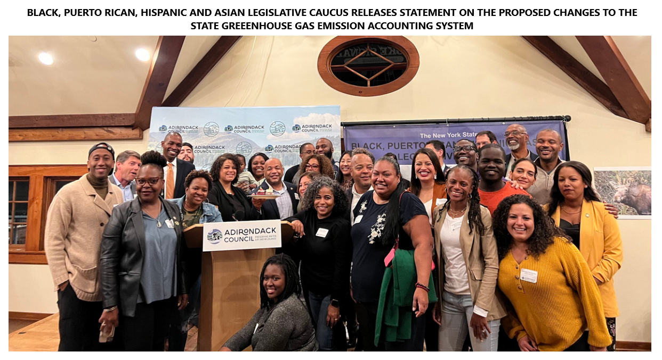

# N.Y. Governor Walks Back Push to ‘Weaken’ Climate Law After Uproar – Crace Ashford and Daana Rubenstein - New York Times – 2023 04 05 - <https://www.nytimes.com/2023/04/05/nyregion/hochul-climate-law.html?oref=csny_firstread_nl>

<https://twitter.com/yeampierre/status/1643281548404310018>

**10 minute video of Sit In at the entrance to the Governor’s office** – 2023 04 04 -

<https://soundcloud.com/mediasanctuary/climate-protests-force-governor-to-retreat-on-methane-rules>

**A Trojan Horse That Would Subvert Climate Justice in New** **York** - from the Natural Resources Defense Council. 2023 04 05 - <https://www.nrdc.org/bio/christopher-casey/trojan-horse-would-subvert-climate-justice-new-york>

## **Assembly Member Anna Kelles’ Breakdown of S6030/A6039 -**

<https://docs.google.com/document/d/1aiuH2ULjiyLCwmm5sYkeoItTX-lwPKxemBP8TKqahkw/edit>

**NY Renews Maintains this folder with 66 Memos of Opposition to S6030** (As of 2023 04 07) - <https://drive.google.com/drive/folders/1gUsbDgT6usMSTIbWKxKH8Rsx_2XJ09Wq>

## **Governor Hochul Drops Push to Gut NY Climate Law** - Food & Water Watch Statement - 2023 04 05 - <https://www.foodandwaterwatch.org/2023/04/05/governor-hochul-drops-push-to-gut-ny-climate-law/>?

# Hochul Math: The governor’s power grab to rewrite climate law In-depth article by journalist Lissa Harris – 2023 04 05- <https://empireofdirt.substack.com/p/hochul-math-the-governors-power-grab?utm_source=substack&utm_medium=email>

**The Anti-Electrification Force -** Rob Galbraith – Public Accountability Initiative – 2023 03 08 - The New York utility corporations trying to block building electrification to protect billions of dollars in profits - - <https://public-accountability.org/report/the-anti-electrification-force/>

# Fueling Obstruction - Rob Galbraith – Public Accountability Initiative - 2022-11-02 - The Fossil Fuel Networks Undermining Climate Action in New York State - <https://public-accountability.org/report/fueling-obstruction/>

# Just like that a proposal to roll back NY’s climate law got nixed - Rebecca Lewis – City & State – 2023 04 06 - <https://www.cityandstateny.com/policy/2023/04/just-proposal-roll-back-nys-climate-law-got-nixed/384900/>

**Climate plan sticker shock** – Marie French – POLITICO – 2023 04 03 - <https://www.politico.com/newsletters/weekly-new-york-new-jersey-energy/2023/04/03/climate-plan-sticker-shock-00090105>

**Hochul Throws Climate ‘Grenade’ Into Budget Talks** - Colin Kinniburgh – NY Focus - 2023 04 04

<https://www.nysfocus.com/2023/04/04/hochul-climate-grenade-methane-accounting-clcpa/>

**Environmental advocates and lawmakers incl Assemblymember @DeborahJGlick, chair of EnCon committee, holding a presser outside NY Senate opposing changes to climate law –** Marie French - tweet covering press conference with several legislative leaders - <https://twitter.com/m_jfrench/status/1642914770176155651?cxt=HBwWhoC9ie2R58wtAAAA&cn=ZmxleGlibGVfcmVjcw%3D%3D&refsrc=email>

**Letter from 31 Scientists to Governor and Legislature Leaders –** 2023 04 05

<https://www.ny-geo.org/assets/pdf/2023+04+05+Scientist+climate+law+sign-on+letter>

# Hochul Tried To Help Her Fossil Fuel Donors Gut Key Climate Law – Julia Rock – The Lever -2023 04 04 - <https://www.levernews.com/hochul-is-helping-her-fossil-fuel-donors-gut-key-climate-law/>

## **Environmentalists alarmed by push to ‘undermine’ New York’s climate law** – Marie French – POLITICO 2023 04 02 - <https://www.politico.com/news/2023/04/02/undermine-new-yorks-climate-law-00090024?oref=csny_albanyagenda_nl>

**New York environmental officials say methane change won’t be a budget priority** - Nick Reisman – State pf Politics – April 5, 2023 - <https://nystateofpolitics.com/state-of-politics/new-york/ny-state-of-politics/2023/04/05/new-york-environmental-officials-say-methane-change-won-t-be-a-budget-priority?oref=csny_firstreadtonight_nl>

# NY Renews Plays Offense for Climate Justice as Gov Hochul and State Agencies Attack NYS Climate Act – press release - <https://www.nyrenews.org/news/2023/4-4/nyroffense>

**Saving New York Money, Saving New Yorkers’ Lives The Climate, Jobs & Justice Package will save New Yorkers nearly a billion dollars on energy bills and nearly $40 billion a year statewide** - NY Renews Brief - <https://docs.google.com/document/d/1BAM9KFP_jiriOY2bkwLHcNEbZO2fuu6CWnxQ-XPwnN0/edit>

**The Climate, Jobs, and Justice Package (CJJP) Would Save New York State Almost $500 Million a Year** - NY Renews Brief - <https://docs.google.com/document/d/1TT3wBX-wGePhfXDzdLpuc5J0WvmothF4KP-hPvzwNFw/edit>

**Equitable Energy Rebates for New York State** - NY Renews Brief - <https://docs.google.com/document/d/11ruPEtUdiyFgmBJE95VH3yL1AnD89pGNNl5FB3YdgZg/edit#heading=h.59q6vexrt7r6>

**It is truly impressive how many people responded on pretty short notice to defend our NY climate law! Makes me proud to be a New Yorker.** Tweet from Climate Action Council member Robert Howarth <https://twitter.com/howarth_cornell/status/1643809618810871810?cxt=HBwWhIC9-fKI_s8tAAAA&cn=ZmxleGlibGVfcmVjcw%3D%3D&refsrc=email>

**BACKGROUNDER: Dumping Methane Accounting Standards Would Gut  
New York’s Climate Law** – Climate Nexus - [**https://docs.google.com/document/d/1y4OIQsD0uEUEexnEu7yw6752tufTappGGAi7j2-A958/edit**](https://docs.google.com/document/d/1y4OIQsD0uEUEexnEu7yw6752tufTappGGAi7j2-A958/edit)