August 2023 Newsletter  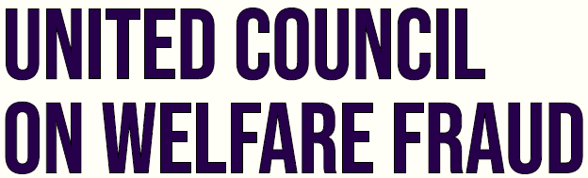P.O. Box 164, Westmoreland, Iowa 66549 · (785) 477-5424 · www.ucowf.net  PRESIDENT’s BLOG  On June 7, 2023, UCOWF returned to Washington D.C., where Past President Dawn Royal testified in the U.S. House of Representatives’ Agriculture Committee. UCOWF’s Intergovernmental Committee Co-Chair, Andy McClenahan, and I were in attendance. Mrs. Royal’s testimony can be found on our website at www.ucowf.net under Legislative, Fact Sheets, titled “Transcript – Dawn Royal Testimony to House Agricultural Committee on Program Integrity for the Supplemental Nutrition Assistance Program.” While we were in Washington D.C., Dawn Royal and I had just enough time to visit Senator John Barrasso’s office to continue to spread UCOWF’s message.  This quarter, UCOWF has been interviewed by several different news organizations. One of which was Fox News, who aired a short piece on Wednesday, July 26th during the Special Report regarding EBT cloning/skimming with reporting journalist, William LaJeunesse.  On June 30, 2023, FNS completed the FY2022 National Quality Control Payment Error Rate Report where our Intergovernmental Committee and I submitted a statement on July 7, 2023, saying the FY 2022 Payment Error Rate of 11.54 percent represents a loss of $1 billion per month in unrecovered overpayments. While the error rate is not the fraud rate, it is a smaller subset of overall fraud, waste, and abuse in SNAP and is completely unacceptable. (Read the entire statement on our website.)  (Continued on page 2) |  | 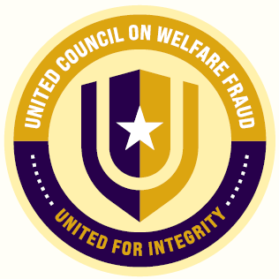  Inside This Issue  President’s Blog  CWFI Testing  Executive Board  Upcoming Events  50th Annual Conference  REGISTRATION IS CLOSED!  Virginia Beach, VA September 11-14, 2023  In the News  Follow UCOWF on Instagram, LinkedIn and Facebook where members share news, trends, success stories, and stay connected to legislative news!
President’s Blog (Continued)  UCOWF is looking into California Assembly Bill 133. This is a huge health care bill passed by California and is largely funded by federal dollars. This bill specifically deals with the Medicaid program and “state” funded Medicaid program Medi-Cal. According to the California Health Care Foundation www.chcf.org, “FY2021-22, Medi-Cal was financed 70% by the federal government, 21% from the state general fund, and 9% using other state and local funds.” This state bill was passed in California and a few other states are trying to follow this model, making this a national issue. Stay tuned to the “facts sheet” on our website and social media posts for a more detailed summary about this issue.  On a personal note, what a year! I kept thinking, this will be my last “President’s Blog”. I’ll be stepping down in September. In 2009 I attended my first UCOWF conference and have had the privilege to attend several conferences throughout the years and have connected with numerous like-minded professionals across the nation, learning new techniques and tools for my profession. I’m excited to attend this year’s National Training Conference in Virginia Beach, as I have seen firsthand all the hard work the Conference Committee has accomplished to obtain yet another great week. I have really enjoyed my time as the UCOWF President and have been proud of everything that has been accomplished this year and know that next year, our great work will continue to collaborate, educate, and advocate.  Sincerely,  Andrew Petitt, CWFI  CWFI EXAM: Those interested in in taking the exam, please be sure to have your application submitted by 12:00 PM on September 12th, exam fee of $50 must also be paid at this time. You can submit your application by visiting the UCOWF.net website, go to the Training tab, select CWFI and review the instructions. The NEW study guide is available in the member portal now. |  | Executive Board  President  Andrew Petitt (WV)  President-Elect  Carrol Christian (KS)  Vice President  Ashley Wilkes (FL)  Treasurer  Christopher O’Neil (FL)  Secretary  Ellis Bryson (WV)  Business Manager  Laura Lindsey (KS  ucowfmail@gmail.com

