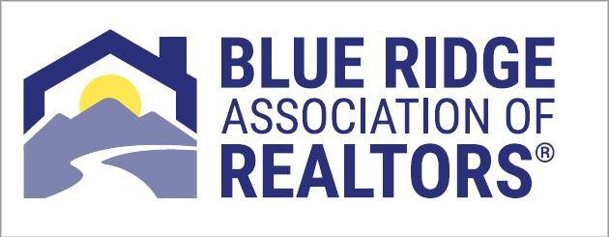

$300.00 (BRAR Dues)

$210.00 (Sentrilock Dues & Plan Processing Fee)

$225.00 (State Dues & RPAC Contribution"optional")

$195.00 (National Dues)

**Page 1 of 2**

$510.00 (BRAR Dues, Sentrilock Dues and Plan Processing Fee)

$420.00 (State Dues, National Dues, RPAC Contribution "optional")

**2024 Quarterly Plan**

Week of November 28, 2022

Week of February 20, 2023

Week of May 22, 2023

Week of August 28, 2023

**TOTAL: $930.00**

**2024 Semi Annual Plan**

Week of February 20, 2023

Week of August 28, 2023

**TOTAL: $930.00**

The breakdown as follows: **subject to any price changes implemented by Local, State and National Associations**

2024 Membership Dues Payment Plan

To sign up for the 2024 Dues Payment Plan **please read below and complete page 2** of the form and return it to BRAR or email a copy to [lauri@brarva.com.](mailto:lauri@brarva.com.)

You credit card will be automatically charged on the dates for the amounts listed below based on the plan you select. Please note the charge will appear on your bank statement as an “ACH Debit.” You agree that no prior notification will be provided unless the amount changes, in which case you will receive notice from us prior to the payment being collected.

A one-timeprocessing fee of $35.00 will be charged as part of the payment plan. All RPAC (Realtor Political Action Committee) contributions are optional.

**Contributions to Virginia REALTORS® RPAC are voluntary and are used for political purposes; they are not deductible for federal or state income tax purposes. Members may contribute more or less than the suggested amount and may refuse to contribute without reprisal. The National Association of REALTORS® or any of its state associations or local boards will not favor or disfavor any member because of the amount contributed. NAR has established state Federal RPAC Disbursement Allocations based on anticipated National RPAC needs. Thirty percent of all Major Investor contributions are sent to NAR to be applied to the Federal RPAC Disbursement Allocation and are charged against the limits under 2 U.S.C. 441a with the remaining seventy percent maintained for state and local usage. Decisions regarding Virginia REALTORS® RPAC contributions to meet the Federal RPAC Disbursement Allocation will be made throughout the fundraising year. The contributor certifies that they are at least 18 years old and are making this contribution with their own personal funds- not those of another person or entity, nor are they a foreign national or federal contractor.**

**I understand that this authorization will only remain in effect until August 31, 2023, and I agree to notify Blue Ridge Association of REALTORS® in writing of any changes in my account / credit card information or termination of this authorization at least 5 days prior to the next billing date. If the above noted payment dates fall on a weekend or holiday, I understand that the payments may be executed on the next business day.**

**In the event of an ACH Transaction being rejected for non-sufficient funds (NSF) I understand that Blue Ridge Association of REALTORS® will notify me via email "one time only" to provide an updated or valid credit card. I acknowledge that the origination of ACH transactions to my account must comply with the provisions of U.S. law. I certify that I am an authorized user of this credit card and will not dispute these scheduled transactions with my bank or credit card company; so long as the transactions correspond to the terms indicated in this authorization form.**

**Page 2 of 2**

DATE

SIGNATURE

(initial) I DO NOT WISH TO MAKE AN INVESTMENT TO RPAC.

Quarterly Payment Plan Option (Weeks of: November 28, 2022, February 20, 2023, May 22, 2023 and August 28, 2023

**Recurring Payment Authorization Form for 2024 Dues Payment Plan**

Schedule your payment to be automatically charged to your Visa, MasterCard, American Express or Discover Card. Just complete and sign this form and return to BRAR or email to: [lauri@brarva.com](mailto:lauri@brarva.com) to get started!

**Here’s How Recurring Payments Work:**

You authorize regularly scheduled charges to your credit card. Your card will be charged each billing period either quarterly or semi-annually (select option below). The charge will appear on your bank statement as an “ACH Debit.” You agree that no prior notification will be provided unless the date or amount changes, in which case you will receive notice from us prior to the payment being collected.

**Please complete the information below:**

I , agree to the Payment Plan terms on Page 1 and authorize Blue Ridge Association of REALTORS® to charge my credit card indicated below for the future payments of my 2024 Dues:

Semi Annual Payment Plan Option (Weeks of February 20, 2023 & August 28, 2023)

**Credit Card**

Visa MasterCard

Amex Discover

Cardholder Name Account Number Exp. Date

Security Code (CVV#)