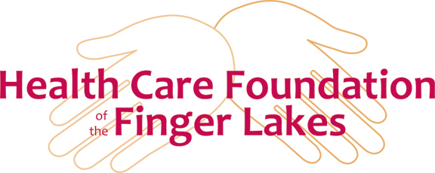**Commitment to Enroll**

**Facility Partner Nursing Leadership Program**

The Health Care Foundation of the Finger Lakes is proud to sponsor the Facility Partner Nursing Leadership Program. The Foundation will reimburse participating facilities seventy five percent (75%) of the cost of the program for employees (employed for at least a year) that successfully complete training sessions. The current sessions being offered are outlined below.

LPN/RN Clinical Skills Update –

This unique LPN/RN Clinical Skills Update Training program addresses the higher acuity levels of residents in long-term care. Aspects of this learning include both classroom and skills lab training, providing a focus on CHF, COPD, MI, Pneumonia, and UTI; those diagnoses that often lead to hospital re-admissions. In the classroom setting, several case studies are presented and discussed to further develop clinical reports and to practice communication of those reports to the provider using the SBAR tool. Additionally, nurses will have the opportunity to practice their updated clinical skills in the Wingman’s School of Nursing state-of-the-art Simulation Center.

LPN Professional Development Training –

The LPN Professional Development Training supports the LPN management role in long-term care settings. Training focuses on communication with residents, families, staff and providers, collaborative work teams, role modeling for staff empowerment, decision-making, team building, listening skills, conflict resolution and strategies for a positive work environment. During the three training days, instructor-led classes are supplemented with case studies, work experience discussions, and faculty guest speakers to provide a well-rounded support for LPN’s in this dynamic role.

RN Leader Training Modules -

**Discover the Leader in You** - This one-day module focuses on the leadership role of the RN in long-term care, and includes classroom instruction and discussion about leadership theories, emotional intelligence, understanding authority/power, and more to help RNs identify, develop, and understand their own individual leadership style.

**Maximizing Your Management Skills** - In this one-day training module, the RN management role will be identified and discussed, along with tips and strategies for problem solving, managing stress, Human Resource matters, resident behaviors/issues, and more.

**Quality & Satisfaction** - This one-day training module includes in-class discussion, videos, and instruction on the quality and satisfaction issues relevant to long-term care and care of the elderly that includes change management, elderly assessment, and the elements for positive outcomes.

**The Impact of Communication** - Concepts and strategies for providing effective communication, giving/receiving feedback, communicating with staff, providers, and family, and the problem-solving process are just some of the topics covered in this one-day training module. Incivility in the workplace will also be addressed and discussed.

**TeamSTEPPS® -**This evidence-based training program is designed for a group of health professionals from a facility to improve communication and teambuilding within the organization. Using TeamSTEPPS® for LTC, instructors will present team-building strategies, problem-solving skills, case studies, and videos focused on teamwork. Through in-class team exercises, participants will learn how to effectively collaborate to promote quality care.

**Dementia Training** - This one-day training module is facilitated by an expert in the field of dementia care and includes classroom exercises, videos, and discussion of the following:

* Pathophysiology of dementia
* Dealing with difficult behaviors (Residents and family members)
* Alternate therapies (i.e. music and art therapy)
* Behavior modification
* Behavior management
* Anti-psychotic medication indications
* Sensitivity training

***Please take a moment to complete the information below and return it to the Foundation. Note that the individual must be employed at least a year to participate in reimbursement through the Foundation.***

***========================================================================================***

Name of Employee: _________________________________________________ Date of Hire: ________

Current Position: _______________________________________________________________________

Please write at least one paragraph outlining why this employee was chosen to participate ________________________________________________________________________________________________________________________________________________________________________________________________________________________________________________________________________________________________________________________________________________________________________________________________________________________________________________________________________________________________________________________________________________________________________________________________________________________________________________________________________________________________________