Westerville Area Chamber office 99 Commerce Park Dr. 43082

Agenda Tuesday, April 4, 2023, 3:30-4:45 PM

Attendees: Jeff Akers, Amy Balster, Bill Bishop, Mike Carlson, Ashley Fellers, Patrick Harris, Laura Hartman, Gene Hollins, Tamara Howard, John Kellogg, Charlene Kott, Dina Shultz, and members of the Business Inclusion and Opportunities Council (BIOC)

Staff member: Janet Tressler-Davis

1. Welcome & Introductions, Jeff Akers

2. Members of teams – Committee Reports

**Healthcare:** Andy H. – No new information

**Taxation/Worker’s Comp.:** Brandon/Charlene – No new information

**Workforce**: WorkWISE – John Kellogg/Janet/Gene

* Westerville Prepared Event will be Thursday, May 11. They are still looking for businesses to participate. If you are interested, please get in touch with Janet.
* U.S. Chamber information on the second page of agenda: 5.1 million more job openings than unemployed workers, Small Biz optimism up in Feb (U.S. Chamber). Optimism has been below the 48-yr av. for 14 months. 47% expect conditions to be better in the next six months.

3. Future Meeting Topics

* COTA Update and future projects
* State Budget
* Other Suggestions?

4. Updating City Economic Development Plan

* Del Boyette & Kay Stebbins, Boyette Strategic Advisors, led a discussion with the group as Boyette seeks to help Westerville develop their next strategic and economic development plan.

5. Upcoming Events

* Legislative Roundtable (sponsored by Asset Management Consultants) is Thursday, April 20, 8:00 AM (so far… 2 State Reps., 2 Senators, Mayor, Trustee confirmed)
* Questions discussed were related to childcare, healthcare, and development (business and residential)

6. Upcoming Meetings: May 2, June 6, July 11, or recess

* The Business Advocacy Council meets on the first Tuesday of every month

7. Adjourn: 4:45PM

Despite strong job growth, labor participation lags as problems with workforce continue.

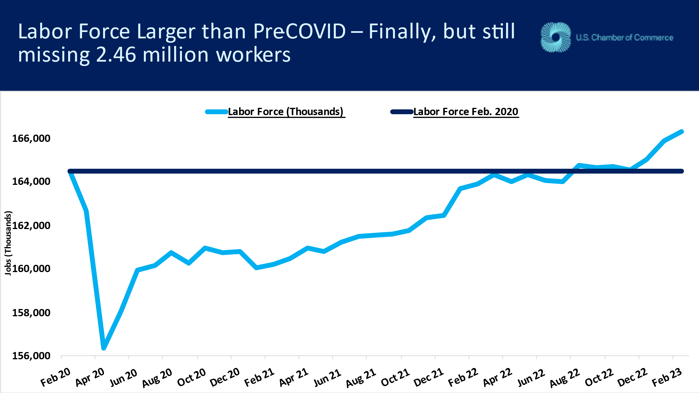

Leisure and Hospitality added 105,000; Education and Health 74,000; Wholesale and Retail Trade 61,000; Government 46,000; Professional and Business Services 45,000; Construction 24,000;

Information -25,000, Transportation and Warehousing -21,500, and Manufacturing -4,000 lost jobs.

