May 5, 2022

The Honorable Cecilia Aguiar-Curry
Assemblymember, 4th District
1021 O Street, Suite 6350
Sacramento, CA 95814

RE: AB 1656 (Aguiar-Curry): Cannabis: industrial hemp
NOTICE OF SUPPORT

Dear Assemblymember Aguiar-Curry:

The California Cannabis Industry Association (CCIA) is pleased to support your bill, AB 1656 (Aguiar-Curry), which clarifies that licensees in possession of a commercial cannabis license may also manufacture, distribute, and sell hemp products, in accordance with existing law.

CCIA has long supported cannabis licensee's ability to integrate hemp into the cannabis supply chain. Specifically, CCIA supports the incorporation of hemp cannabinoids into manufactured cannabis products, the ability of cannabis licensees to also manufacture hemp products within their facilities, and the opportunity to sell hemp products within licensed dispensaries. The licensed cannabis industry and the framework set forth in the MAUCRSA is already well suited to accommodate hemp products and would benefit from the opportunity to expand product offerings.

AB 228 (Aguiar-Curry, 2019), which was held in the Senate Appropriations Committee, authorized cannabis licensees to manufacture, distribute and sell hemp CBD products. Since that time, CCIA and our coalition partners have been working with the Legislature and the Administration to address outstanding concerns associated with the integration of the two supply chains. Subsequently, the hemp and cannabis industries agreed to a compromise, memorialized in AB 45 (Aguiar-Curry, 2021), which directed the Department of Cannabis Control (DCC) to complete a study by July 1, 2022, “outlining the steps necessary to allow for the incorporation of hemp cannabinoids into the cannabis supply chain.”

As we await the findings of the report from the DCC, our expectation is that AB 1656 will be used as a vehicle for an acceptable supply chain integration solution. For these reasons, CCIA is pleased to support AB 1656 which will give licensed cannabis businesses the flexibility to manufacture, distribute and sell hemp-based products, and we thank you for your steadfast leadership on this important issue.

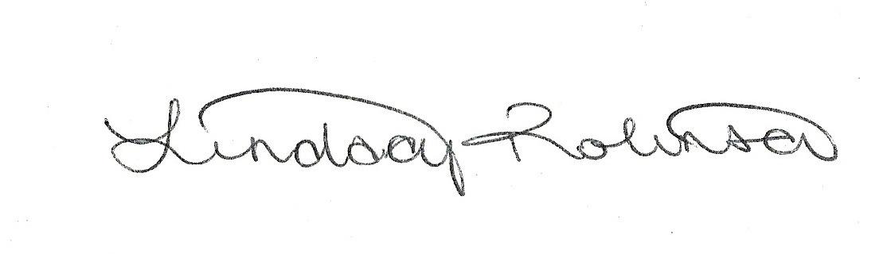
Sincerely,

LINDSAY ROBINSON
Executive Director

