Nexam User Guide
Overview:
A simple, elegant and geometric based design. It provides a simple and modern look that can be used for any kind of business or association. The landing page features a prominent hero graphic with h1 and call to action buttons.
Strong headlines highlighted with a line accent will be sure to make your content stand out. The box accent style adds the geometric flare and can be added to any column or image plugin with the addition of an ‘ID’ text label. On the inside pages, the logo and menu overlay a shorter full width background area adding a touch of design without distracting from the content.
Additional Features:
These are optional and included by default. Any content area or widget can be removed or replaced with another.
- Sticky menu: Allows users to navigate to the menu as they scroll down the page.
- Testimonial slider
- Highlights area: Can be used to highlight any information. Examples are events, new members and news
- Image or logo carousel: Commonly used to display sponsors.
Capabilities/and How To's:
- Header and Footer: These are set up with the Beaver Themer add-on. They can be edited within the page editor just as you would a page. To access the Beaver Themer options go to the Dashboard > Builder > Theme Layouts
- Note: The Beaver Themer allows you to choose whether you want the header to be sticky or not. This can be edited from the Dashboard > Builder > Theme Layouts. Click on ‘Edit’ below the header. The ‘Theme Layout Settings’ will display. Click on ‘Update’ once you have chosen your selections.
- Hero Graphic: This can also be a video, solid color, single image or a slide show. Click on the Page editor > Row Settings (the tool icon that displays at the bottom when you hover over the graphic). In the pop up window under the ‘Style’ tab you can select your preferences
- Line Accent: this is a drag and drop widget that can be found under Page editor > Basic modules > Separator. Drag it into you desired content area and select from the styling options.
- Box Accent: The two ‘ID’ text labels that are used to create this effect are…
1. “box-before” – creates a box to the left of the image
2. “box-after” – creates a box to the right of the image
Place this text into the ‘ID’ input field under the ‘Advanced tab’ of the Column Settings or widget.
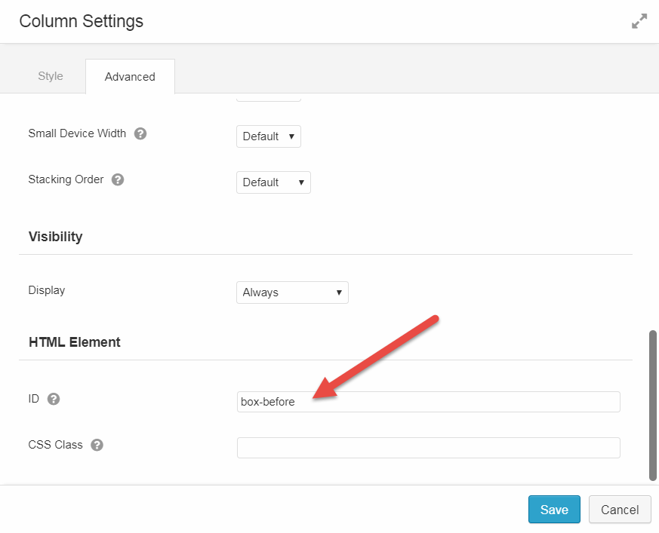
- Corners Touching Tip: Set the column widths to align vertically by choosing percentages that together equal 100%. This can be found in Page editor > Column Settings (the 2-columns looking icon that displays when you hover over the column). While in the Column settings, select the Advanced tab and make sure that the margin between them is set to ‘0’ to align them horizontally.
- Testimonials Slider: This is a drag and drop widget that can be found at Page editor > Advanced Modules > Testimonials. You can also use a ‘Content Slider’ widget for this.
- Highlights area: This uses the ‘Call to Action’ widget by default. It can be found under Page editor > Advanced Modules > Call to Action. The background image is placed in the column settings and can be switched by accessing Page editor > Column Settings.

