COVID-19 Resources for Minnesota Workplaces
MN COVID-19 Response: For Businesses and Organizations
https://mn.gov/covid19/
- Resources for business and organizations
  - Guidance and resources for all employers
  - Resources for Small Businesses
    - A Guide for Minnesota Small Businesses Who Need Help

MN Department of Employment and Economic Development
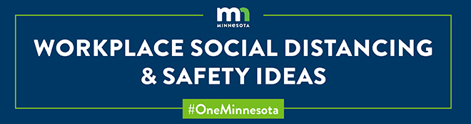
https://mn.gov/deed/newscenter/covid/
- Safely Returning to Work
  - For Businesses: Safely Returning to Work
  - For Workers: Safely Returning to Work
- Guidance on Reopening Businesses
- Business Stories
  - Businesses Doing Good
  - Workplace Social Distancing and Safety Ideas
- Eligibility for Critical Sector Worker Exemption
- Frequently Asked Questions

MN Department of Labor and Industry
https://www.dli.mn.gov/business/workplace-safety-and-health/mnosha-compliance-novel-coronavirus-covid-19
UPDATES RELATED TO COVID-19
- COVID-19 Preparedness Plan template and instructions
- Checklist guidelines for creating a COVID-19 Preparedness Plan
- Frequently asked questions for employers and employees related to COVID-19
- Minnesota OSHA printable handouts and resources related to COVID-19
  - COVID-19 health and safety guidelines for the meatpacking industry
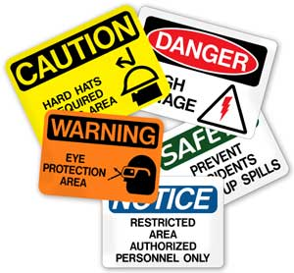
  - COVID-19 in construction
  - COVID-19 Preparedness Plan: Convenience stores
  - COVID-19 Preparedness Plan guidance for manufacturing
  - COVID-19: Health and safety guidelines for dentistry
  - COVID-19: Protecting bait shop workers and customers
  - COVID-19: Protecting golf course workers and customers
  - COVID-19: Protecting manufacturing workers
  - COVID-19: Protecting grocery store workers
  - Equipment for COVID-19, non-essential businesses
  - Minnesota worker protections related to COVID-19, including sick leave, FMLA, discrimination, reporting health concerns at work, unemployment insurance, workers' compensation
  - Safety and health guidelines for the employers and employees of essential work operation
- Minnesota worker resource guide for employees in processing and manufacturing plants
- Worker protections related to COVID-19
- Workers' compensation bill: Legislation creates a presumption for workers’ comp coverage for first responders and certain health and child care workers who contract COVID-19.
- Unemployment insurance: Visit www.uimn.org.

Minnesota Department of Health
https://www.health.state.mn.us/diseases/coronavirus/businesses.html
- Businesses and Employers: COVID-19
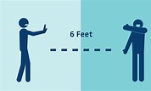
  - Stay at Home order
    - Critical services
    - Non-critical exempt businesses
  - Social Distancing
  - Sick Leave Policies
  - Additional Steps
  - Resources
- Frequently Asked Questions about Executive Orders Related to Bars, Restaurants, and Other Places of Public Accommodation
- Interim Guidance for Hotel Managers and Owners
  - https://www.health.state.mn.us/diseases/coronavirus/lodgingcleaning.pdf

Centers for Disease Control and Prevention
https://www.cdc.gov/coronavirus/2019-ncov/community/organizations/businesses-employers.html

- Interim Guidance for Businesses and Employers to Plan and Respond to Coronavirus Disease 2019
- Prepare your Small Business and Employees for the Effects of COVID-19
- General Business Frequently Asked Questions

