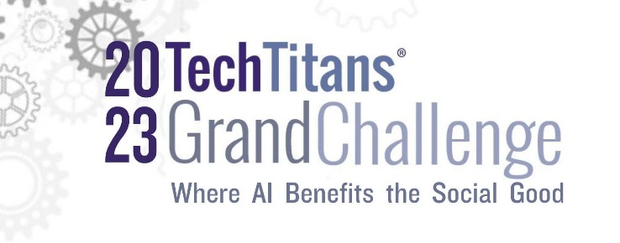

2023 Grand Challenge Company Application

Your name:

Company name/address/phone/email address/website URL
Explain how your proposed solution utilizes innovative solutions, systems, or applications that are centered around Artificial Intelligence Applications for the Social Good.

Social Good can be defined as the application of AI technologies and approaches to leverage the capabilities that create solutions centered around such social issues as poverty, inequality, healthcare, education, human rights and more. It is a responsible and purposeful use of technology to ensure the well-being of individuals and communities.
(1,000 words or less)

Tech Titans Grand Challenge continued P 2

What is your ideal outcome in terms of a business relationship with the participating companies?

Provide your company’s background with specific details about how it applies to your technology and confirm your company is in pre-revenue or revenue status of less than $2million annually (1,000 words or less).

Brief bios for members of your management/leadership teams

Please return to Jo Yezak no later than August 4th at 5 p.m. (CT) to be considered.

411 Belle Grove Drive • Richardson, Texas 75080-5297 • (972) 792-2850 • www.techtitans.org

