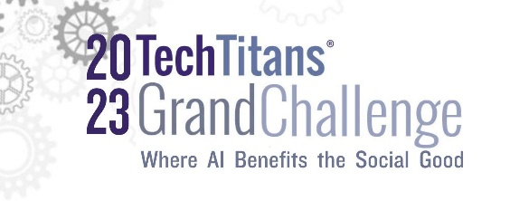

Funding for the 2023 Grand Challenge

The 2023 Tech Titans Innovation Collider Grand Challenge is seeking innovative solutions, systems, or applications that advance AI for the Social Good.
Entrepreneurs, start-ups, small and MBE/WBE-certified technology companies should be pre-revenue to revenue less than $2 million. There is no cost to participate. Participating companies can be located anywhere in the United States, and do not have to be Tech Titans members. Deadline for applications to be submitted is August 4, 2023, at 5:00 pm CT.

The winning company will be presented with a cash award from Tech Titans at the annual Awards Gala on September 29, 2023.

Contact Paul Bendel at 972-792-2854, paul@techtitans.org or Jo Yezak at 972-792-2817, jo@techtitans.org

Presenting Sponsor - $5,000 (up to 4 sponsors)
- Company logo on all electronic and printed marketing materials and the Tech Titans website.
- Signage at the awards gala
- Opportunity to be a part of the award presentation
- Arrange a meeting with the winning company
- Up to 2 guests may attend the awards gala

Associate Sponsor - $2,500 (up to 8 sponsors)
- Company logo on all electronic and printed marketing materials and the Tech Titans website.
- Signage at the awards gala
- One guest may attend the awards gala

Supporting Sponsor - $1,000
- Company logo on all electronic and printed marketing materials and the Tech Titans website.
- Signage at the event
- One guest may attend the awards gala

