Free job postings
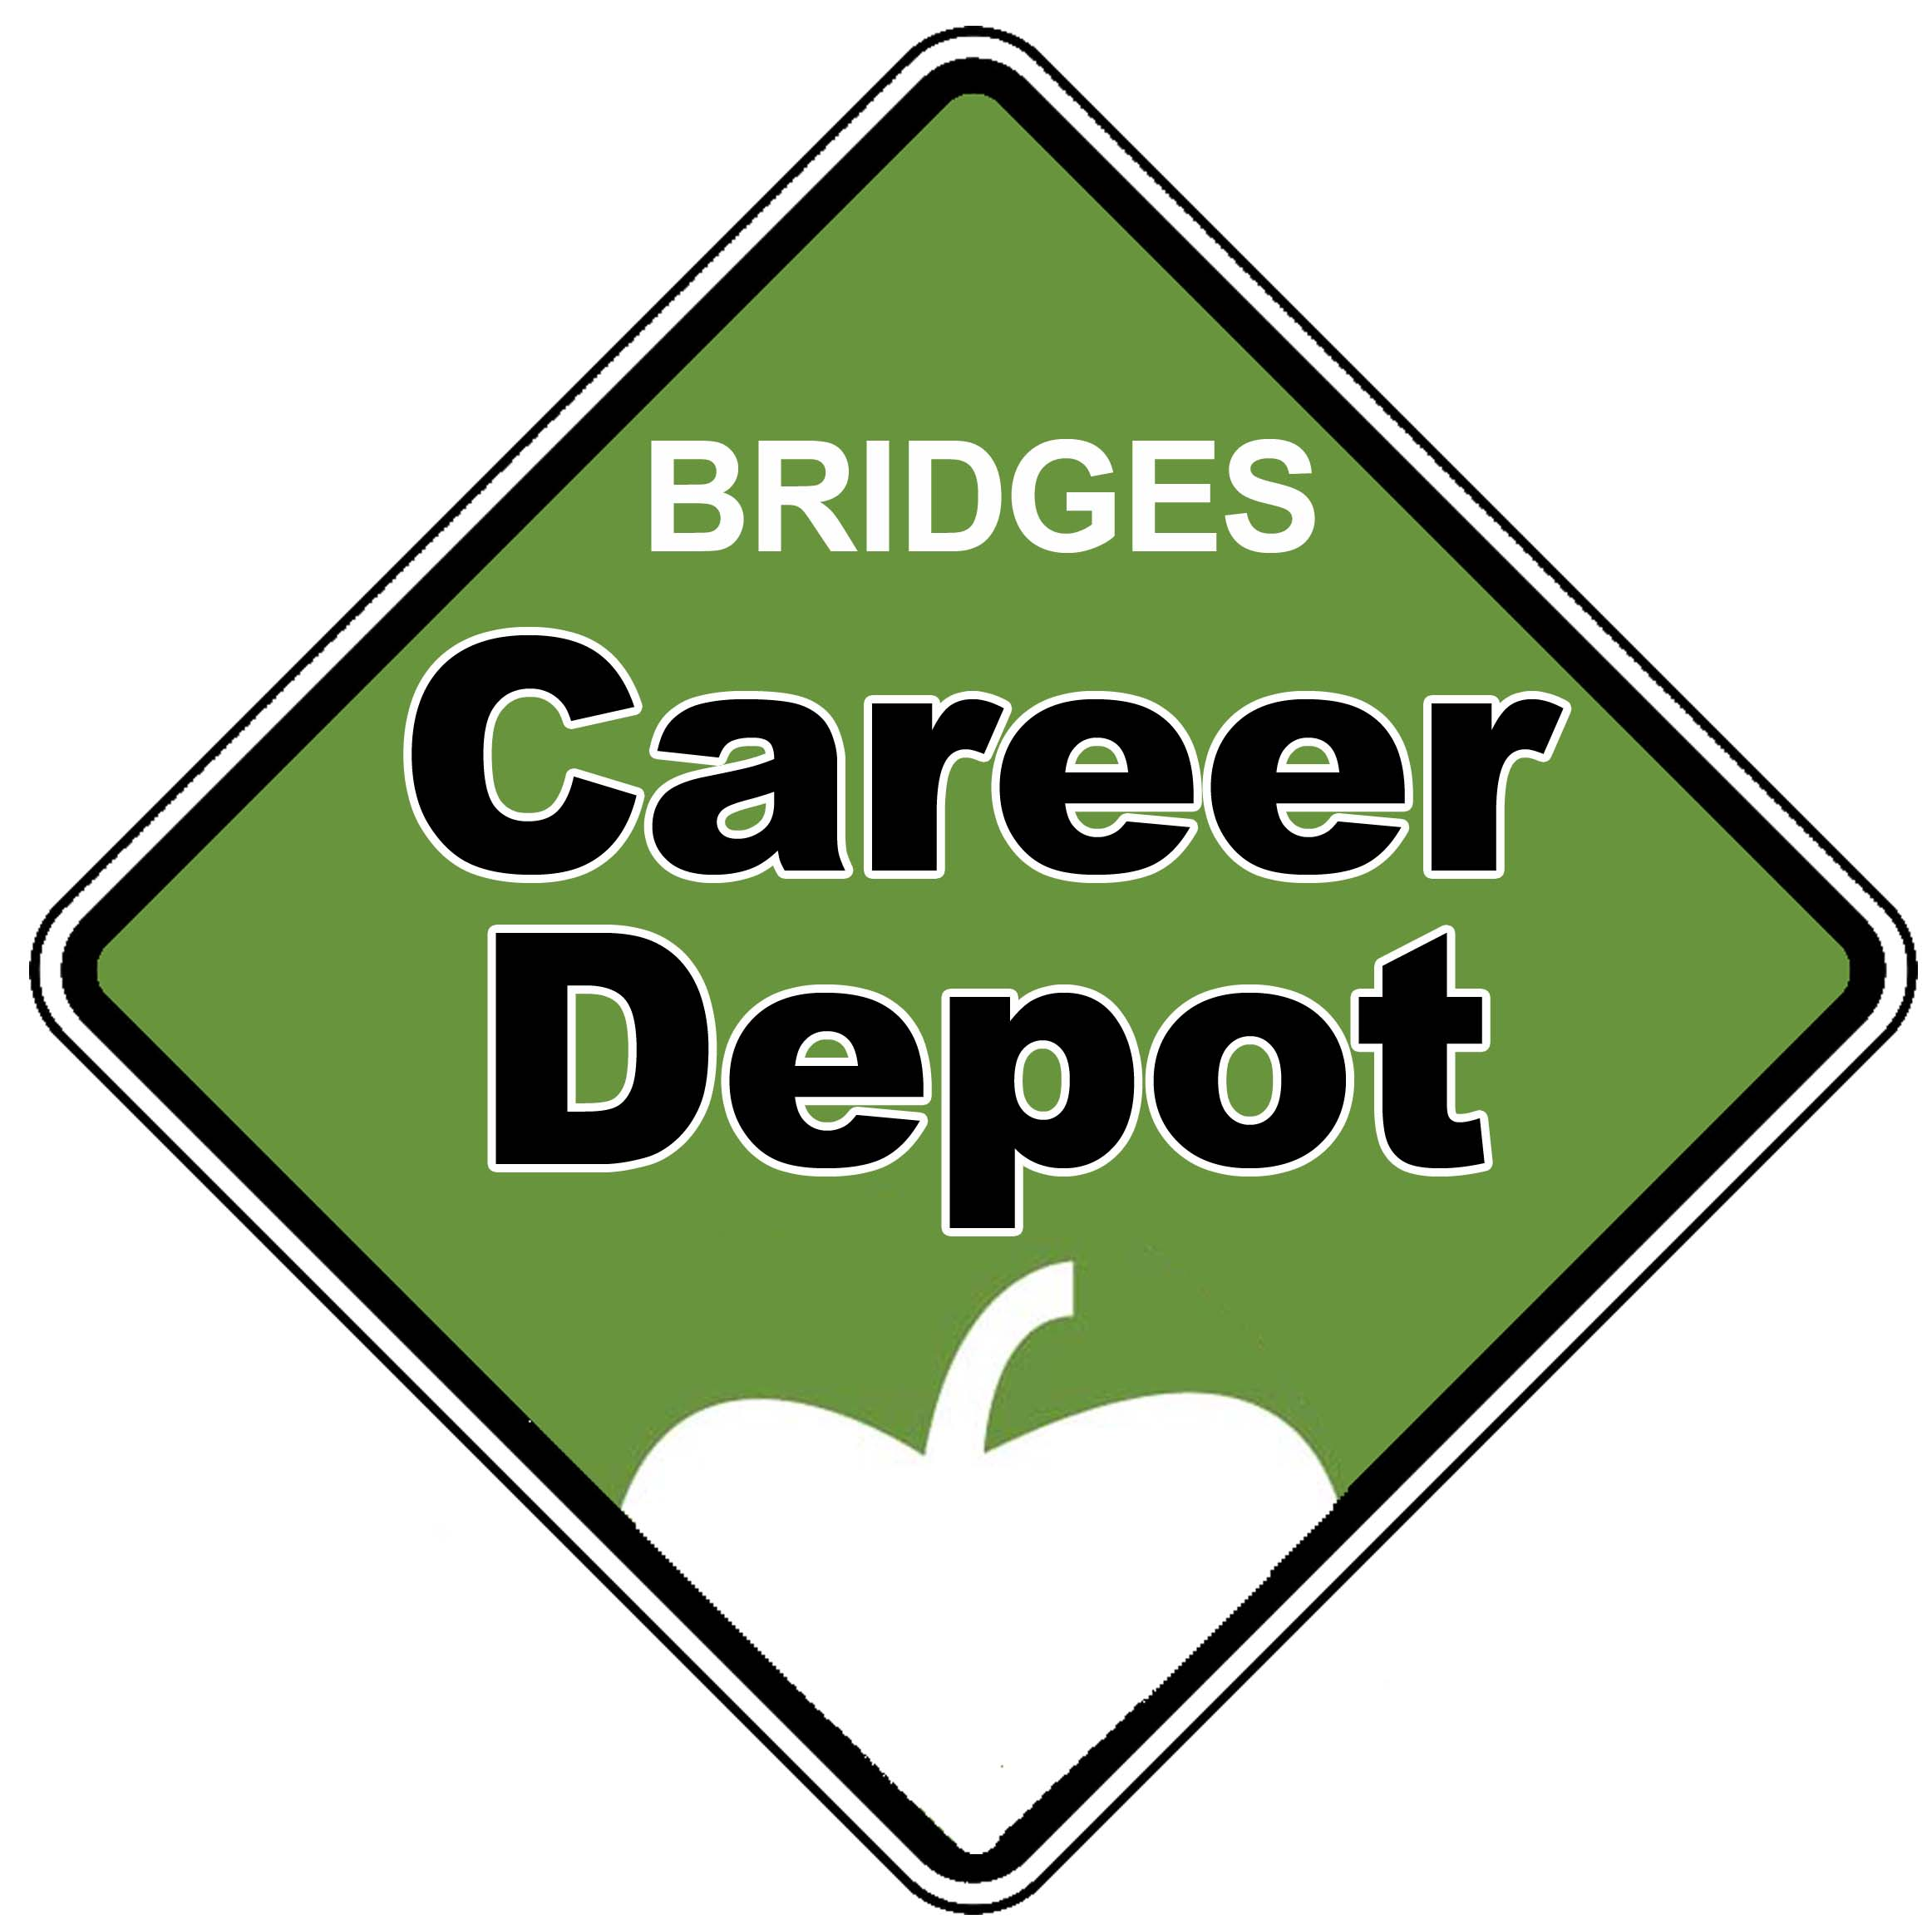
to recruit high school employees

The Bridges Career Academies
& Workplace Connection has a Job Search feature to help area high school students find a jobs — and we need your open positions! The Bridges Career Depot is an easy-to-use database of jobs just for high schoolers, as well as an interactive web portal of career exploration tools and resources.

Promote your positions
Simply complete the online job posting form. The posting is FREE and it can run for as long as or as little as you’d like. We can even schedule when your positions would be viewable, if you’d like to wait to recruit employees later in the spring.

Openings will not only be included on our website (www.BridgesConnection.org/jobs), but also posted to the Bridges Facebook page.

If you have a job that high schoolers can do, we want the posting. Just complete the online job posting form, or call your Chamber for more information.

The Career Depot is funded in part by Sourcewell and the Central Lakes Perkins Consortium. Find a complete list of Bridges’ program funders at www.BridgesConnection.org.
