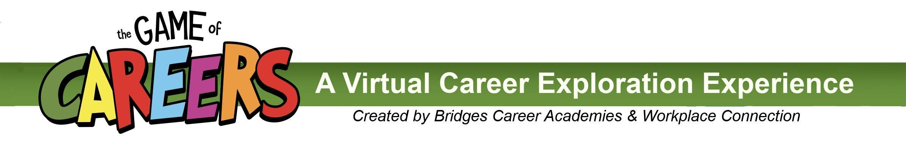
Proposed Messaging From Principal or Counselor
Email TEXT to parents -- send out the week of March 1

Thanks to a partnership with the Bridges Career Academies & Workplace Connection, __(name of school)____ High School students are being introduced to a new, fun website that will help them explore local career options. TheGameofCareers.com is a new website that showcases local industries and careers through interactive online simulations and activities, videos, photos, and relevant career information, all in a free, secure setting.

Students will receive their login information from an instructor or counselor. Their username is the students first and last names with no spaces between the names, and our school’s password is ________________________.

From March 5 – 26, 2021, students will earn points for every exploration activity they experience. Points accumulate into digital Career Badges and provide automatic entry to prize drawings.

Career information is displayed in an engaging, game-like format. The website offers descriptions of what popular jobs do, skills and education needed, local salary ranges and local job outlook information. There are even interactive career-based skills simulations, as well as related games and activities, which offer students virtual insight into what each career is like.

Career and college planning can happen at any age and any grade. We encourage you to ask your child about this website, and even log in with them at home to explore potential career pathways.

