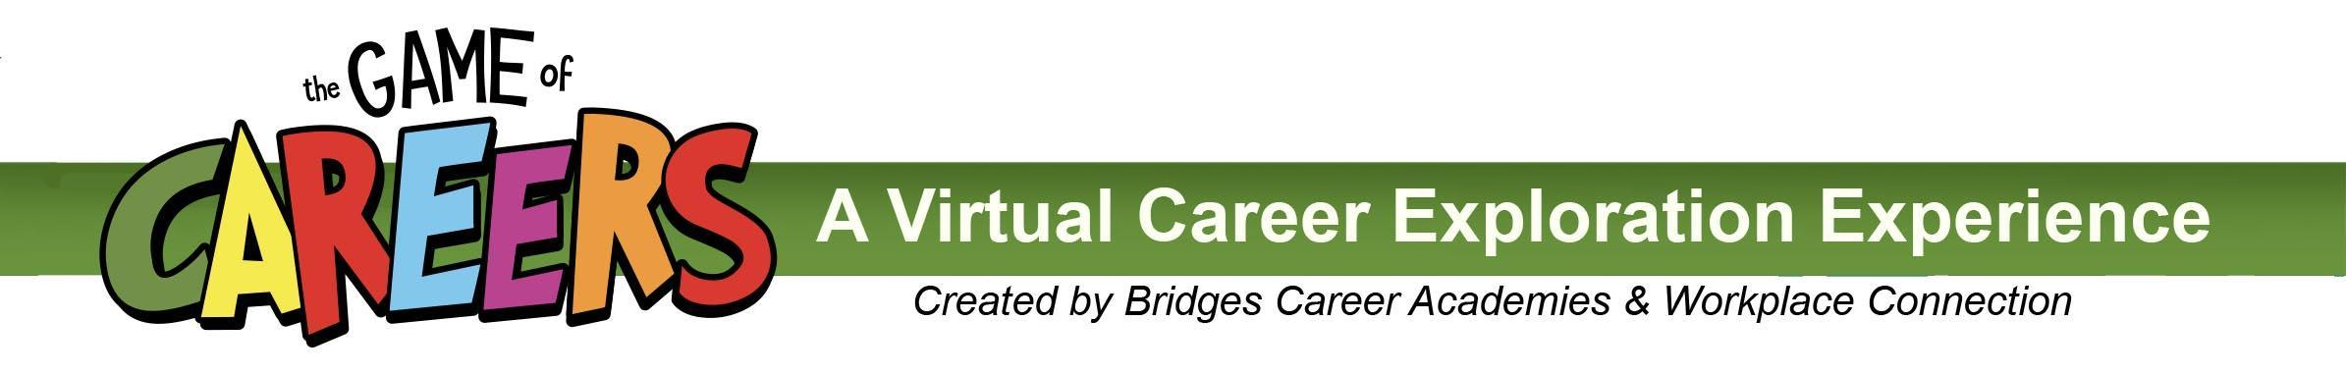
Proposed Messaging From Principal or Counselor
Email TEXT to students -- send out the week of March 1

Starting this Friday, March 5, Bridges Career Academies & Workplace Connection is launching a new virtual career exploration experience called The Game of Careers. TheGameofCareers.com website showcases local industries and careers through interactive online simulations and activities, videos, photos, and more. You can even submit a question to a local professional!

To log in, type in your username (your first and last names with no spaces between the names), and our school’s password is ________________________.

For all the career exploration activity you experience between March 5 – 26, 2021, you will earn points. These points accumulate into digital Career Badges and provide automatic entry to prize drawings.

Check with your instructors or counselor to see if completing the Game Card or other projects could support any of your grades.

It’s never too late to start thinking about your career options. So, visit this new website — TheGameofCareers.com, and explore your options!

