For immediate release

For more information, contact:

Kathy Moore, Marketing Consultant

(218) 330-3993, Kathy@BridgesConnection.org

or

Mary Gottsch, Executive Director

(218) 839-2310, Mary@BridgesConnection.org

**Bridges Launches The Game of Careers . com —**

**A New Virtual Career Exploration Experience**

On March 5, 2021, the Bridges Career Academies & Workplace Connection is launching a new, localized career exploration experience for area high school students. **TheGameofCareers.com** is a new website that showcases local industries and careers through interactive online simulations and activities, videos, photos, and relevant career information, all in a free, secure setting.

For the past 13 years, Bridges hosted a one-of-a-kind Career Exploration Day, offering more than 2,500 students from 28 local school districts a unique way to meet business professionals and explore careers. Due to Covid-19 crowd restrictions, Bridges is prevented from hosting this event in 2021. Despite this, Bridges still wants to offer students the opportunity to explore the hundreds of careers available to them and better understand local career options.

**TheGameofCareers.com** brings together the best information from Minnesota State’s CAREERwise and the US Department of Labor’s CareerOneStop websites, as well as with input from the local business community and post-secondary partners, to make career information relevant to Central Minnesota and our market needs. Content is displayed in an engaging, game-like format. Students will receive their login information at their high school. Then, from March 5 – 26, 2021, students will earn points for every exploration activity they experience. Points accumulate into digital Career Badges and provide automatic entry to prize drawings.

This virtual career exploration experience is available 24/7. The password-protected website will lead students to different industries within a community. Each industry will offer background on their field and feature a handful of specific careers. Industry and occupations would be showcased through easy-to-understand descriptions of what each job does, skills and education needed, local salary ranges and local job outlook information, as well as engaging videos and 360 degree “clickable” photos of regional business interiors. The highlight of this online career exploration experience is the interactive career-based skills simulations, as well as related games and activities, which offer students virtual insight into what each career is like. Business professionals and post-secondary partners will also be available to respond directly to questions student submit.

Students and educators will utilize **TheGameofCareers.com** as a career or college readiness project, as an on-going part of a class curriculum, or as a special “one-day” activity — similar to attending the live event. Students with logins may also access the site independently whenever they are in search of local career information.

The website will also include links to the Bridges’ Career Depot, [www.BridgesConnection.org/Jobs](http://www.BridgesConnection.org/Jobs) — the only jobs website in the region with job postings exclusively for 14-18 year olds. High school students can search for summer jobs that will earn them some money and teach them about real-world work responsibilities, and maybe, their new career pathway.

**TheGameofCareers.com** will complement the live Bridges Career Exploration Day event when it returns. This website will become the new cornerstone for the Bridges program — incorporating in speakers, career videos, the Career Depot, and more — to provide a more cohesive career & college readiness package for high schools. Industry-specific promotions are being planned for the 21-22 school year.

Funding for this new Bridges project is being provided in part by Sourcewell, the **Central Lakes Perkins Consortium**, the Initiative Foundation, and the Crow Wing Power Community Trust fund. The Bridges Career Academies & Workplace program also partners with the Brainerd Lakes Chamber, Central Lakes College, MSTATE, Rural MN Cep and area school districts.

**About Bridges**

The Bridges Career Academies & Workplace Connection is a workforce development initiative that strives to better integrate work-based learning between schools and business and promote career and college readiness to high school students. In addition to the annual Bridges Career Exploration Day event and new Game of Careers website, the other Bridges activities that offer a direct connection to business through career experience activities include: speakers in the classroom/virtual speakers, Topics on Demand video series, Career Depot youth jobs portal and an ever-growing library of career videos. Bridges’ academic enrichment program, Career Academies, showcase integrated courses at participating high schools that focus on the knowledge and skills within a specific career field. Each course includes technical skills and employability skills with real-world business and industry experiences.

All of these Bridges efforts are designed to expand career awareness, exploration and preparation to ensure a viable workforce. To learn more about Bridges, visit www.BridgesConnection.org.

# # #

*Suggested art:*

1. Program logo
2. Program header graphic
3. Sample poster

1)

2)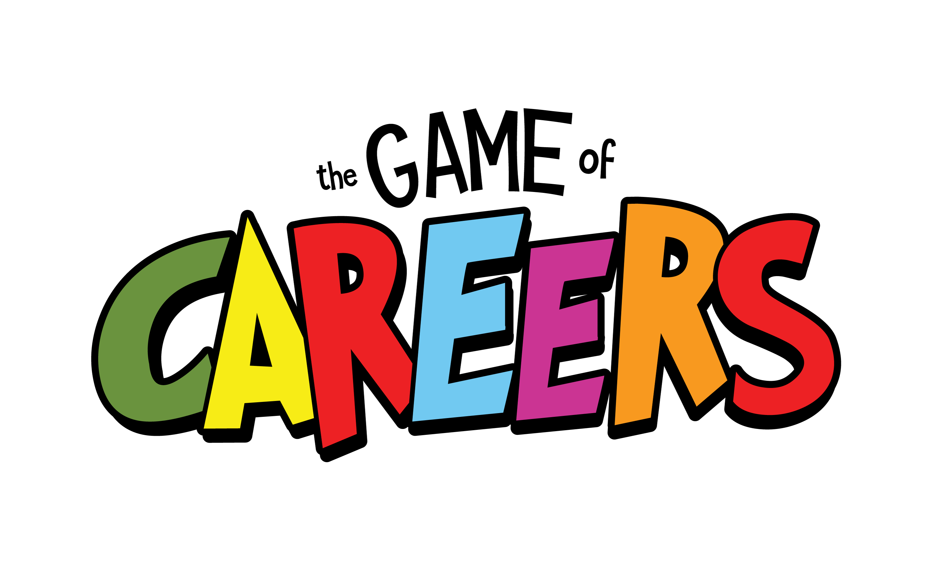

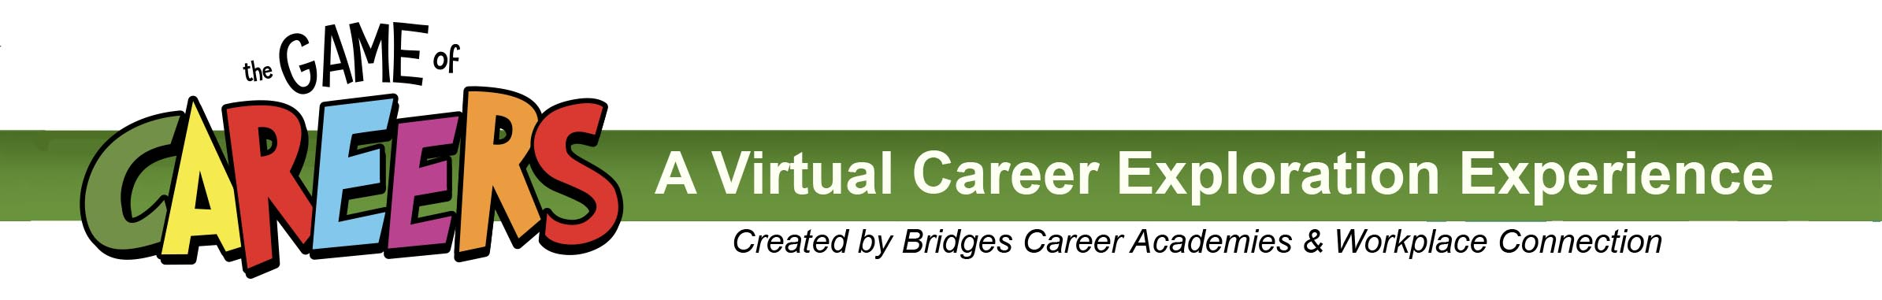

3)

