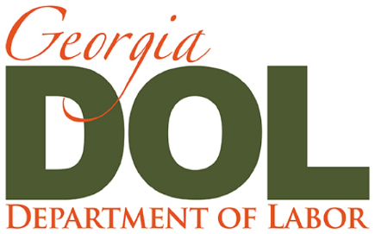 | Press Release
Mark Butler | Commissioner | Office of Communications

Suite 642  148 Andrew Young International Blvd., NE  Atlanta, GA 30303-1751 | (404) 232-3685  Communications@gdol.ga.gov  dol.georgia.gov

Federal Unemployment Aid Coming to Georgians Not Eligible for State Benefits
The Georgia Department of Labor (GDOL) is updating its current systems to distribute federal unemployment funds as part of the CARES Act (Coronavirus Aid, Relief, and Economic Security) bringing relief to many Georgians currently not eligible for state unemployment benefits.
Pandemic Unemployment Assistance or PUA, is the program that will provide unemployment benefits to those not ordinarily eligible for them. This includes individuals who are self-employed, gig workers, 1099 independent contractors, or those with limited work history who will not qualify for state unemployment benefits. The GDOL is modifying its current online unemployment application adding new questions to better identify those individuals who may be eligible for PUA. This modified application is expected to be available on Monday, April 13, 2020, on the GDOL website. Once the application is received, it will take several weeks to process. These additional questions in the application will help determine qualified applicants to continue the process for PUA benefits, including a different set of wage verifications and a different process for certification of wage benefits. The GDOL is partnering with other state agencies to assist with wage verification simplifying the process for PUA applicants.
If you have already filed a claim with the GDOL and will be eligible to potentially receive benefits under this program, you do NOT have to refile your claim. These individuals will be identified and sent an email with a link to provide additional information for the Pandemic Unemployment Assistance (PUA) Program.
“We are on the forefront of this economic effort to provide relief to a brand-new group of Georgians who have never received unemployment benefits before,” said Labor Commissioner Mark Butler. “Our team is working to make sure we can offer assistance as soon as possible to those in need while also establishing a system that in compliance with federal law.”
Please continue to visit the GDOL website at https://dol.georgia.gov/gdol-covid-19-information for daily updates.

