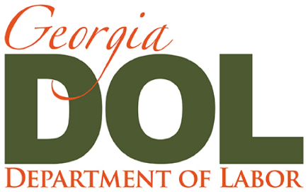 | Press Release
Mark Butler | Commissioner | Office of Communications

Suite 642  148 Andrew Young International Blvd., NE  Atlanta, GA 30303-1751 | (404) 232-3685  Communications@gdol.ga.gov  dol.georgia.gov

April 10, 2020

GDOL Announces Updates to CARES Act

The Georgia Department of Labor (GDOL) is updating its current systems to distribute federal unemployment funds as part of the CARES Act (Coronavirus Aid, Relief, and Economic Security) bringing economic relief to many Georgians.

The Federal Pandemic Unemployment Compensation program, or FPUC, provides a $600 supplement per week to any individual eligible for any of the Unemployment Compensation programs – State and Federal. The GDOL will begin sending this additional payment to those currently receiving state unemployment benefits beginning next week. This supplement will be an additional payment to regular weekly state unemployment benefits and will include all eligible weeks beginning with the week ending 4/4/2020. The supplement amount is contingent upon any deductions required by the state or federal government.

Pandemic Unemployment Assistance or PUA, is the program that will provide unemployment benefits to those not ordinarily eligible for them. This includes individuals who are self-employed, gig workers, 1099 independent contractors, employees of churches, employees of non-profits, or those with limited work history who will not qualify for state unemployment benefits. The GDOL is modifying its current online unemployment application adding new questions to better identify those individuals who may be eligible for PUA. This modified application is expected to be available on Monday, April 13, 2020, on the GDOL website. Once the application is received, it will take several weeks to process.

The additional questions in the application will help determine qualified applicants to continue the process for PUA benefits, including a different set of wage verifications and a different process for certification of wage benefits. The GDOL is partnering with the Georgia Department of Revenue (DOR), if given authorization by the applicant, to assist with wage verification simplifying the process for PUA applicants.

If GDOL is unable to verify your wages with DOR, applicants may be asked to provide documentation to prove wages. The past wages used to establish your PUA claim may use income not normally covered by regular state unemployment, such as contract labor or self-employment earnings.

Acceptable Proof of Wages/Income Used for PUA Claims
- Proof of wages/income for the most recently completed tax year 2019:
- If you are an employee or 1099 independent contractor, you can upload copies of pay stubs, earning statements, IRS Form W-2 or IRS Form 1099 and federal income tax Form 1040 and Schedule C, F, or SE.
- If you are self-employed, you can upload IRS Form 1040 and a copy of Schedule 1, 2, C, F or SE tax return.

Individuals who have already filed a claim with the GDOL and will be eligible to potentially receive benefits under this program, you do NOT have to refile a claim. These individuals will be identified and sent an email with a link to provide additional information for the PUA Program.

