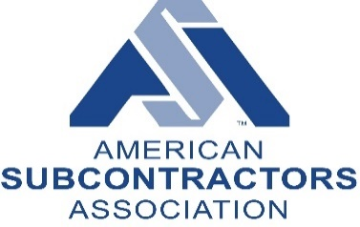
ASA 2021 Legislative Priorities

- COVID-19 – please see ASA Website
- 2021 Legislative Priorities
  - Infrastructure Plan
  - H.R. 2949 – Exemption of Increases to the Miller Act Bond Threshold
  - H.R. 1641, S. 638 – P3 Bonding Transportation Requirements
  - Freedom from Government Competition Act
  - FY22 NDAA Request to Rep. Crow (D-CO) to include Small Business Protection Act of 2020 (HR 9012) legislation addressing unfair competition to be included in the national defense act, along with including these guiding principles
    - Maintain Existing Procurement Frameworks for Architect and Engineering Service
    - Clarify Cybersecurity Maturity Model Certification Requirements
    - Exempt the Federal Miller Act from Threshold Increases Due to Indexing for Inflation
    - Improving Accuracy in Real Property Management
  - Continued Issues of Concern:
    - Change order reform in construction contracts
    - Payment protections for construction subcontractors
    - Provide certainty regarding claims under federal construction contracts
    - GAO statute of repose study and report
    - Withhold amounts under federal acquisition regulation
    - Pre-bid transparency of federal construction services
    - Strengthening qualifications based selection
  - We support the Construction Procurement Caucus

