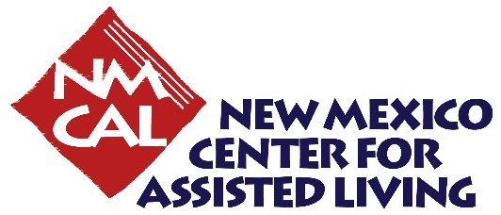

COVID19 REPORTING CHECKLIST

NMHCA/NMCAL is providing this checklist to assist facilities in the event of a COVID19 outbreak. While NMHCA/NMCAL makes every effort to ensure we provide the most comprehensive information available, it is recommended facilities seek further direction from the NM Department of Health to ensure compliance with all reporting and other requirements.

- Call the State Epidemiology Department hotline # to report a positive result at
1- 855-600-3453 and that message will get relayed to the Infectious Disease Epidemiology Bureau. If you have questions and need a call back, include information in the message. They will most likely send out test kits to test your entire facility, all residents and staff, and will work closely with you, be sure to follow their instructions

- Call the Division of Health Improvement Complaints department and self-report, the information is disseminated to all “need to know” parties within DHI.
Phone (800) 752-8649
Fax (888) 576-0012
Email: incident.management@state.nm.us

ADDITIONAL EMAILS/CONTACT INFORMATION:

Christopher Burmeister, Director
Christopher.burmeis@state.nm.us
Division of Health Improvement
505.476.9074
505.252.4492
2040 S. Pacheco St
Santa Fe NM 87505

Maurella Sooh, Bureau Chief
Maurella.sooh@state.nm.us
District Operations Bureau
Division of Health Improvement
2040 S. Pacheco
Santa Fe, NM 87505
(505) 476-9039
Fax (505) 476-9048

The link for online incident reporting instructions is:
https://nmhealth.org/about/dhi/ane/rahf

- Report COVID positive results to CDC (NHSN) web portal, weekly reporting or more if desired is the usual protocol.
- Promptly (within 12 hours) notify HCP, residents, and families about identification of COVID-19 in the facility. See QSO-20-26-NH, Upcoming Requirements for Notification of Confirmed COVID-19 (or COVID19 Persons under Investigation) Among Residents and Staff in Nursing Homes https://www.cms.gov/files/document/qso-20-26-nh.pdf
  - Provide educational sessions or handouts for HCP, residents, and families
  - Reinforce basic infection control practices within the facility (e.g., hand hygiene, PPE use and environmental cleaning).
  - Maintain ongoing, frequent communication with residents, families, and HCP with updates on the situation and facility actions
- Contact your state Ombudsman to give them resident/ family contact information, and to update them on status of the facility as needed.
- A state “rapid response” team will contact you to help you through the identified positive results. This team is comprised of individuals from Aging and Long-Term Services (who will call and initiate the rapid response), DHI, epidemiology and Infection Control Consultants of NM, who will arrange an infection control assessment. These entities will all work closely with your facility.
- Report to OSHA within 4 hours of notification of staff positive. Employers may now report positive COVID-19 cases in the workplace to the New Mexico Occupational Health and Safety Bureau online.

Other Resources:

New Mexico Health Care Association/New Mexico Center for Assisted Living COVID19 updates webpage:
https://www.nmhca.org/covid19/

American Health Care Association has many resources:
https://www.ahcancal.org/facility_operations/disaster_planning/Pages/Coronavirus.aspx

CDC responding to COVID19 in nursing homes:
https://www.cdc.gov/coronavirus/2019-ncov/hcp/nursing-homes-responding.html

CDC infection control guidance:
https://www.cdc.gov/coronavirus/2019-ncov/hcp/infection-control.html

For further information, please call New Mexico Health Care Association and ask for Pat Whitacre or Tracy Alter, 505-880-1088.

