CREATING a HAPPY, OPTIMISTIC
& PRODUCTIVE WORKPLACE

Presentation
by
Michael Mercer, Ph.D.
Book Author + Business Psychologist + Speaker
Mercer Systems LLC
PH = 847-521-2554
EM = DrMercer@MercerSystems.com
Website = www.MercerSystems.com

© Copyright 2021 Mercer Systems LLC
All Rights Reserved.

Optimists Focus on ________________________

Pessimists Focus on ________________________

Optimists Love to Make Everything
+
+
+

Pessimists Love to Do 3 Things
A.
B.
C.

Syllabus I Created for my MBA Students

In My Syllabus

MBA Student after her last MBA class – my class – insisted on private meeting

RESEARCH on REASONS to BE OPTIMISTIC

> ____________
P_______________
E_________________

> ____________________________

2

Terry Terrific - Abilities & Behavior Forecaster™ Tests

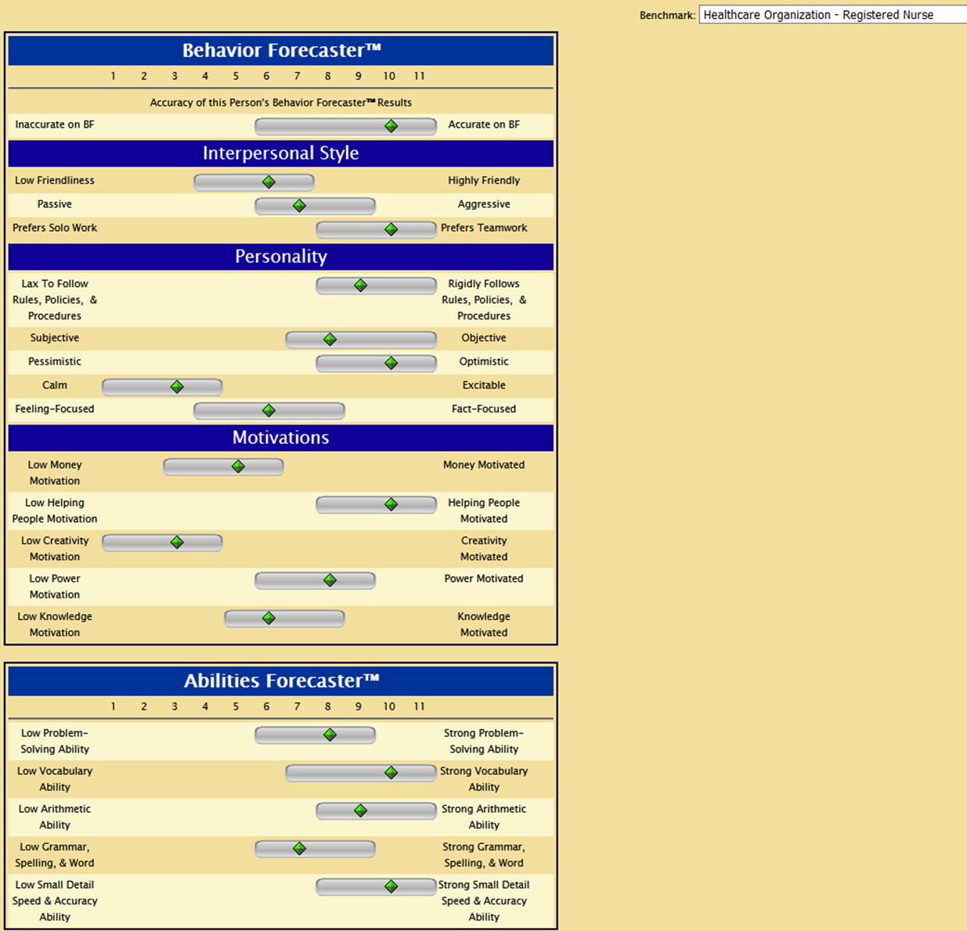

© Copyright 2001, 2012, 2021 Mercer Systems LLC
All rights reserved.
www.MercerSystems.com, phone = 847-521-2554

3.

Lee Lousy - Abilities & Behavior Forecaster™ Tests
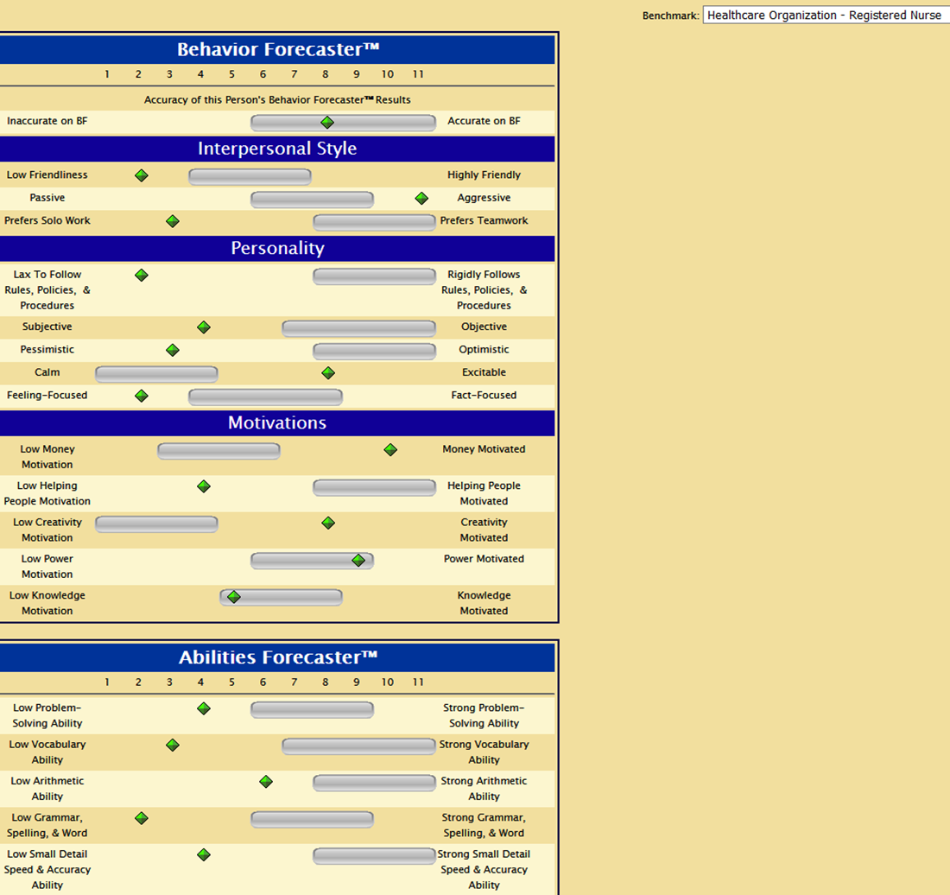

© Copyright 2001, 2012, 2021 Mercer Systems LLC
All rights reserved.
www.MercerSystems.com, phone = 847-521-2554

4

5 FAST WAYS TO BE OPTIMISTIC – INSTANTLY

1.

2.

3.

4.

5.

5

7 ACTIONS YOU CAN DO EVERY DAY TO
+ BE FANTASTIC ROLE MODEL OF OPTIMISM
+ SPREAD CHEERFUL, UPBEAT FEELINGS

1. LOOK ________________

2. __________ – at A LOT OF PEOPLE

3. SAY, “__________” – to A LOT OF PEOPLE

4. ________________________ 2 OR MORE TIMES IN EVERY CONVERSATION

REASON =

5. ASK “_________________” QUESTIONS

6. ASK VERY, VERY FEW “__________________________” QUESTIONS

7. OFTEN SAY
+ “___________________”
+ “________________________”

TERRIFIC TIP FOR MANAGERS & LEADERS

“SHADOWING”

ASSIGN PESSIMISTIC EMPLOYEE TO _________________________

YOU MUST SCHEDULE & HOLD _______________________

6

COMMON PHRASES YOU MUST NOT USE

DO NOT SAY DO SAY

GIVE 3 OR MORE _____________ PER DAY

MUST BE ________________

MY RESEARCH COMPARING HIGH-ACHIEVERS versus UNDER-ACHIEVERS

7

“GRACE” by YOU
PRODUCES HEALING

Dr. Mercer’s Definition of “GRACE” =

+

+

+

+

YOUR “GRACE” HELPS PRODUCE HEALING IN YOUR

*

*

*

*

*

HOMEWORK ASSIGNMENTS
to
HELP YOU + YOUR WORKPLACE
1.

2.

3.

4. Within 1 week, send EM to Dr. Mercer or Call Dr. Mercer – to tell him your ….

8

YOU CAN CONTACT DR. MERCER for . . .

> Speeches & Seminars & Webinars – for your organization
* Creating an Optimistic, Positive, Upbeat Workplace
* Hire the Best & Avoid the Rest™
* Leadership
* Turning Your HR Dept. into a Profit Center™
* Teambuilding & Highly Productive Teamwork

> Pre-Employment Tests
* Abilities Forecaster™ Tests
* Behavior Forecaster™ Test
* Dependability Forecaster™ Test

> Free subscription – to “Dr. Mercer’s Management e-Newsletter”

> Books – autographed to you – including
* Spontaneous Optimism™
* How Winners Do It: High Impact People Skills for Your Success
* Hire the Best & Avoid the Rest™
* Turning Your HR Dept. into a Profit Center™
* Job Hunting Made Easy
* Absolutely Fabulous Organizational Change™

> Your Questions – about topics in this webinar/presentation

Call = 847-521-2554
or
E-Mail = DrMercer@MercerSystems.com

