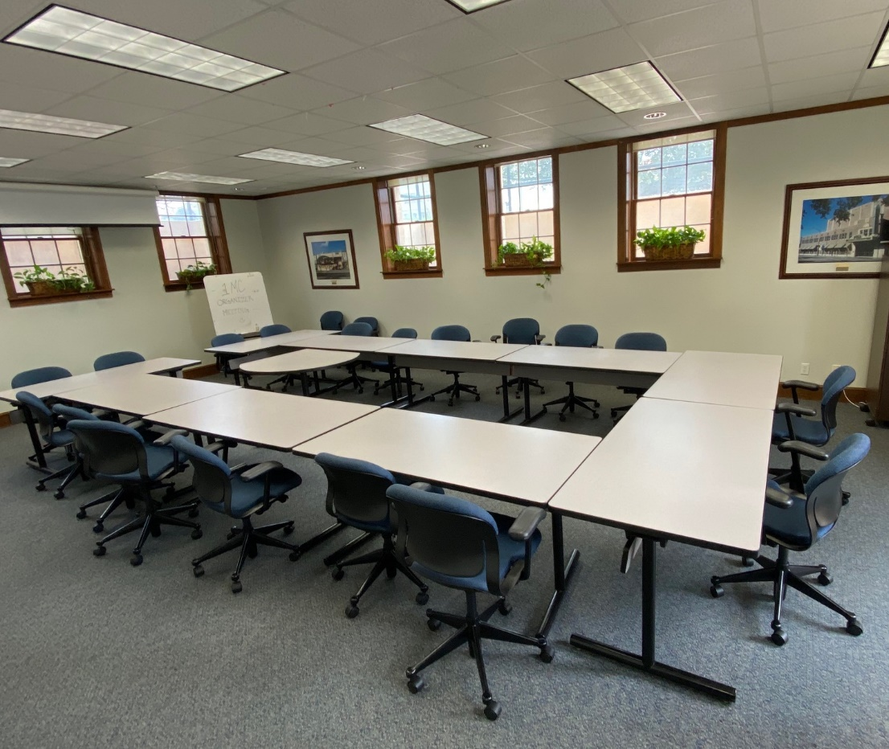
Conference Room (Downstairs)
35 Lake Morton Drive
Lakeland, FL 33801
Maximum seating of 32 people

35 Lake Morton Drive, Lakeland FL 33801 Phone: (863)688-8551 Fax: (863) 683-7454
MEETING ROOM REQUEST FORM
Date of Request: ______________________
Company: __________________________________
Contact Person: _______________________________________________________________________
Address: _____________________________________________________________________________
Phone: ________________________________ Email: ________________________________________
Date(s) Room Requested: ______/_______ /_______ to _______/_______ /_________
Board Room (maximum of 30 people)

__ Full Day (8:00am-5:00pm)
Non-Members
$50 per hour
$175 per half-day
$320 per day
Members
$40 per hour
$150 per half-day
$275 per day
__ Half Day
8:00am-12:00pm
1:00pm-5:00pm
__ Other: ________________

Anticipated Number of Attendees: _____________ Event Start Time: ___________ Event End Time: ___________
Equipment Provided:
Internet Connection/Free wireless internet (Wi-Fi)
LCD Projector

Payment Options:
Total Amount Due $___________________________
Check Number: # _______________
Credit Card Number: _________________________________ Exp. Date: ______ / _______
Authorized Signature: _______________________________________________________
Name (Printed):____________________________________________________________
Date: ____________________________________________________________________

For more information, contact:
Jazz Lyons, jlyons@lakelandchamber.com

