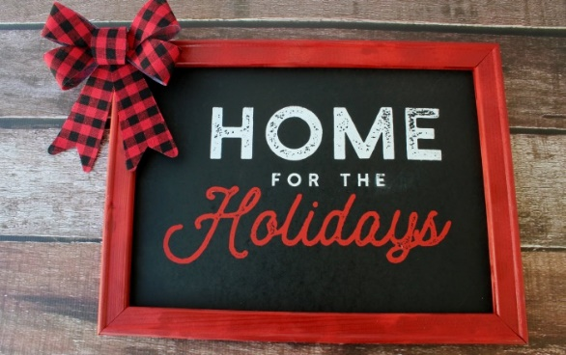
Friday Night Festivities!
City Hall Lawn, Main Street, 5:45pm
Join in for the Tree Lighting and Singing!
Start the holiday season with the lighting of the City holiday tree by Mayor Paul Brodeur. To help you get into the holiday spirit, local Melrose musicians will lead us in some festive holiday songs! Bring your singing voice!
Main Street, Downtown Melrose, 6:20pm – 6:30pm
Santa Arrives!
Following the City Hall tree lighting, Mayor Brodeur turns on the downtown holiday lights along Main Street, and Santa Claus arrives in Melrose! Enjoy holiday music by our Chamber DJ at the courtyard of the YMCA on Main Street. Santa will be on top of a Melrose Fire Department Engine and led by Melrose High School Drummers.
You don’t want to miss this!
THEN, the celebration continues at the Knights of Columbus from 7:00 – 9:00 pm. Get your picture taken with Santa, dance to holiday tunes, donate an unwrapped gift for Toys for Tots, and more.

The festivities continue for people of all ages with entertainment, holiday music, shopping and dining throughout downtown on Friday and then all over Melrose on Saturday & Sunday!

