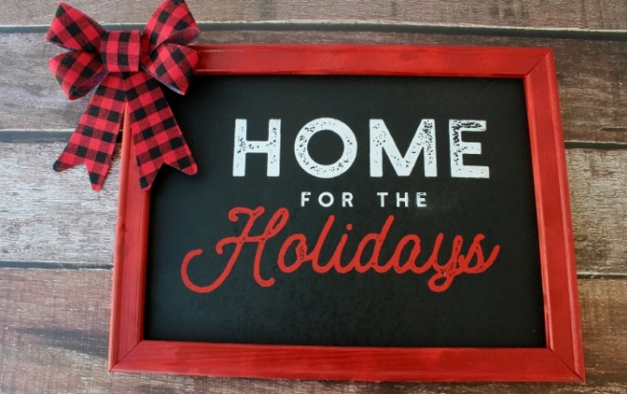
Weekend Events
Beebe Estate
235 West Foster Street
Artisanal Ladies Return
Dec 2nd open 6-9, Dec 3rd (10th and 11th) open 11-3
Seven artists featuring unique gifts. Textile homeware and art pieces, photography, jewelry, paperwork’s, art to wear.
First Congregational Church is located at 121 West Foster Street; just one block off of Main Street.
We invite you to our Annual Winter Wonderland Christmas Fair as part of the city's Home for the Holidays celebrations. Come join us for dinner on Friday evening and lunch on Saturday while you and your family enjoy a marketplace, gingerbread house decorating, raffle baskets, a bake sale, "wine pull," and much more. We will have activities both inside and outside. We also invite families or individuals to have seasonal portraits taken and/or video messages recorded in front of your choice from a variety of virtual backgrounds. Images and video will be provided to you via email. Prices start at $15 for three poses and $20 for a video message.
Our Christmas Fair will be held on Friday Evening from 6:00 to 8:00 p.m. and on Saturday from 9:00 a.m. to 2:00 p.m. Visit our website at fccmelrose.org or find us on Facebook!

Folllow Your Art Community Studios
647 Main Street
Friday from 10-6 pm: It's the Follow Your Artisan Market representing 35 local artists and makers! Shop small and local with handmade treasures for you and your loved ones.
Saturday 10-2: By now a tradition, Shrinkies are back! Make a one of a kind hanging suncatcher for your window or tree, appropriate for all ages. $5 for 2 shrinkies*. While you are here, make sure you stop by the Follow Your Artisan Market for handcrafted art, jewelry, ceramics and more.
*what is a shrinky, you ask? Think of the classic "Shrinky Dinks" but better because you create your own (templates are available!)

Melrose High School Band's Annual Christmas Tree Sale
Melrose High School Parking Lot, 360 Lynn Fells Parkway, Band Christmas Tree and Wreath Sale (Fri. 5-9 pm, Sat. 8 am – 9 pm , Sun 9-noon)
Friday, December 3 - Sunday, December 5 in the high school parking lot. The fresh Christmas trees are delivered directly from Nova Scotia! Wreaths (decorated and plain), kissing balls, poinsettias and sweet treats will be on sale for one weekend only. For best selection, arrive early! Cash, checks and credit cards are accepted. This is our largest fundraiser for the year. Thank you for supporting the band!
Melrose Youth Ballet presents the 25th Annual Presentation of The Nutcracker
Memorial Hall, 590 Main Street
Directed by Andrea Fanikos and Travers King
Performances: Friday, 12/3 8:00pm; Saturday, 12/4 1:00pm and 7:00pm; Sunday 12/5 1:00pm. Tickets available online only: www.melroseyouthballet.org
St. Mary’s School
4 Myrtle Street, Friday 11:00 am – 9:00pm; Sat 9:00am – 6:00pm, Sun 9:00 am – 1:00 pm
Come to the annual Christmas Tree Sale to support the 8th Grade class. Premium trees, wreaths, kissing balls, baked goods, raffle baskets and more!! Santa will be popping in throughout the weekend to say Ho-Ho-Ho!!

Trinity Church - 131 West Emerson
Festival of Trees
Friday - Dec 2 from 7pm to 9pm
- Reception for Melrose community with music & free refreshments
- View large assortment of decorated trees & baskets - all available by raffle
- Silent auction including art & Bruins' tickets
- Shop for Thrift Shop treasures
Saturday - Dec 3 from 9am to 3pm (Cedar Park Trolley Stop)
- Decorated trees & baskets - all available by raffle
- Silent Auction
- Thrift Shop treasures
- Bake sale
- Free craft-making for kids

