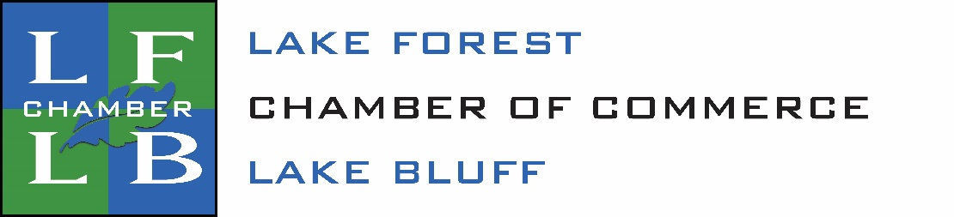

It’s a great time to join the Chamber!
Join now for 2020 at the 2019 rates and receive
the rest of this year free!

Join Today!
Rates are based on full time employees
(2 part time = 1 full time)
Non-profit organizations receive a 20% discount off the regular rates.

Number of Employees | Full-Year Dues | Non-Profit Dues
1-5 | $325 | $260
6-10 | $425 | $340
11-20 | $565 | $452
21-30 | $685 | $548
31-50 | $810 | $648
51-75 | $915 | $732
76-100 | $1,155 | $924
101-200 | $1,390 | $1,112
201-300 | $1,600 | $1,280
301-400 | $1,975 | $1,580
401-1200 | $2,360 | $1,888
1200+ | $3,050 | $2,440

Questions? Contact us!
847-234-4282
info@lflbchamber.com
www.lflbchamber.com

