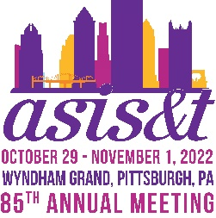
Budget Toolkit
 | Registration Category | Early Bird  by 12 Aug '22 | Regular & On Site  13 Aug-1 Nov '22 | Includes  Membership
 | First Time - Member | $550 | $650
 | First Time - Non-Member | $700 | $800 | Yes
 | Full Conference - Member | $600 | $700
 | Full Conference - Non-Member | $750 | $850 | Yes
 | Full Conference Retired Member | $350 | $400
 | Full Conference Student Member | $350 | $400
 | Full Conference Student Non-Member | $395 | $445 | Yes
 | Daily Rate - Member | $310 | $350
 | Daily Rate - Non-Member | $380 | $425
Registration Fee | $_________
Please select the appropriate registration fee from the table above.
Flights | $_________
Use average costs from your region to Pittsburgh International Airport (PIT).
Visa | $_________
Check the type of visa you may need to travel from your country to the U.S.A.
Housing | $_________
ASIS&T has secured a competitive hotel rate you can obtain by booking through our housing block. Single or double rate is $179 (plus tax) per night.
Airport Transportation | $_________
One-way taxi fare between Pittsburgh International Airport and Downtown is about $40. Port Authority Transit 28X Airport Flyer Bus fare between the airport and Downtown is $2.75 each way. (Note: Exact change is required.) Passengers are responsible for handling their bags when getting on and off the vehicle. Uber and Lyft also are authorized to pick up and drop off passengers.
Local Transportation | $_________
The Port Authority of Allegheny County allows visitors to search for public transportation routes using interactive Google Maps technology. Port Authority of Allegheny County is the public transit agency for the Greater Pittsburgh area, providing bus, light rail, incline and paratransit service to thousands of riders daily.

Meals | $_________
Attend the opening plenary, awards luncheon, business meeting and breakfast, workshops, welcome reception, president’s reception and poster presentations, and other events to save on meals. Show your meeting badge at participating establishments for a discount!
TOTAL | $_________

