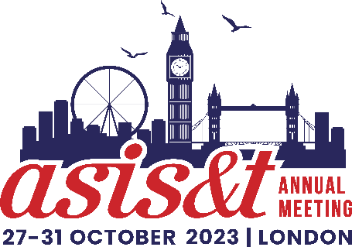
Budget Toolkit
 | Registration Category | Regular  12 Aug - 13 October '23 | Onsite  14-31 October '23 | Includes  Membership
 | First Time - Member | $700 | $800
 | First Time - Non-Member | $860 | $960 | Yes
 | Full Conference - Member | $750 | $850
 | Full Conference - Non-Member | $910 | $1,010 | Yes
 | Full Conference Retired Member | $425 | $475
 | Full Conference Student Member | $425 | $475
 | Full Conference Student Non-Member | $475 | $525 | Yes
 | Daily Rate - Member | $410 | $460
 | Daily Rate - Non-Member | $485 | $540
Registration Fee | $_________
Please select the appropriate registration fee from the table above (higher onsite fees 14-31 October)
Flights | $_________
Use average costs from your region to Heathrow International Airport (LHR).
Visa | $_________
Check the type of visa you may need to travel from your country to the UK
Housing | $_________
ASIS&T has secured a competitive hotel rate you can obtain by booking through our housing block. Special Rate Bed & Breakfast at £159.00 Single occupancy & £169.00 Double occupancy per night. VAT included.
Airport Transportation | $_________
One-way taxi fare between Heathrow International Airport and the hotel on average costs around €105 (£90). Uber is authorized to pick up and drop off passengers. Less expensive transportation is available by using the underground subway system, “the Tube” which has stations at Heathrow and stops near the hotel in Hammersmith.
Meals  Attend the awards luncheon, business meeting and breakfast, workshops, welcome reception, president’s reception and poster presentations, closing plenary luncheon, and other events where food is served to save on meals. If you stay at the Novotel Hotel, breakfast is included. | $_________
TOTAL | $_________

