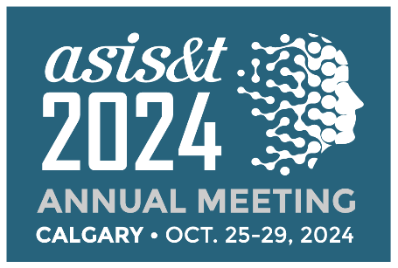
Budget Toolkit
 | Registration Category | Early Bird  by 5 Aug '24 | Regular  6 Aug- 10 October '24 | Includes  Membership
 | First Time - Member | $600 | $700
 | First Time - Non-Member | $760 | $860 | Yes
 | Full Conference - Member | $650 | $750
 | Full Conference - Non-Member | $810 | $910 | Yes
 | Full Conference Retired Member | $375 | $425
 | Full Conference Student Member | $375 | $425
 | Full Conference Student Non-Member | $425 | $475 | Yes
 | Daily Rate - Member | $360 | $410
 | Daily Rate - Non-Member | $430 | $485
Registration Fee | $_________
Please select the appropriate registration fee from the table above (higher onsite fees 11-29 October)
Flights | $_________
Use average costs from your region to Calgary International Airport (YYC).
Visa | $_________
Check the type of visa you may need to travel from your country to Canada
Housing | $_________
ASIS&T has secured a competitive hotel rate you can obtain by booking through our housing block. Special hotel rate of CA$249.00 single occupancy plus 12.7% taxes and fees.
Airport Transportation | $_________
One-way taxi fare between Calgary International Airport and the hotel on average costs around CA$40.It’s about a 15-minute ride. Uber is authorized to pick up and drop off passengers (CA$30).
Meals  Attend the awards banquet, business meeting and luncheon, coffee breaks, workshops, welcome reception, president’s reception and poster presentations, closing plenary luncheon, and other events where food is served to save on meals. | $_________
TOTAL | $_________

