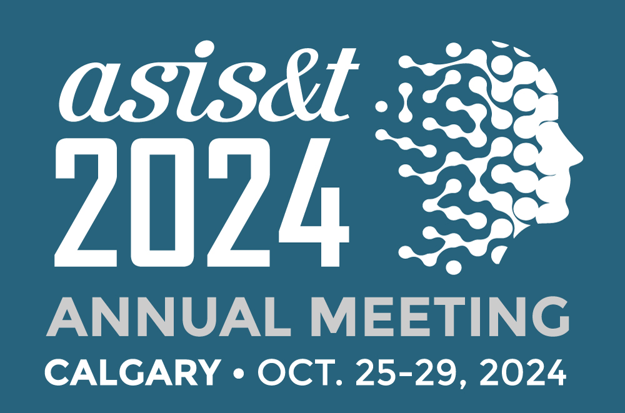

CALL FOR PARTICIPATION
Doctoral Colloquium
2024 Annual Meeting of the Association for Information Science and Technology
Hyatt Regency Calgary, Calgary, AB, Canada | Saturday, 26 October 1:00 p.m.-5:00 p.m.
We invite doctoral students to participate in the 2024 ASIS&T Doctoral Colloquium, which will take place as part of the 2024 Annual Meeting of the Association for Information Science and Technology. This half-day event is intended for doctoral students in the later stages of dissertation research, i.e., students who are post-proposal, begun data collection and analysis, are writing, or have defended their dissertations before the conference. Students who are writing their proposals and have a completed research design will also be considered.

Students must be ASIS&T members to participate in the Doctoral Colloquium and upon confirmation of their membership status will be awarded complimentary conference registration

The goals of the 2024 ASIS&T Doctoral Colloquium are to provide doctoral students with a supportive and critical learning opportunity to discuss their work, highlight theoretical and methodological problems for further discussion and inquiry with senior mentors and Colloquium participants. As in previous years, the organizers will invite a group of prominent professors and experts to serve as mentors during the Doctoral Colloquium. Participants will have the opportunity to receive feedback and comments about their work, in one-on-one sessions with mentors. There will also be an open discussion session where students can ask the mentors questions about the job search, managing an academic career, developing, and maintaining a research agenda, and other topics of interest. Another goal of the Colloquium is to develop a supportive community within which students can begin to develop a professional network, interacting with peers and senior scholars in information science and related disciplines.
How to Apply:
Students should submit a five-page essay (in English, including references) describing their PhD research proposal or dissertation project and a nomination letter from their advisor or chair, which should be attached to the essay. All essays must be single author and will not be published. The competed application essay needs to be submitted electronically using the ASIS&T conference submission system and paper template at: https://www.conftool.org/asist2024/

In your essay, please address each of the following questions:
1. Problem statement: What is the problem that you are addressing?
2. Relevance: Why the problem is important?
3. Related work: How have others attempted to address this problem?
4. Research question(s): What are the research questions that you plan to address?
5. Methodology: How are you planning to address your research questions?
6. Evaluation plan: How will you measure your success - faster/more accurate/less failures/etc.?
7. Preliminary results: Do you have any preliminary results that demonstrate that your approach is promising?
8. Implications: What are the theoretical, methodological, practical, and societal contributions of your work?
Important Dates: Deadline for submission: 5 June 2024 | Decisions made: 2 August 2024
If you have questions, please contact the Doctoral Colloquium organizers:
Dr. Howard Rosenbaum, Luddy School of Informatics, Computing, and Engineering, Indiana University
Denise Agosto, College of Computing and Informatics, Drexel University

