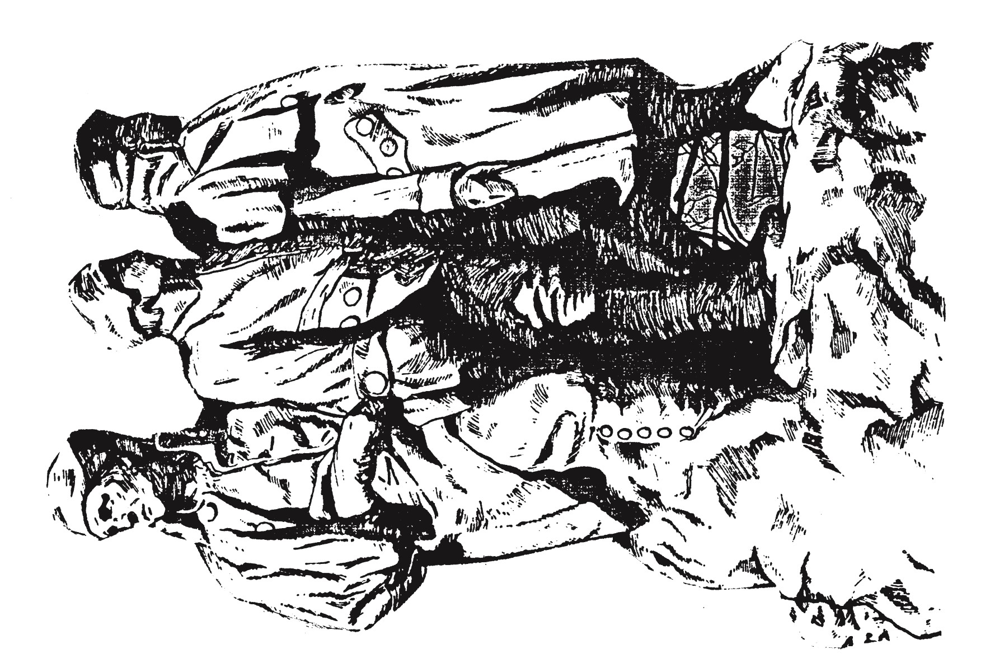
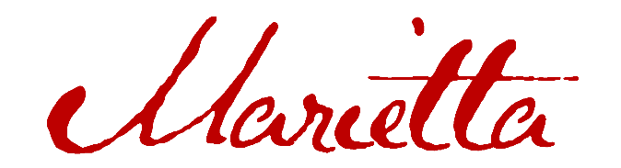

Founded in 1788 Joshua D. Schlicher America’s Start of the Northwest Territory Mayor

OFFICE OF THE MAYOR
301 Putnam Street
Suite 1000
Marietta, OH 45750
740-373-1387
mariettaoh.net

March 24, 2020

To: The citizens, business owners, visitors and officials of Marietta

From: Josh Schlicher, Mayor

Re: Official response from the Marietta Mayor’s Office regarding the COVID-19 worldwide pandemic

The Marietta Mayor’s Office releases this official response after consultation with the Marietta/Belpre City Health Department, Marietta Department of Public Safety and Service, Marietta Fire Department, Marietta Police Department, Ohio Department of Health, city officials and area mayors.

The city administration is working with other public entities to protect our residents, our first responders and city personnel. The main objectives we are working towards are to:
- Minimize number of COVID-19 cases and fatalities among Marietta residents.
- Protect the public health of public workers, health care workers and first responders.
- Prevent unnecessary overwhelming of the local health care system.
- Minimize impact of COVID-19 on the local economy.

We have complied with the Ohio Department of Health’s mandate of “staying at home” for all nonessential employees and department operations.

THE CITY OF MARIETTA PUBLIC BUILDINGS WILL BE CLOSED AS OF MARCH 23, 2020 UNTIL FURTHER NOTICE.
The Director of Public Safety and Service has handwashing and sanitizing stations available to use at the buildings. The City Building at 301 Putnam Street as well as the City Administrative Services Building at 304 Putnam Street are being sanitized by city staff.

We ask the members of the public to conduct essential business activity with the city but encourage alternate methods that do not put the public and city employees in close proximity.

The following information is concerning the Mayor’s Office, Water and Wastewater Office, Marietta City Income Tax Department, Marietta Police Department, Marietta Fire Department and other public offices.

Marietta Mayor’s Office (301 Putnam Street):
The Mayor’s Office and Marietta Department of Public Safety and Service will remain staffed from 8 am to 5 pm Monday-Friday. All general inquiries can be made through the office by calling 740-373-1387. After hours and for an emergency call the Marietta Police Department at 740-373-4141.

Marietta City Water and Wastewater Office (304 Putnam Street):
The City of Marietta Water & Wastewater office will remain staffed to provide essential services to our customers. Please phone our office by calling 740-373-3515 to see if your presence is required or necessary. Office hours will remain the standard Monday-Friday, 8:00 a.m. – 4:30 p.m. unless otherwise announced.

- Drop box is available and encouraged for routine payments.
- Delinquent Customer Accounts (shut-off notices) – A standard ten-day extension will be granted to all customers via phone request with our office personnel. Once request is made and confirmed, a copy will be mailed to you with due-date information.
- For new services – please call in advance for instructions.

These policies will remain in effect and be updated as additional information becomes available. As always, if you have an after hour water/sewer emergency, please call 740-374-6864 for water services or 740-373-3858 for wastewater services.

Marietta City Income Tax Department (301 Putnam Street):

For the safety of our taxpayers and city employees the Marietta City Treasurer’s Office and City Income Tax Department will be closed to public business. The office will remain staffed for processing tax returns and other pertinent business.

Use the drop box located in front of the building. If you need assistance with your tax return call the office at 740-373-4032. If you require assistance with filing forms or need curbside service contact the office.

All taxpayers with a prearranged agreement should call the office for further assistance.

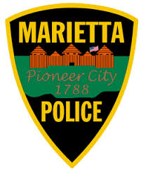
Marietta Police Department (301 Putnam Street):

The Marietta Police Department remains fully staffed and all guidelines and directives for officer and public protection are in place.

All walk in visitors are allowed to enter the department only if business is essential.

All general inquires may be made to the department by calling 740-376-2007

All citizens needing service are to call the police department at 740-373-4141 or 911 for emergencies.

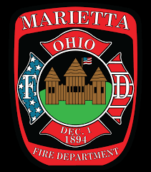

Marietta Fire Department (Station 1, 301 Putnam Street, Station 3 and 4)

The Marietta Fire Department is continually seeking to keep the safest environment for our firefighters and our patients. With this in mind, the following changes will be implemented.

- All ride along time for students/residents will be temporarily suspended.
- No visitors to any of the fire stations
- Fire inspections have been suspended at this time, to protect our personnel as well as the public
- Fire Chief and Assistant Chief will be located in separate buildings moving forward to limit the risk of exposure.

All firefighters, EMT’s and Paramedics will adhere to strict directives given by Fire Chief C.W. Durham and the Washington County EMS Response Guidelines COVID-19.

All general inquires may be made to the department by calling 740-373-4631

All citizens needing service are to call the fire department at 740-373-3131 or 911 for emergencies.

All other city offices should be contacted by phone to determine the appropriate means to
conduct business.

Marietta City Engineering Department 740-373-5495
Marietta City Development Department 740-373-9354

This office will continue to release information to the public as the situation develops.

Josh Schlicher
Mayor

