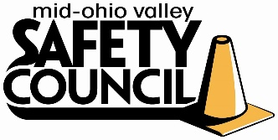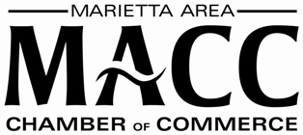

Mid-Ohio Valley Safety Council
2023 College Scholarship Application

Name:__________________________________________________________________
Current Address:__________________________________________________________
Email Address:
Phone Number:
High School Attending :_____________________________________________________
Graduation Date or Expected Graduation Date:__________________________________
GPA and Class Rank (please attach transcript):___________________________________
Are you a U.S. Citizen? Yes No
College you plan to attend:__________________________________________________

On a separate sheet, please complete the following in 300 words or less and attach to your application:
- Please describe your desire to attain a degree in an HSE (Health, safety and environmental) related field of study and why.
- Describe any achievements, honors, or extracurricular activities completed while in high school.

Application is due April 15, 2023. Submit via email to president@mariettachamber.com or mail to the following address:
Attn: Safety Council Scholarship
Marietta Area Chamber of Commerce
100 Front St., Suite 200
Marietta, OH 45750

Mid-Ohio Valley Safety Council
Annual College Scholarship Guidelines
The Mid-Ohio Valley Safety Council will award up to $1,000 in nonrenewable scholarships to graduating seniors from area high schools in Washington and Wood counties. The following criteria apply:
- Graduating or Graduated Senior
- GPA of 3.0 or above
- Field of study must be HSE related
- Apply toward continuing education tuition and/or related expenses
- Deadline for application April 15, 2023

MOVSC Organization Background:

The Mid-Ohio Valley Safety Council is a program of the Marietta Area Chamber of Commerce, co-sponsored by The Ohio Bureau of Workers' Compensation Division of Safety & Hygiene.
Purpose:
It takes concern and dedication to instill an awareness of worker safety. The MOV Safety Council strives to provide increased safety awareness through the combined efforts of companies and the community at large.
Safety Council Goals:
- To provide a forum for businesses and industries interested in occupational safety and health.
- To examine and resolve potential and existing safety and environmental health problems.
- To inform participants of new safety and health techniques, products and services and to provide a thorough knowledge of these services.
- To encourage safety programs through a Safety Campaign.
Membership to Safety Council is open to representatives of business and industry in the Mid-Ohio Valley interested in developing increased safety awareness.
Luncheons are held with presentations on a wide variety of safety subjects as requested by the membership. Safety Council meets monthly, usually on the third Wednesday of each month.

